Tamweel Aloula Financing Company
KSA
Consolidated BSDD - Ijarah
Islamic Finance Module-Transact
Date: November 20, 2024



Document History
Author | Version | Date | Description
Kashif Umair | V1.0 | 20th NOV 2024 | BSDD
Kashif Umair | V2.0 | 05TH JAN 2025 | BSDD
Farhan Ullah Khan | V2.1 | 10th FEB 2025 | BSDD
Kashif Umair | V2.2 | 10th Feb2025 | Reviewed and updated

Table of Contents
1. Scope of the Document 10
2. Navigation Tips 10
3. Glossary 11
4. Agreed LMS process functionalities 11
4.1 Step 1: Offer Acceptance: 11
4.2 Step 2: Credit Admin Function (LOS) 11
4.3 Step 3: Contract Stage: 12
4.4 Step 4: Promissory Note Stage: 12
4.5 Step 5: IVR Authentication: 12
4.6 Step 6: Transact GL Entries: 12
4.7 Step 7: Insurance & Registration Details: 12
4.8 Step 8: Repayment Schedule & Tawtheeq: 12
4.9 Cancellation During Cooling Period 12
5. Existing Functionalities 13
5.1 IS.PARAMETER (WS03-IJR-01) 13
5.2 Asset Capture (WS03-IJR-02) 16
5.3 IS Contract Booking (WS03-IJR-03) 17
5.3.1 Input New Contract 18
5.3.2 Down Payment 18
5.3.3 Cost 19
5.3.4 Accounting Entries – IS Contract 20
5.3.4.1 Approval Stage 20
5.3.4.2 Purchase Stage 20
5.3.4.3 End to End IS Contract Entries 20
5.4 Down Payment Recovery (WS03-IJR-04) 21
5.4.1 Accounting Entries – Down Payment 22
5.5 Payment to Vendor (WS03-IJR-05) 23
5.5.1 Accounting Entry - Payment to Vendor 25
6. Credit Arrangement 26
6.1 Arrangement Creation (WS03-IJR-06) 26
6.2 Payment Schedule 28
6.3 SAMA Payment Schedule (WS03-IJR-07) 28
6.4 Arrangement Overview 29
6.5 Accounting Entries - AA Arrangement 30
6.6 Maintenance Activities 31
6.6.1 Cancellation within cooling period (WS01-IJR-08) 31
6.6.2 Deferment of Instalments (WS01-IJR-09) 38
6.6.3 Early Pay off (WS01-IJR-010) 43
6.6.4 Write off (WS01-IJR-11) 52
6.6.5 Partial Settlement (WS01-IJR-12) 55
6.6.5.1 AA - Compression payment 55
6.6.5.2 AA – Principal Decrease 61
6.7 Restructuring (WS03-IJR-13) 68
6.7.1 Request Stage 68
6.7.2 Approval Stage 69
6.7.3 Purchase Stage 70
6.7.4 Arrangement Booking 71
6.7.5 Commodity Restructuring Stage 72
6.7.6 Financial Entries 74
6.8 Enquiries (WS03-IJR-14) 75
7. Deltas 78
WS03-IJR-03-05 79
8. Detailed Description of Deltas 80
8.1 Amend IS Contract Stage - WS03-IJR-03-01 80
8.2 List of Vendors - WS03-IJR-02-01 80
8.3 Validation for sufficient funds - WS03-IJR-02-02 80
8.4 E-Invoice for VAT - WS03-IJR-03-02 80
8.5 Routing Entry for VAT - WS03-IJR-06-01 81
Worksheet details: 81
8.6 Calculate Insurance Balance - WS03-IJR-10-01 81
8.6.1 Worksheet details: 81
8.7 Accident Stop Installment - WS03-IJR-06-02 81
8.8 Insurance configuration WS03-IJR-06-03 to WS03-IJR-06-07 81
8.8.1 Worksheet details: 81
8.9 STMT Transaction - WS03-IJR-06-08 81
8.10 Reversal for Asset Capture and IS Contract - WS03-IJR-03-03 81
8.11 Expiry of Repayment Schedule - WS03-IJR-02-03 82
8.11.1 Worksheet details: 82
8.12 Document upload at Delivery Stage - WS03-IJR-06-09 82
8.13 Validation on pre-paid charge - WS03-IJR-06-10 82
8.14.1 Worksheet details: 82
8.14 Traffic Violation / Renewal Fee - WS03-IJR-06-11 82
8.15 Advance/Partial Payment - WS03-IJR-12-01 82
8.16.1 Worksheet details: 82
8.16 Limit Attachment before Arrangement -WS03-IJR-06-12 82
8.17 Tawtheeq Integration - WS03-IJR-06-13 83
8.18 Discount - WS03-IJR-06-14 83
8.18.1 Worksheet details: 83
8.19 Post Delivery Cancelation 83
8.20.1. With Court Decision - WS03-IJR-10-02 83
8.20.2. Without Court Decision - WS03-IJR-10-03 83
8.20 Termination (in case of reposes car) - WS03-IJR-10-04 84
8.21 Delay Transfer Fees - WS03-IJR-06-15 85
8.22.1 Worksheet details: 85
8.22 Waiver (for only fees) - WS03-IJR-06-16 85
8.23 Loan transfer/Loan transfer with repricing only for Ijarah - WS03-IJR-06-17 85
8.24 Reallocation Payments and Down Payment only for Ijarah - WS03-IJR-02-04 85
8.25 Deferment mandatory insurance payment - WS03-IJR-09-01 85
8.26 Total Loss Settlement through Insurance Claim - WS03-IJR-10-05 85
8.26.1 Total Loss with charge 86
8.27.1.1 Worksheet details: 86
8.26.2 Total Loss without charge 86
8.27.2.1 Worksheet details: 86
8.26.3 Total Loss with Insurance differential 86
8.27.3.1 Worksheet details: 86
8.26.4 Total Loss with Back Date Accident 86
8.27.4.1 Worksheet details: 86
8.26.5 Total Loss with Death Claim 86
8.27.5.1 Worksheet details: 86
8.27 Reversal of Down payment, Admin fee and Insurance - WS03-IJR-03-04 87
8.28 GAP - STP Process - WS03-IJR-02-05 87
8.29 Restructuring - WS03-IJR-13-01 87
8.30 Takaful Treatment in Partial Settlement - WS03-IJR-12-01 87
8.31 Offer letter, contract generation and other letters- WS03-IJR-03-05 88
8.32 Post write-off recovery- WS03-IJR-11-01 88
8.33 Bullet Payment and EPC (Early Payoff Charges) WS03-IJR-10-06 88
8.34 Abnormal Cancellation WS03-IJR-10-07 89
8.35 Residual Value WS03-IJR-06-18 89
8.36 File upload of repayments through IBFT 89
8.36.1 Worksheet details: 89
8.37 No Colling Period: so Ijarah cases will be tread as normal early maturity 89

Scope of the Document
The scope of this document is to provide users with end-to-end functionality of Ijarah product in Transact along with deltas noted during onsite BPR session. This document has two main sections. Section -5 is existing functionalities that explains end to end journey of LMS with respect to subject product. The other section-7 explains the deltas. Each existing functionality has a reference number that has prefix as WS03, for instance WS03-PRODUCT CODE-PROCESS NO. (WS03-IJR-01). Whereas on delta if any gap has been highlighted for the specific existing functionality, then it will be marked as WS03-PRODUCT CODE-PROCESS NO. SEQUENCE (WS03-IJR-01-01).
The pre-requisite of this document is to review agreed end-to-end process flow from LOS to LMS. This document also refers some working sheets that were finalized during onsite BPR session. Under each existing functionality or Delta there is a separate heading named as “Worksheet details” which will cite the reference document / sheet name.

Navigation Tips
This button refers to ‘Validate’ a record on T24. It is placed on top of the screen while input of any transaction on T24. After filling out all mandatory and necessary information, user can press this button to check for core errors or any missing component on the record.
This button refers to ‘Commit’ a record on T24. This button is pressed to make the record part of T24.
This button is used to ‘Delete’ the record. (Only unauthorized records can be deleted from the system)
This button is used to ‘Authorize’ the record. Only upon Authorization marking the record is made the part of LIVE file.
This Button is used to put the record on ‘Hold’.

Glossary
Abbreviations | Description
CBS | Core Banking System
BRD | Business Requirement Document
BSDD | Business Solution Design Document
BPR | Business Process Review
IS.CONTRACT | Islamic Finance Contract
AA | Architectural Arrangement (Loan)
WS | Workstream
STP | Straight Through Process
CUC | Customer
LOS | Infinity or new digital
LMS | Transact

Agreed LMS process functionalities
Please refer to ProcessFlow-TA-Ijarah-v1.8
Process Cycle Overview (3 Working Days)

Step 1: Offer Acceptance:
- Customers have 24 hours to accept the offer.
- Actions required: Down payment and admin fee payment.
- This process has expiry duration of 24 hours

Step 2: Credit Admin Function (LOS)
- Purchase Order (PO) generation by the Credit Admin (LOS).
- Green Card validation conducted by the Credit Admin (LOS).
- Insurance Selection from Broker

Step 3: Contract Stage:
- Contract is generated and signed by the customer via ND.
  - Reversals (if applicable): Down payment, admin fee and insurance with VAT in case customer rejects at any above stages
  - The process 4.2 and 4.3 have expiry duration of 48 hours.

Step 4: Promissory Note Stage:
- Creation and acceptance of the Promissory Note by the customer via NAFITH.
  - Reversals (if applicable): Down payment and admin fee.

Step 5: IVR Authentication:
- Customers must authenticate via IVR.
- Reversals (if applicable): Down payment, admin fee and Promissory Note.

Step 6: Transact GL Entries:
- Asset Purchase
- IS.Contract
  - Reversals (if applicable): Down payment, admin fee, GL Entries and Promissory Note.

Step 7: Insurance & Registration Details:
- Insurance Purchase: Policy bought through Tameeni.
- Istimara Details: Entered and followed by the generation of a Delivery Note.

Step 8: Repayment Schedule & Tawtheeq:
- Repayment Schedule on AA Arrangement (APR generation).
- Registration on Tawtheeq

Cancellation During Cooling Period
- If the process is cancelled within the cooling-off period, the following reversals are Required:
  - Down payment.
  - Admin fee.
  - Insurance costs.
  - Promissory Notes.
  - Tawtheeq Registration.

Existing Functionalities

IS.PARAMETER (WS03-IJR-01)
IS.PARAMETER is the parameter table to define the Islamic Banking product related features. 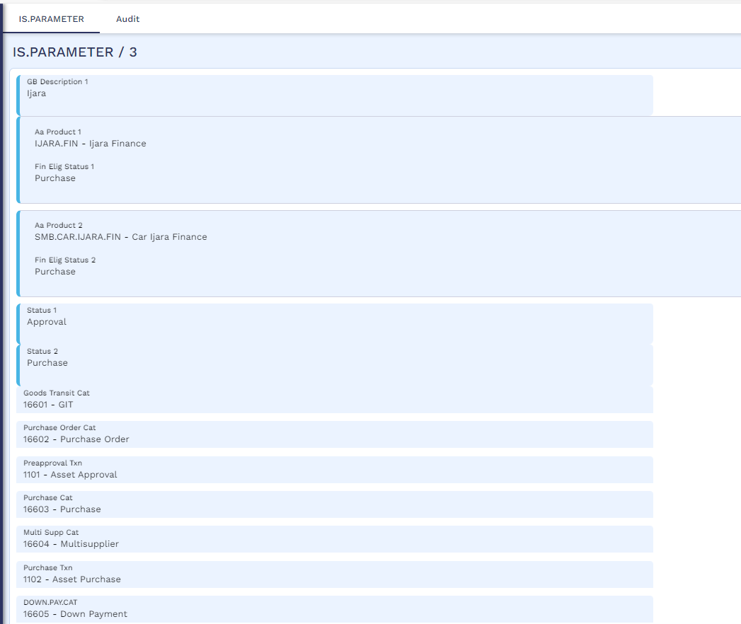
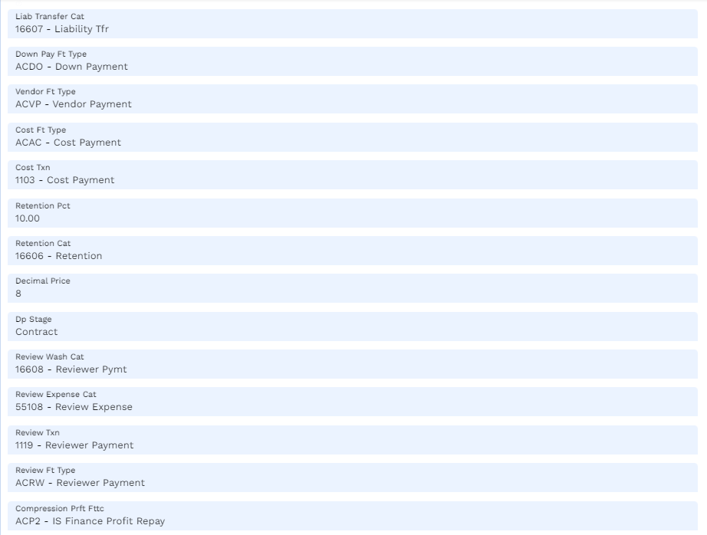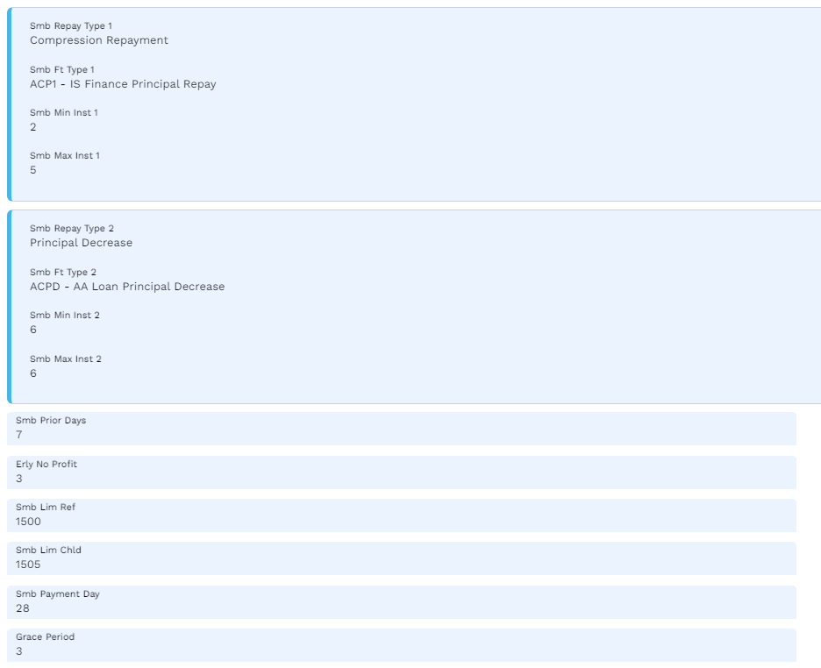

Asset Capture (WS03-IJR-02)
This table capture the details of assets to be financed. Below are mandatory fields that needs to be input by user. Upon authorization of asset capture this record will be available to record IS contract.
FIELDS | INPUT | Definition
Customer | "200027" | CIF ID
Currency | “SAR” | Country Currency
Vendor | “Vendor CIF” | Vendor who buy the asset
Unit Price | “250,000” | Price of the asset
Asset Description | “Nissan Patrol” | Description of the purchasing asset
Asset Short Title | Nissan Patrol 6th Generation | Asset short description
For other fields will
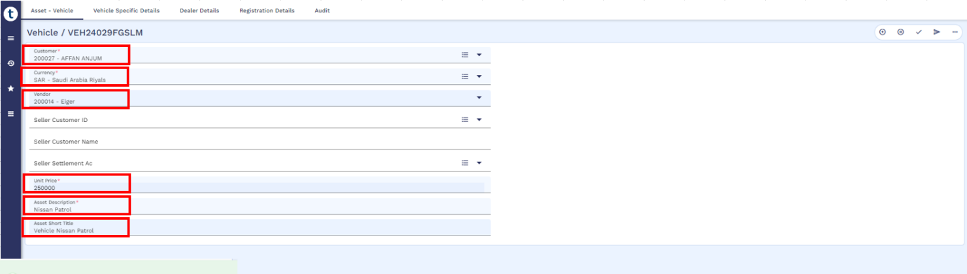

IS Contract Booking (WS03-IJR-03)
The application is used to record all information pertaining to financing of assets. The entire workflow of the product with different statuses is captured in this application. The contract evolves into different statuses like REQUEST, APPROVAL, PURCHASE based on the workflow defined in the product parameter file IS.PARAMETER.
Below fields will need to be input by user or integrated. In case of TA Ijarah, the below process is automated and will be generated through LOS.
Transcript | Data | Description
CUSTOMER | 200027 | CIF ID
Product | 3 | Product ID as per IS Parameter.
Status Value Date | 29 Jan 2024 | Date on which the Status is effective. Defaulted to the date given in the field VALUE.DATE.
Currency | SAR | CURRENCY
Value Date | 29 Jan 2024 | Value date of contract
GB Asset Description | Vehicle Nissan Petrol | The Description of the contract or the Asset being captured.
Request Amount | 250,000 | Finance Amount requested by customer.
Commodity.1 | 1 – Vehicle | Commodity / Assets to be purchased.
Unit Price.1.1 | 250,000 | Unit Price pf commodity or assets being purchased.
Purchase Quantity.1.1 | 1 | This field specifies the quantity of the asset being requested.
Customer Account | 2000000453 | Repayment Account
Down Pay Asset Ref | VEH24032QD2H9 | The asset against which down payment is made.
Down Payment Type | Amount / Percentage | Specifies the DP is defined in Amount / Percentage
Down Pay Percentage | 20% | DP percentage of an individual asset.
Contribution Type | Cash / Asset | Specifies the type of customer contribution payment.
Contribution Counterparty | Bank / Supplier | Specifies whether the customer contribution to be paid to Bank or Supplier.
Contribution Amt | 50,000 | This field is used to specify the Contribution Amounts for corresponding contribution types.
Customer Contribution | 50,000 | This field is used to specify the Contribution Amounts for Corresponding Contribution types.
Bank Contribution | 200,000 | The Total Bank Contribution for the Asset or Commodity. This field is updated with the difference of Customer contribution from the Purchase Price of the Asset or Commodity.
Cost Type | 2 | Specifies the costs incurred during purchase of the Contract.
Cost Payment Type | Contract | The payment type by which cost has to be paid.
Cost Amount | 37,500 | The cost amount for the chosen Cost type in the Purchase Contract Currency.

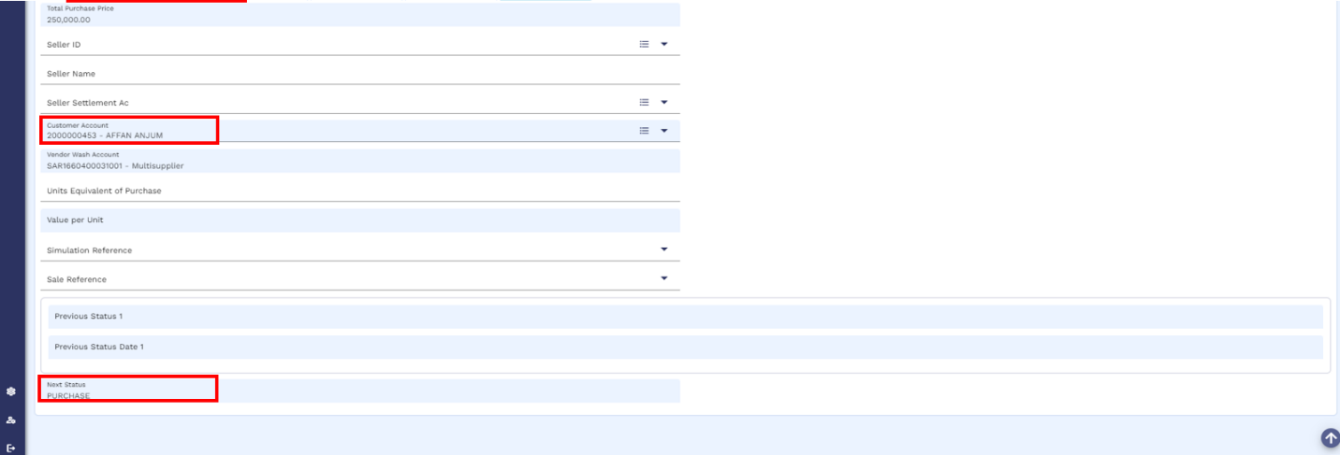
Input New Contract
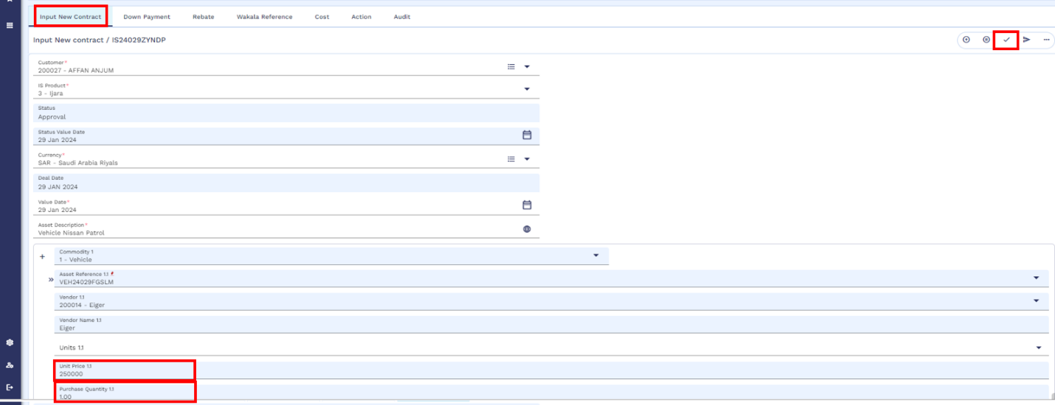

Down Payment
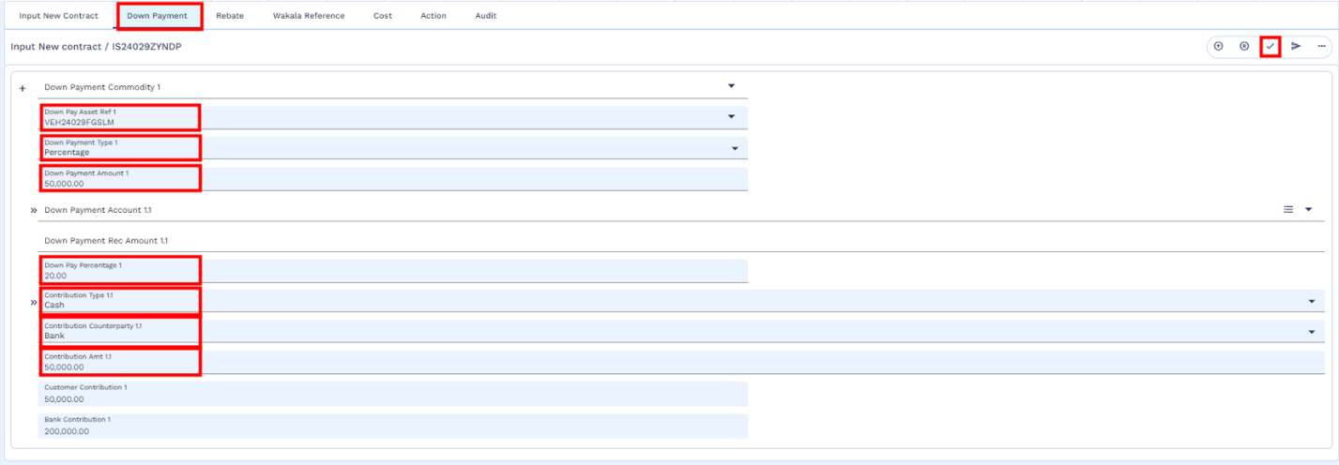

Cost
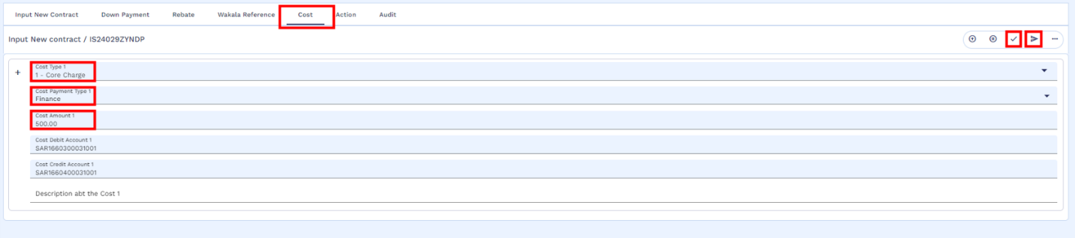
Once the contract is authorized then it will be forwarded to next stage of “Purchase” as defined in IS Parameter.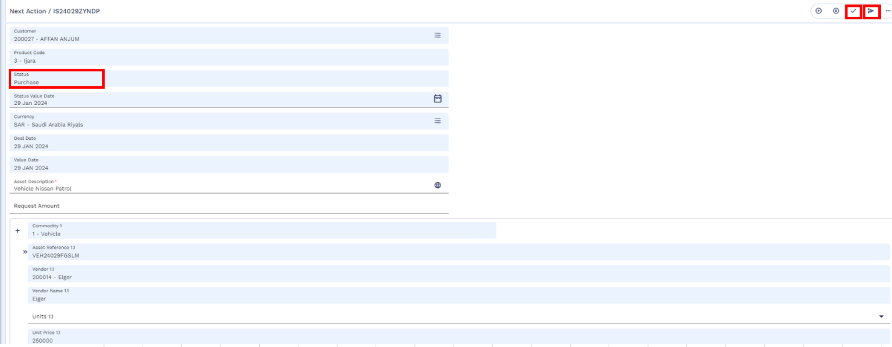

Accounting Entries – IS Contract

Approval Stage
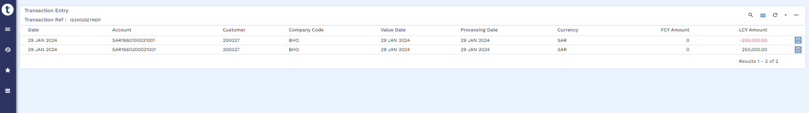

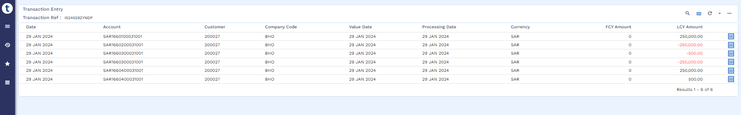
Purchase Stage

End to End IS Contract Entries
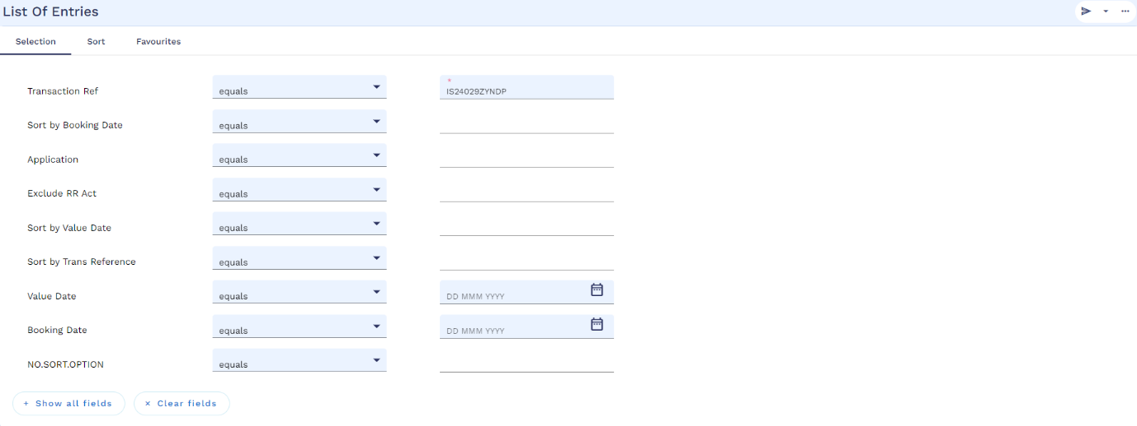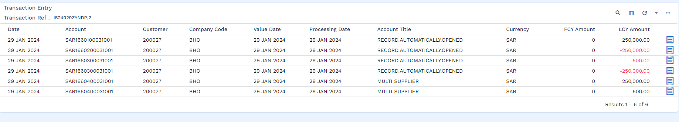

Down Payment Recovery (WS03-IJR-04)
Once the IS Contract purchase stage is completed user needs to input FT to recover down payment amount from customer’s repayment account. Below are the fields that need to be input by the user to execute FT. In case of TA, this process is automated.
Transcript | Data | Description
Asset Reference | VEH24029VMG2L | Valid asset reference record against down payment to be recovered.
Debit Account | 2000000186 | Account from which down payment to be recovered.
Debit Currency | SAR | Currency of transaction
Down Payment Amount | 50,000 | Amount of down payment

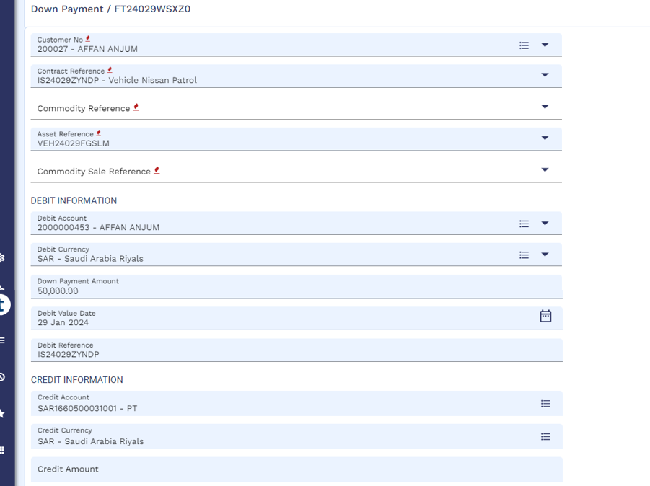
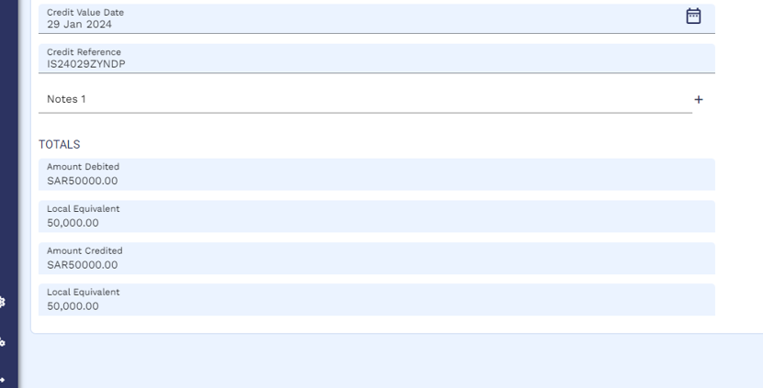

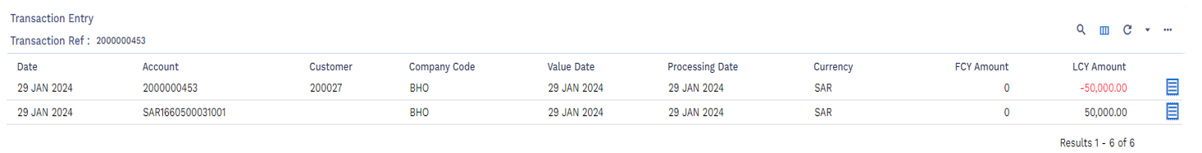
Accounting Entries – Down Payment

Payment to Vendor (WS03-IJR-05)
Steps of setup Vendor in Transact are as follows:
- Open CIF of the Vendor
- Open Account of the Vendor
- Tag CIF and Account in the Vendor Management Setup
Vendor Management
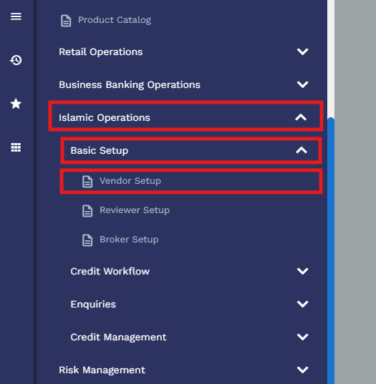
Add CIF of Vendor as stated in point 1 above, in the Vendor Setup From
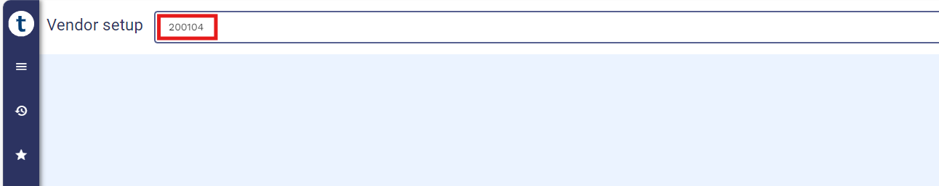

Then add Vendor Related Details, e.g. Name, Company, Currency and then add Vendor account in the account field as stated in point 2 above.
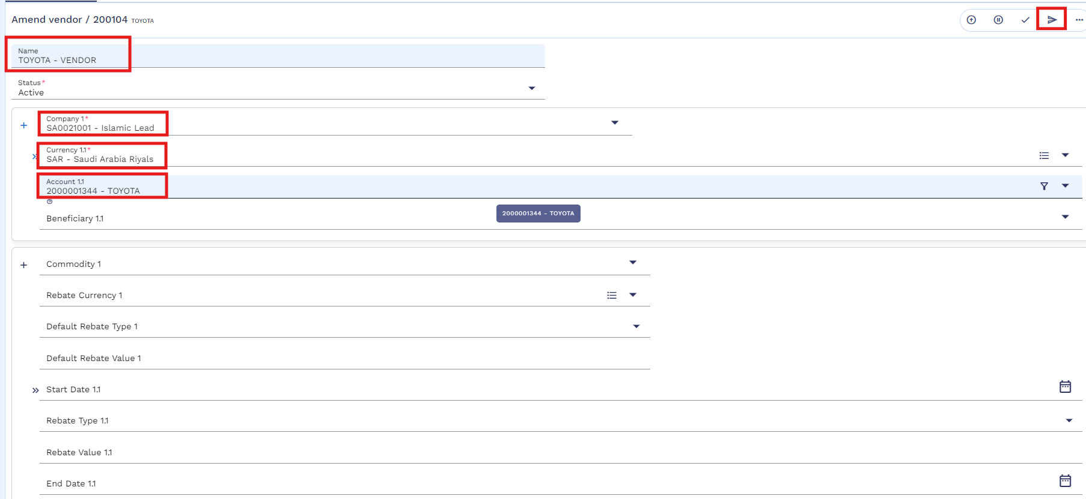
In order to make the payment to asset vendor user needs to execute FT. Below fields that need to be input by user to execute vendor payment FT. In case of TA this process is automated. Once this transaction is executed, a payable to vendor is generated to a pool account from where TA finance team can execute IBFT.
Transcript | Data | Description
Customer No | 200027 | Customer CIF ID
Contract Reference | IS24029ZYNDP | IS Contract # against which asset purchase is made.
Asset Reference | VEH24029VMG2L | Valid asset reference record against IS contract initiated.
Debit Amount | 250,000 | Amount to be paid to asset vendor.
Credit Account | 2000000143 | Vendor account number.
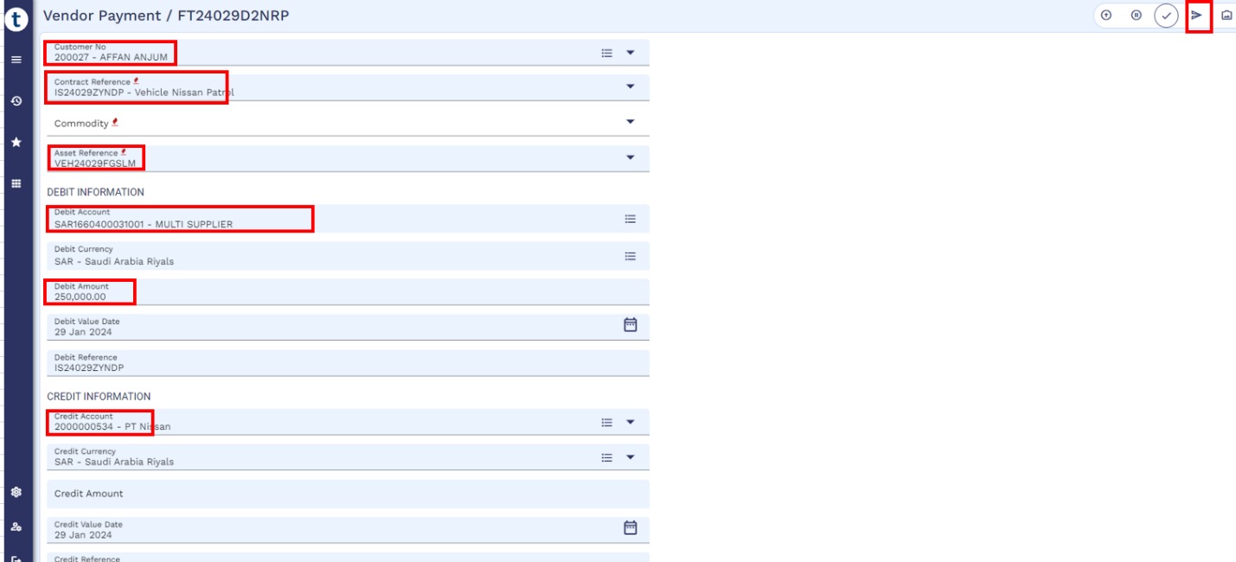

Accounting Entry - Payment to Vendor

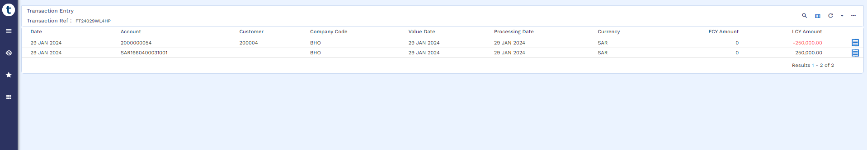

Credit Arrangement

Arrangement Creation (WS03-IJR-06)
Upon the receipt of finance asset, AA Arrangement will be booked in order to deliver the asset to customer. Moreover, repayment schedule will also be generated at this time along with APR
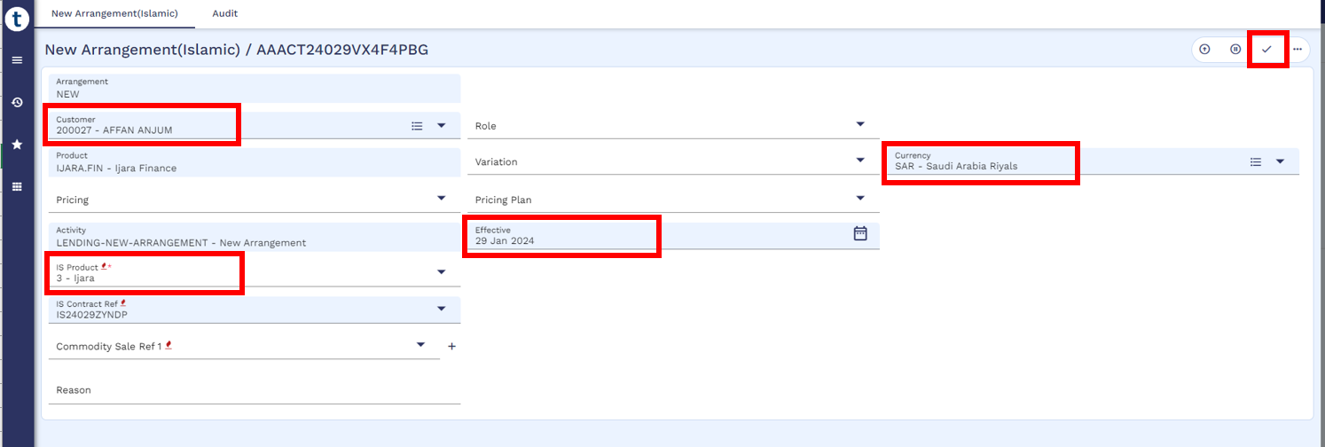
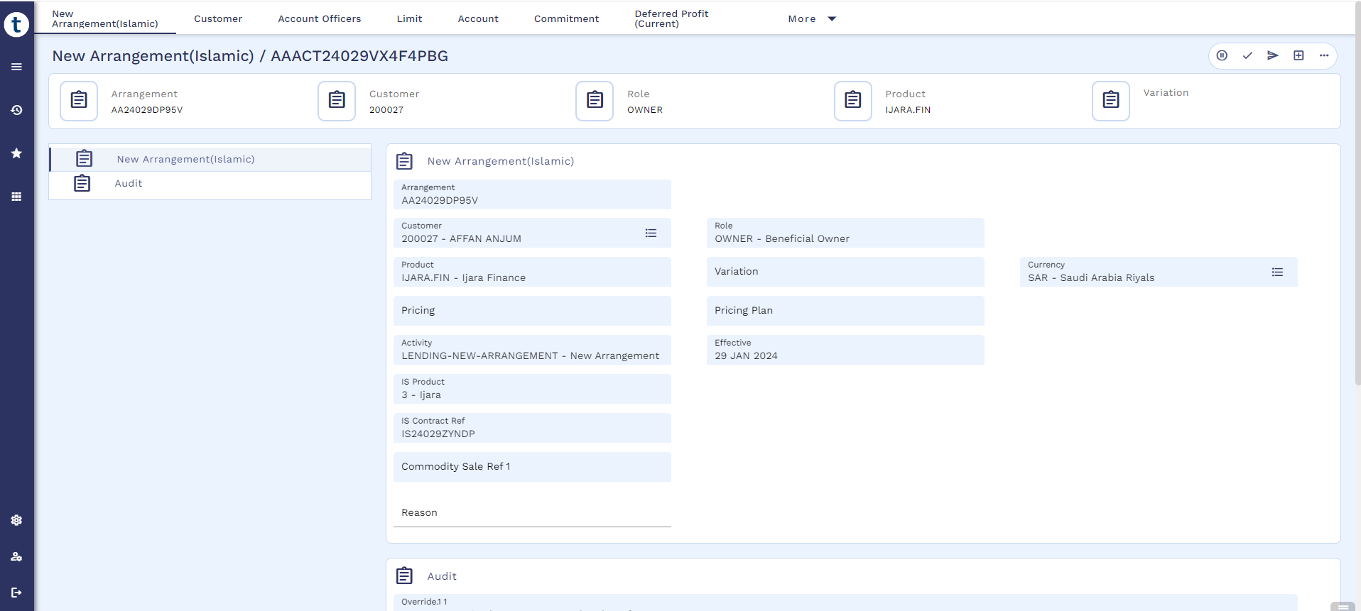
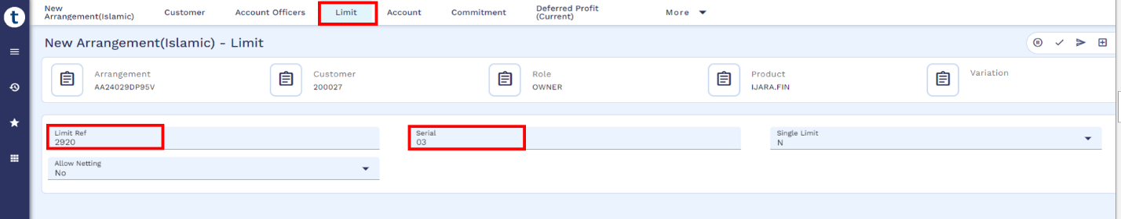
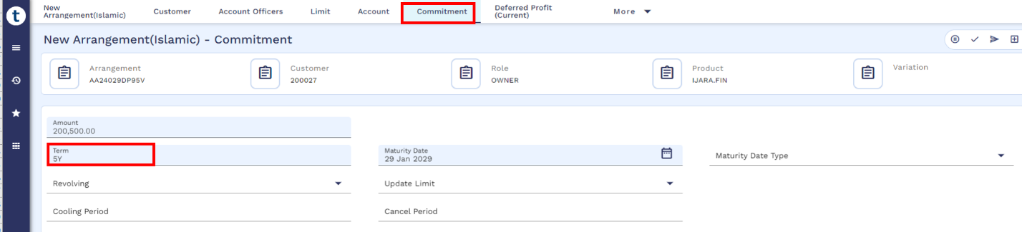
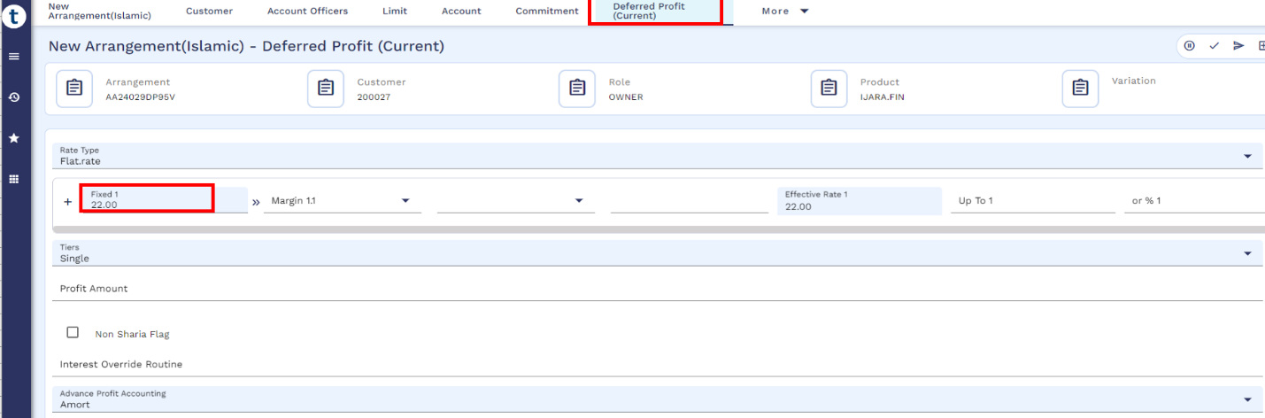
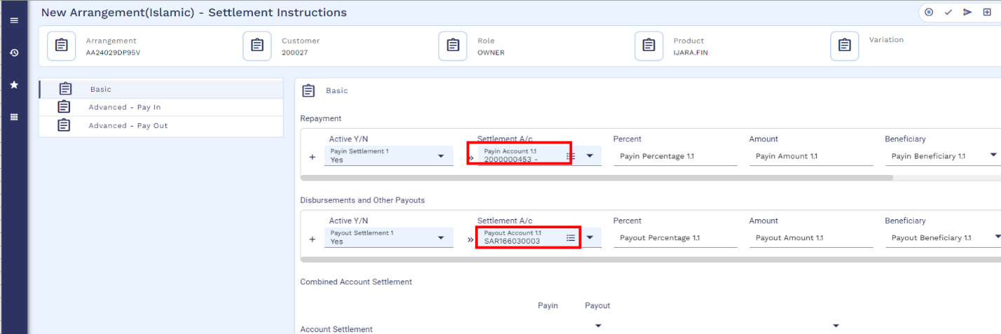
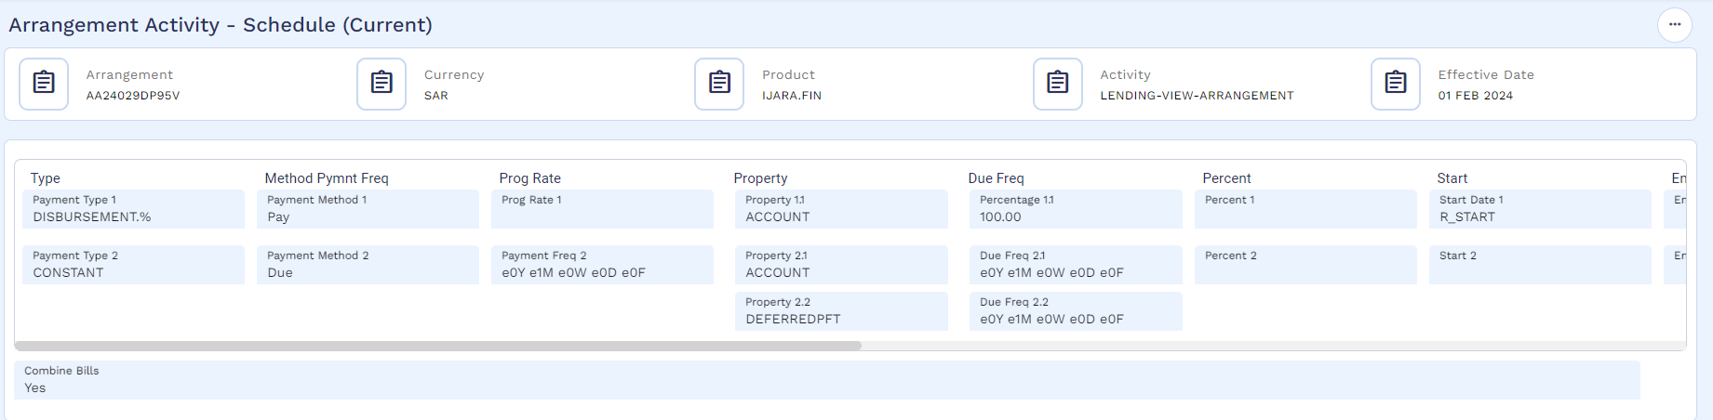

Payment Schedule
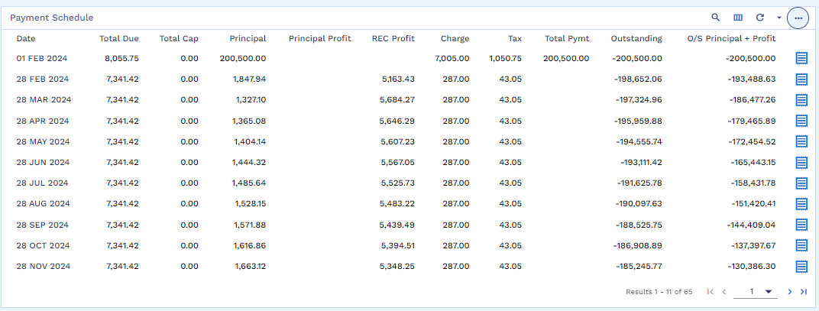

SAMA Payment Schedule (WS03-IJR-07)
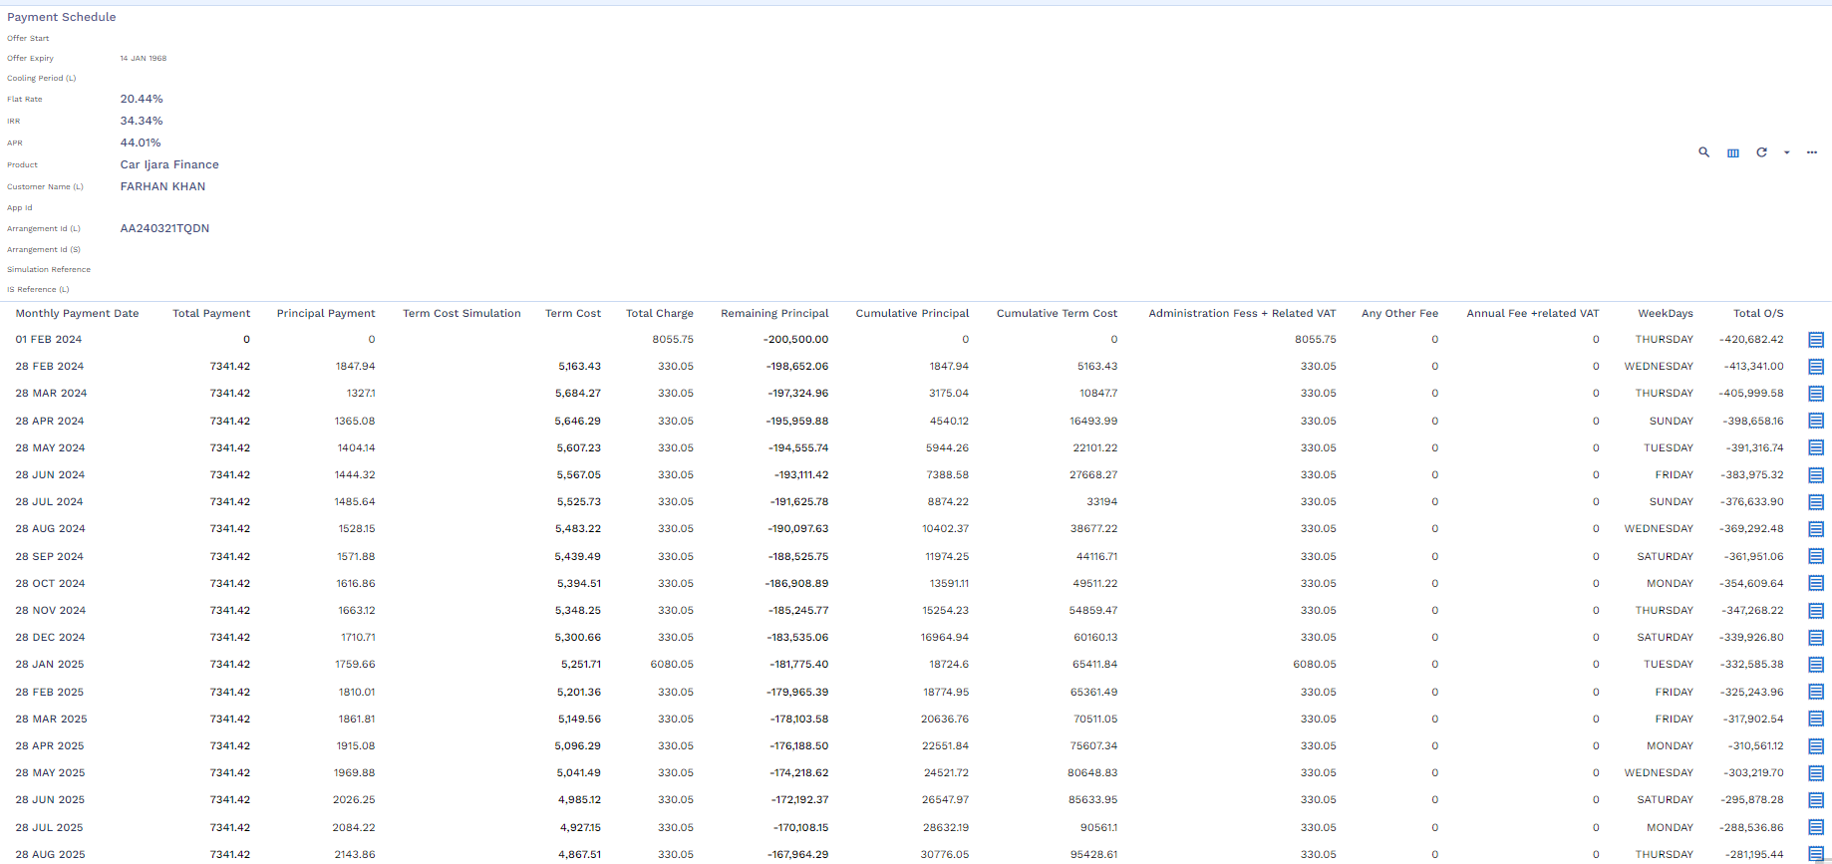

Arrangement Overview
After creation of AA arrangement user can view the arrangement details by navigating through Find Finance Enquiry.
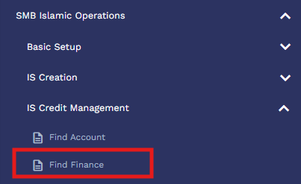
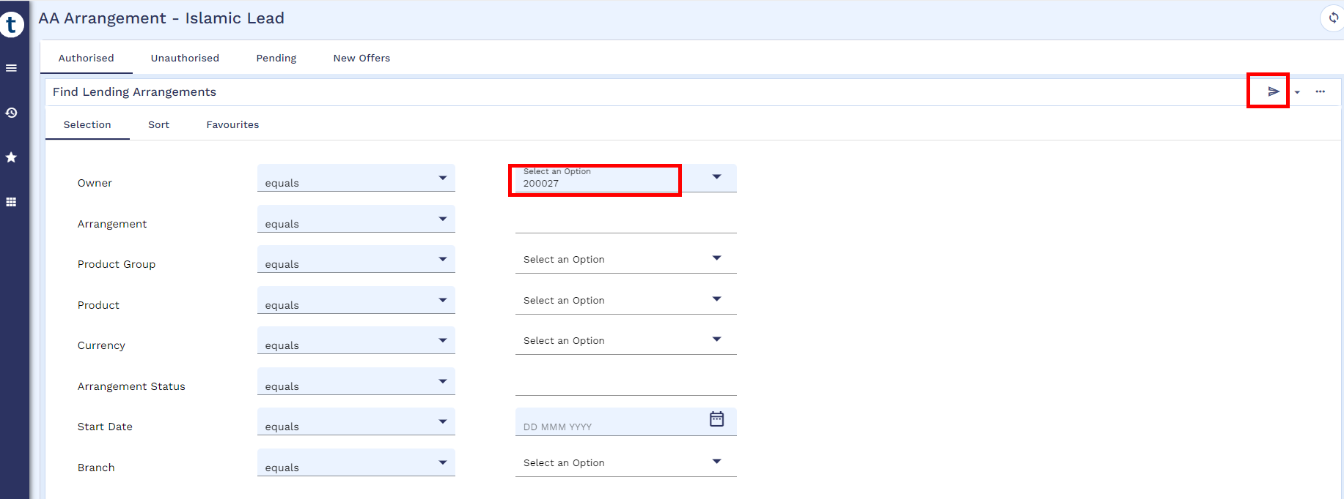
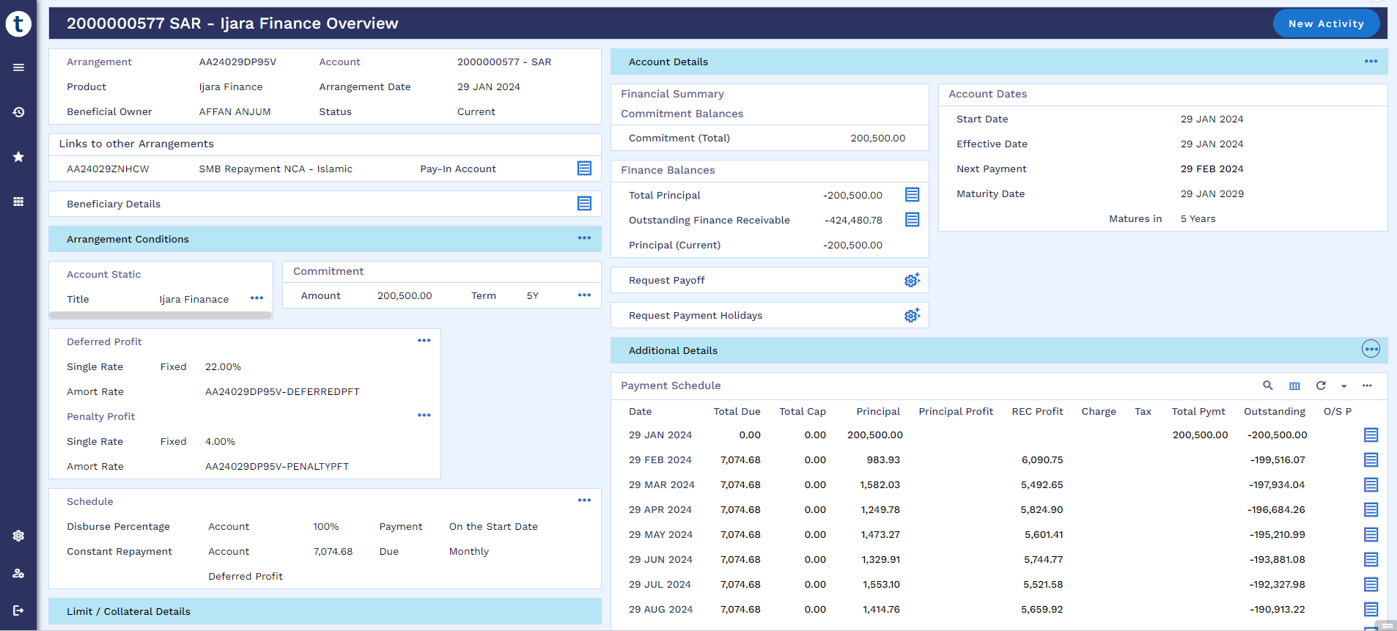

Accounting Entries - AA Arrangement
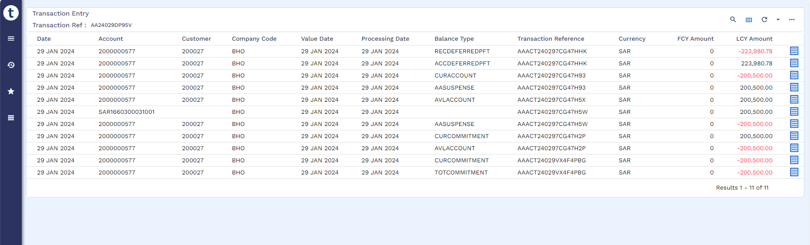

Maintenance Activities
User can perform below Post Disbursement Activities and same activities can be used for servicing app. For servicing app. a separate document needs to be developed for integration purpose, however, calculations and accounting entries will be same in Transact as mentioned in this document as a manual process.

Cancellation within cooling period (WS01-IJR-08)
Cancellation can only be performed after disbursement and when the arrangement is on cooling period. This cooling period starts from the date of loan account creation.
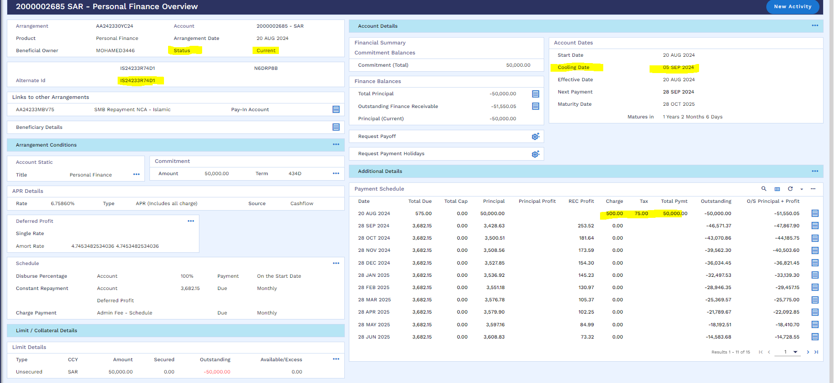
User can perform cancellation as per below navigation.
Menu Islamic Operation Cooling off Period Early Pay Off Cooling Period Payoff Simulation
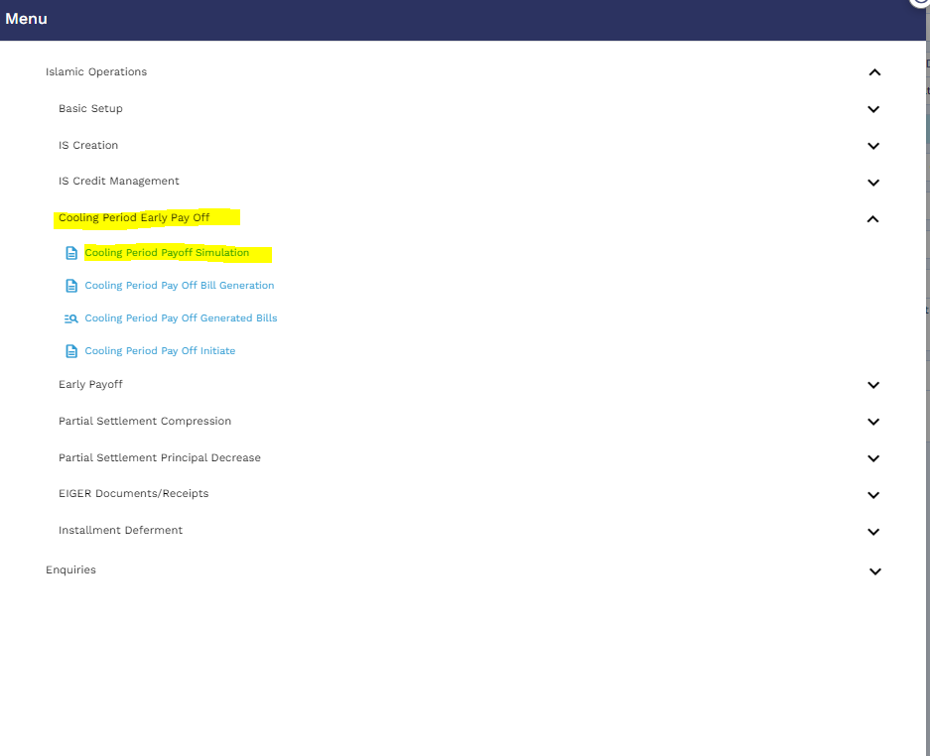

User will click on the new icon
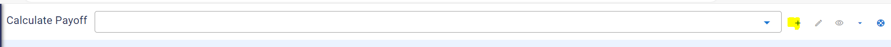

User will put the arrangement reference and click on the validate icon
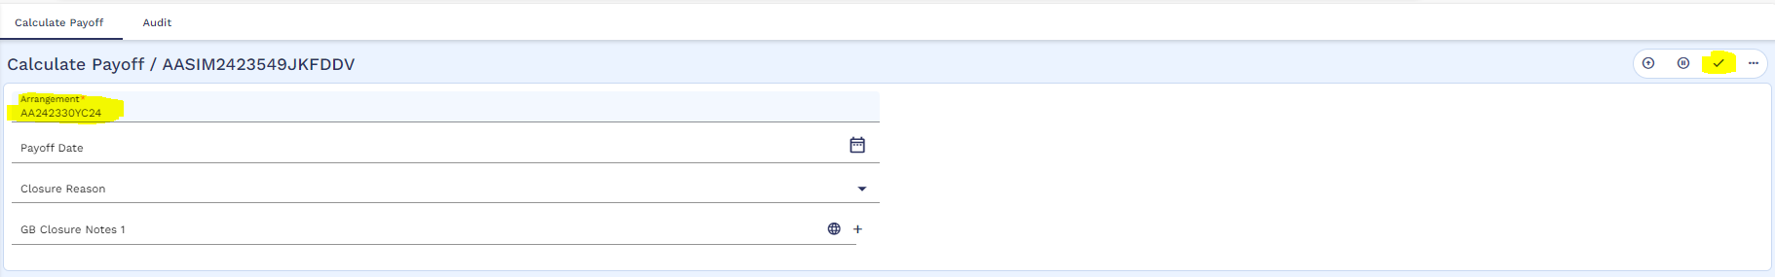
User will validate and commit the below window
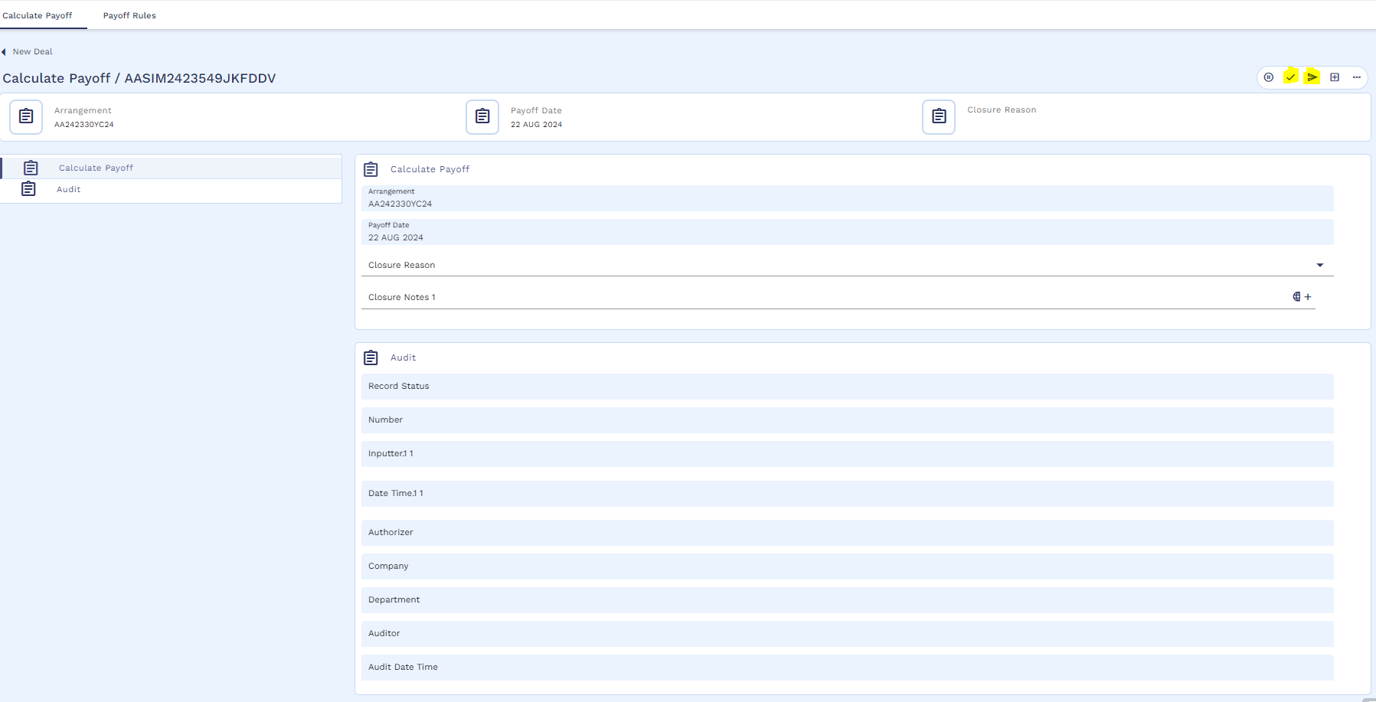
After that Simulation will start processing
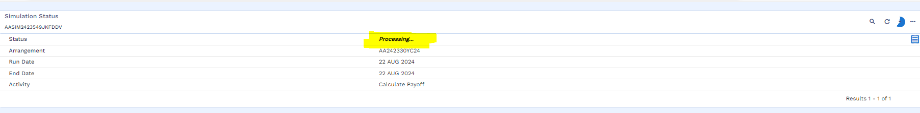
Once the simulation is executed successfully, user will click on the view icon
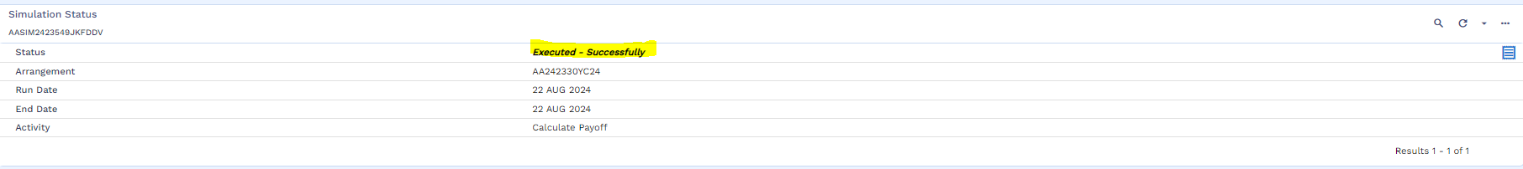

Simulation result is attached below
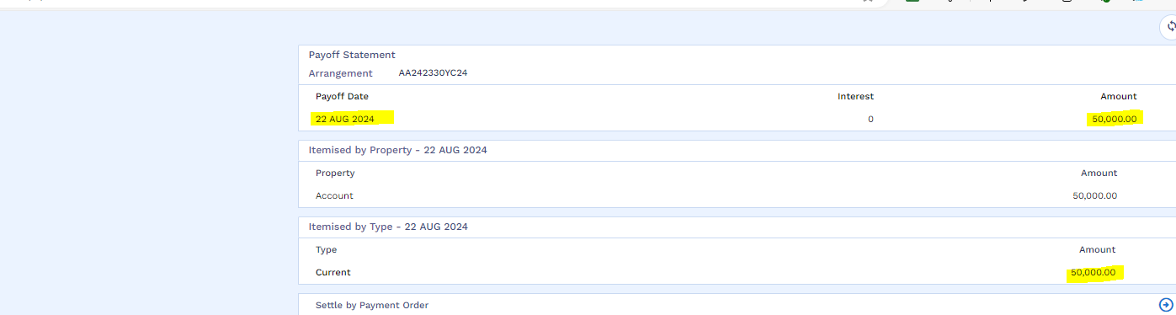
After that user will go for bill generation by following the below navigation
Menu Cooling off Period Early Pay Off Cooling Period Payoff Bill Generation
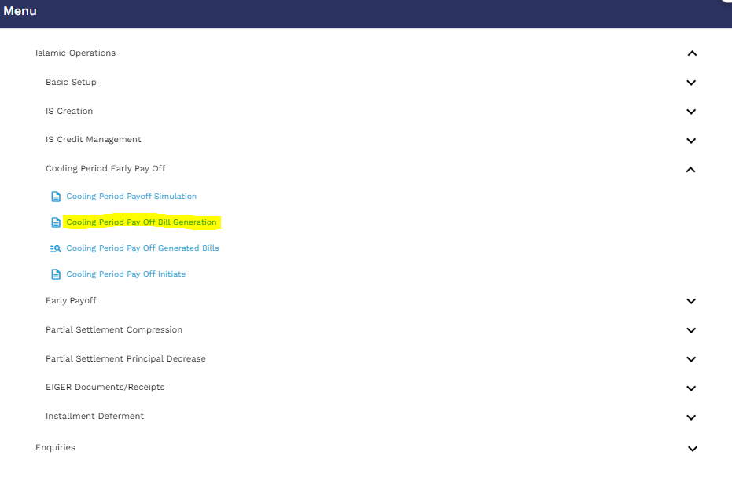
User will click on the new icon
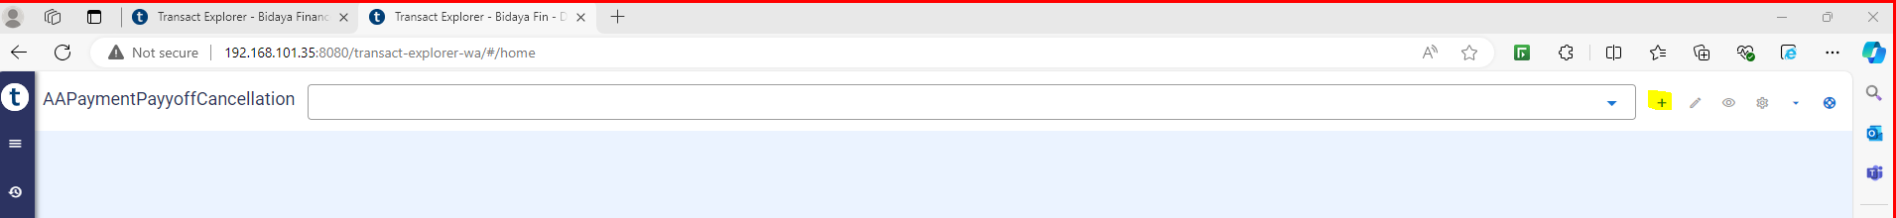
User will put the application ID and mention the source of income then validate and hold the record.
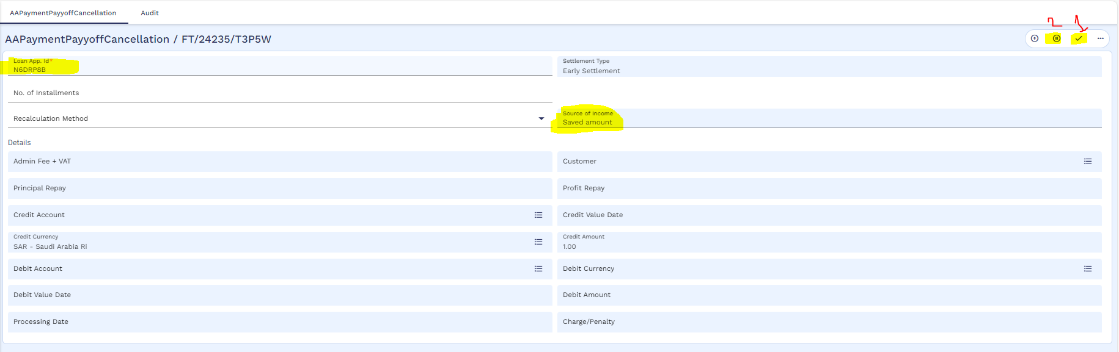
After that bill process is completed
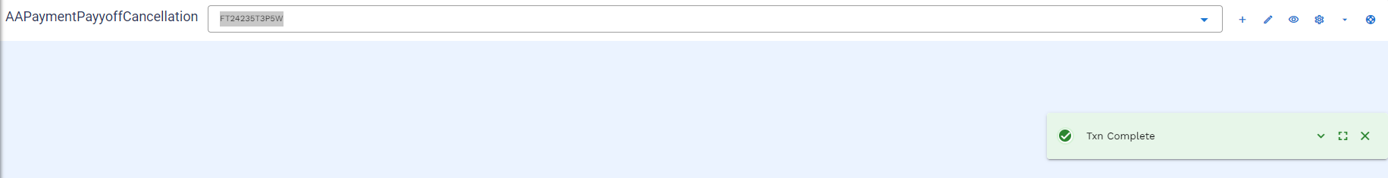

User can view the bill through below navigation
Menu Cooling of Period Early Pay Off Cooling Period Payoff Bill Generated Bills
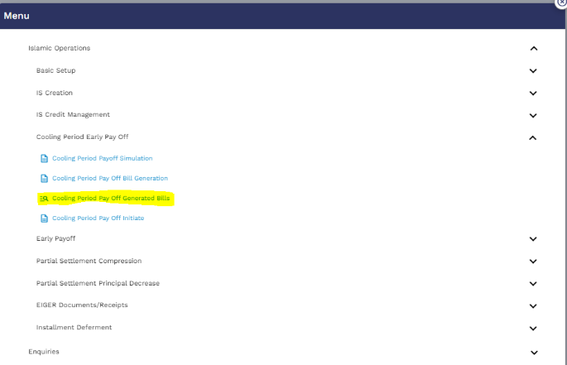
User will put the application ID and then click on the find icon
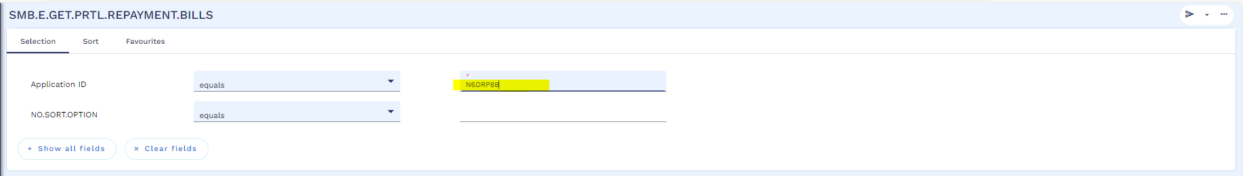
User will click on the view icon
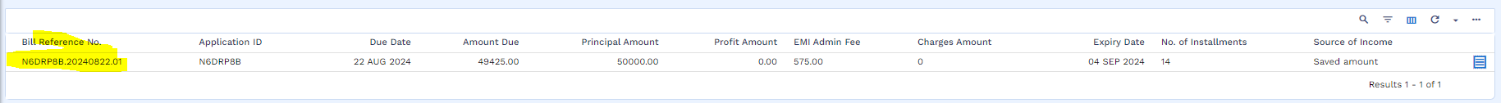
Below is the generated bill (Add narrative for template functionality)
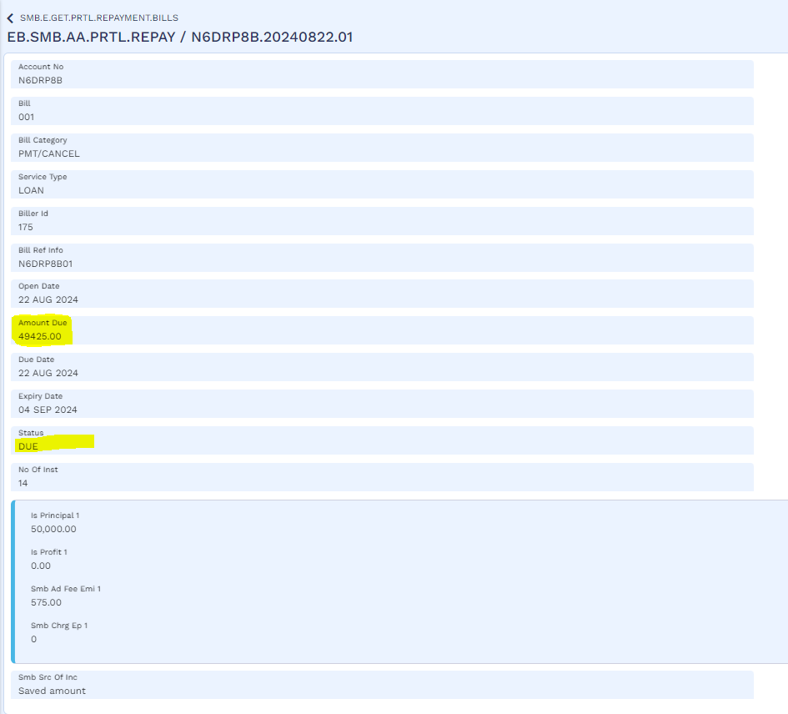
The above template is used to generate bill for any payment gateway, in this case it is SADDAD.

User will make funds available is customer’s repayment account through below navigation
Menu Islamic Operation IS Credit Management Finance Transaction Arrangement Activities AA Fund Transfer
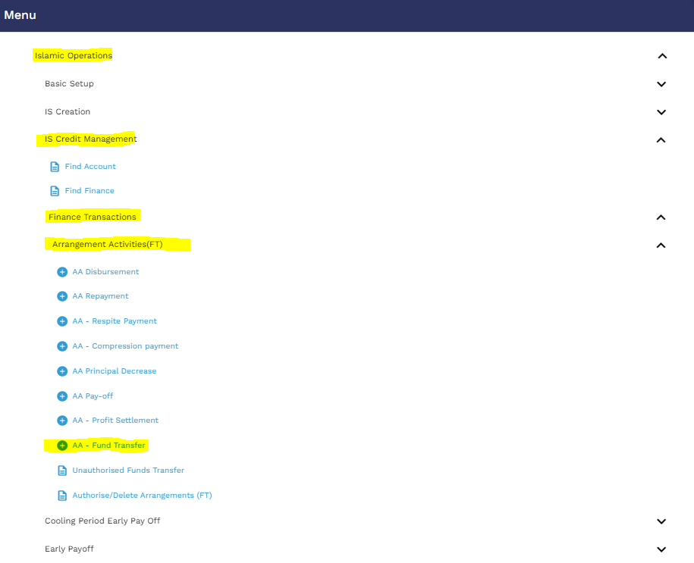
User will mention Credit account as customer repayment account and the debit account of AL Rajhi Bank (2000003363) and the due amount as per bill
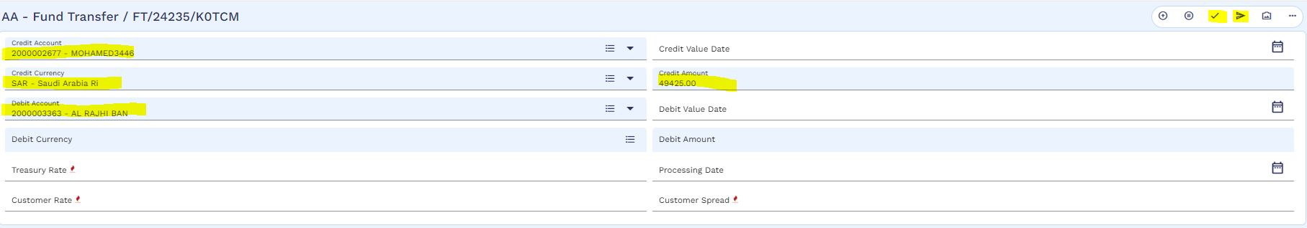
Then validate and commit the record
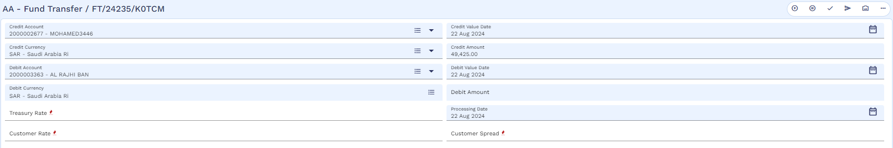
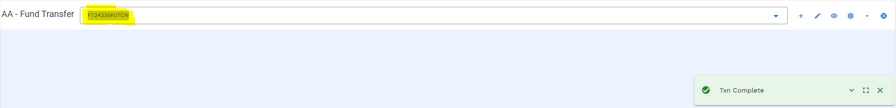

The authorizer will authorize the FT by following the below navigation
Menu Islamic Operation IS Credit Management Finance Transaction Arrangement Activities Authorize / Delete Arrangement (FT)

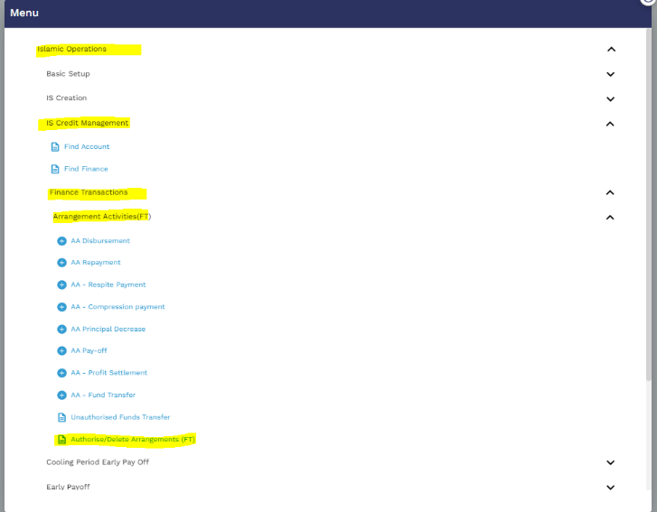
Authorizer will review the FT by using view icon
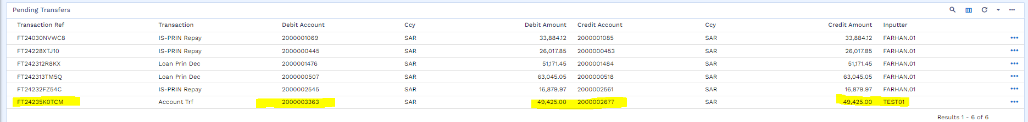
then view and authorize the FT
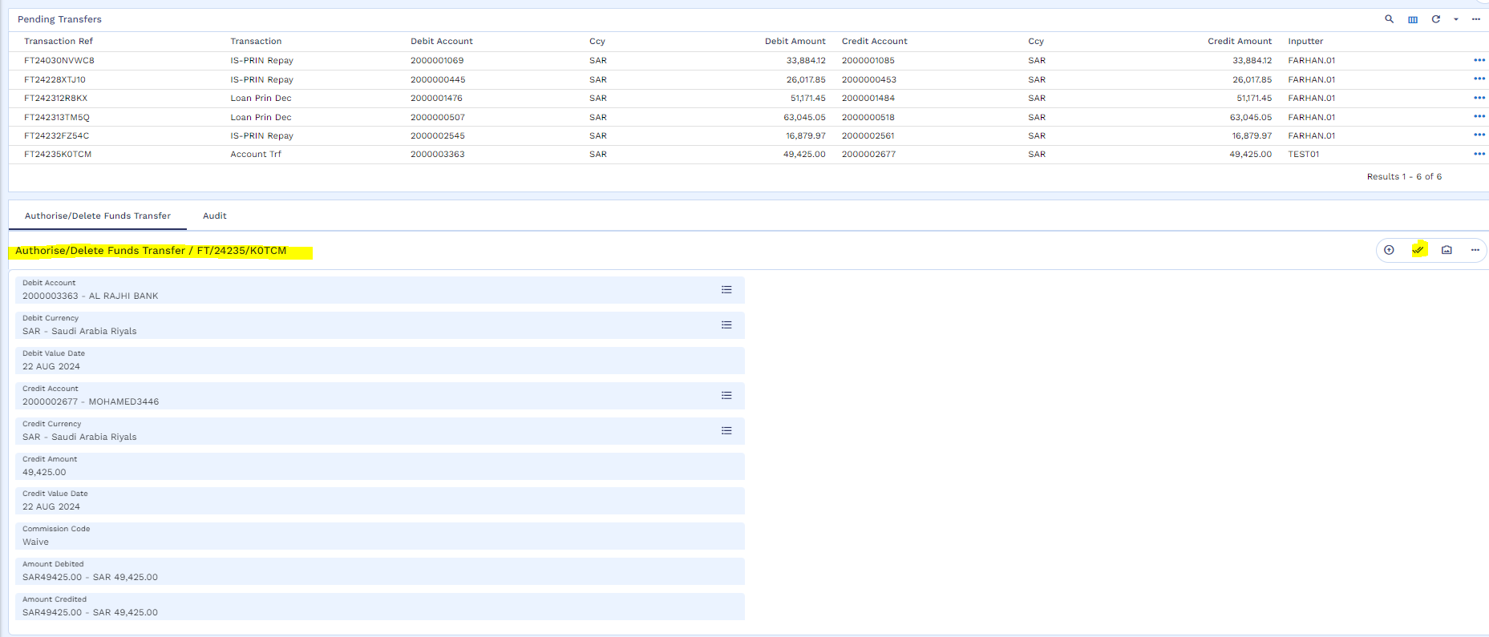

Authorization is completed
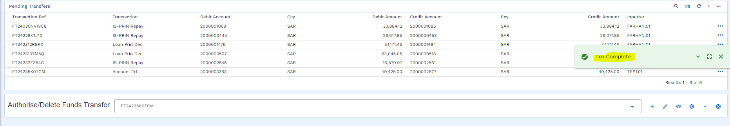
User will initiate cancellation by using following navigation
Menu Islamic Operation Cooling of Period Early Pay Off Cooling Period Payoff Initiate
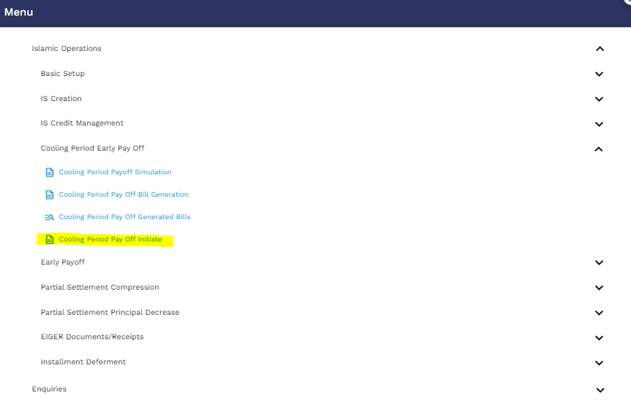
User will put the application ID and icon on the edit icon
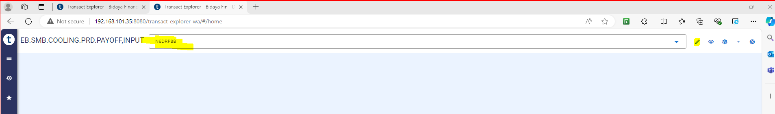
Then user will mentioned bill reference no
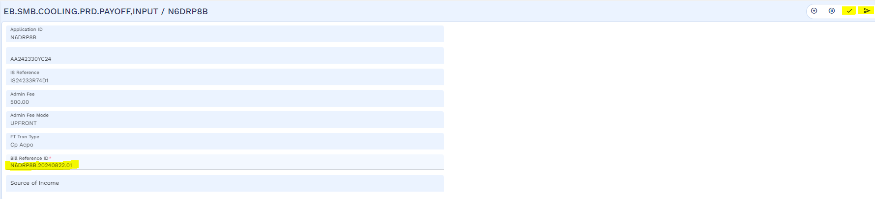
then validate and commit the record
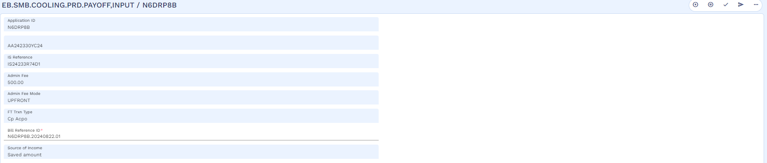

Once the cancellation process is completed, user needs to open the Arrangement to see the status of the arrangement which changed to the “Pending Closure”.
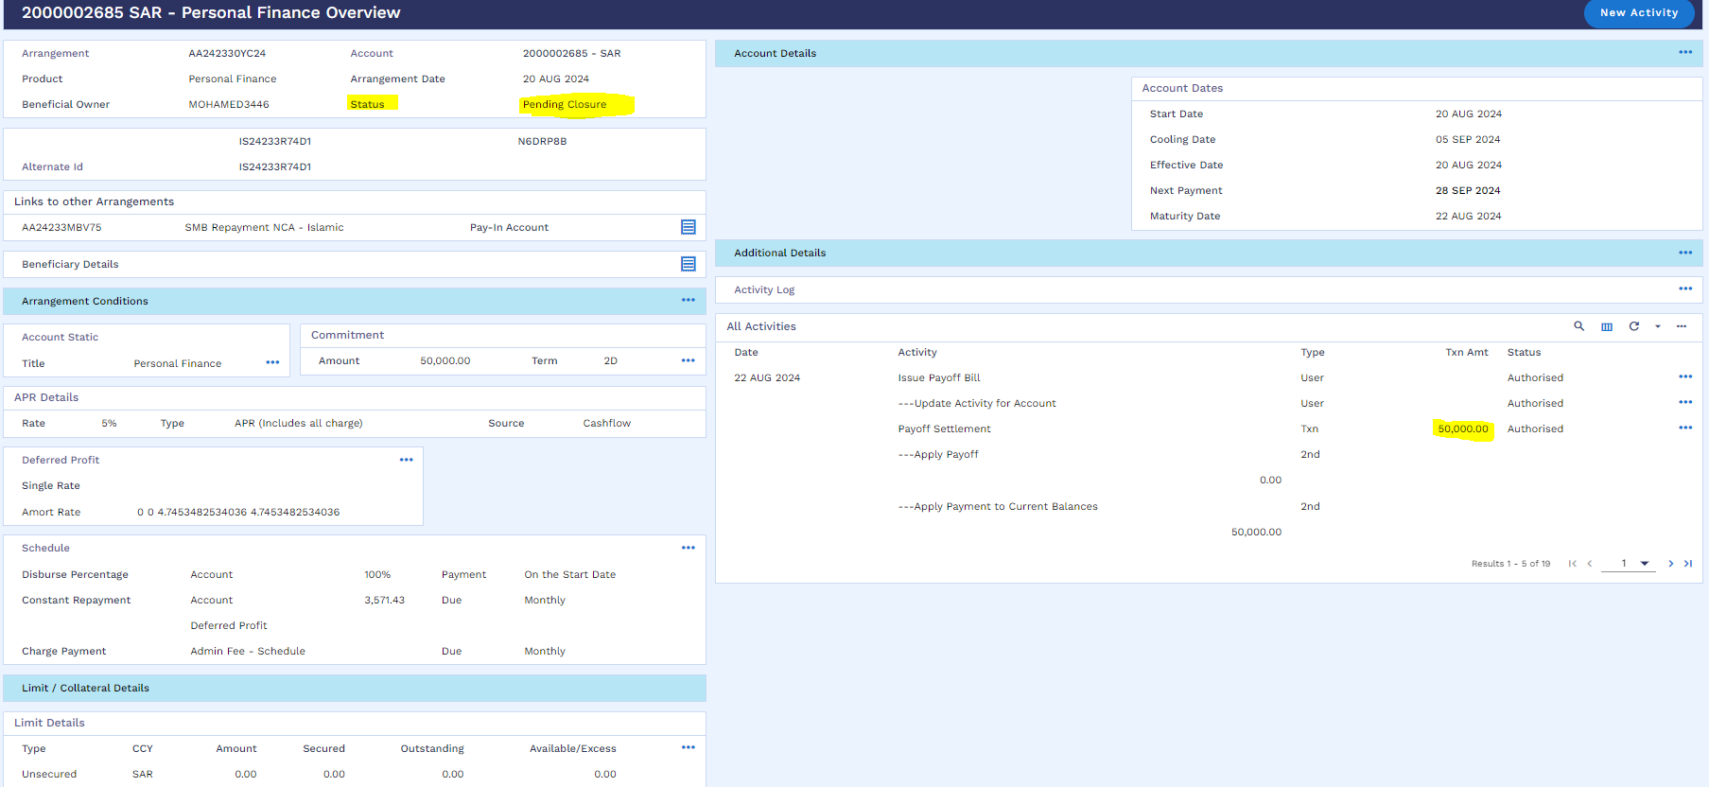

Worksheet details:
- File name : Tawarruq Working Sheet
- Sheet name : Cancellation and SADDAD Accounting Entries-TA
Cancellation & SADAD Accounting entries are same as defined in referred Tawarruq Working Sheet.

Deferment of Instalments (WS01-IJR-09)
For installment deferment/ skip, customer will follow the following navigation:
Menu Islamic Operations Installment Deferment Installment Deferment
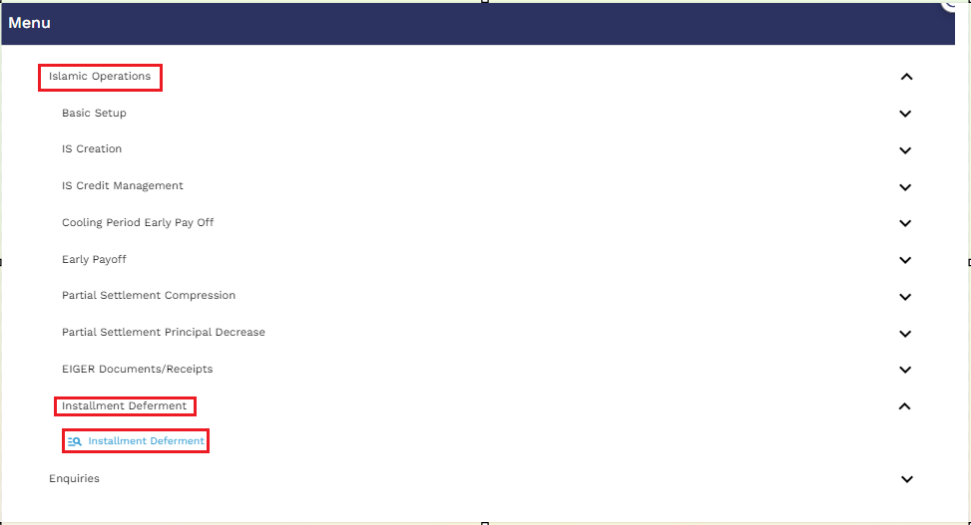

User will put the application ID and click on the find icon
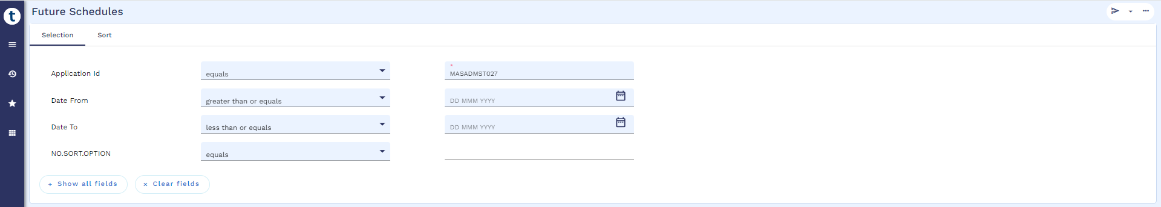
For illustration the upcoming installment on 28 Feb 2024 is going to defer which means there is an increase in tenor by 1 month of the arrangement.
The user will click on the icon located on the right side, which pertains to installments, and then proceed to click on "Simulate."
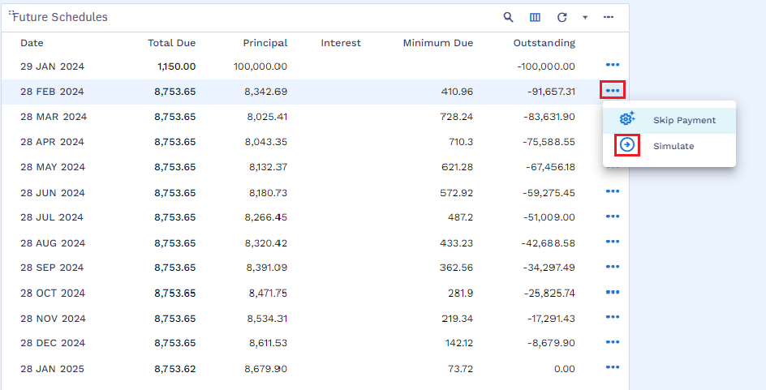
Next, validate the activity by using the icon specified in the screenshot below.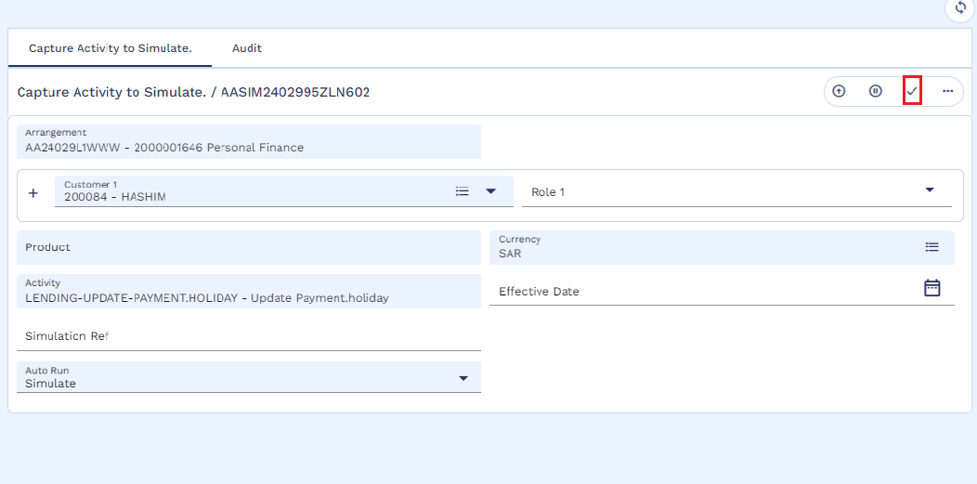

The user will select the "Payment Holiday" tab as indicated in the screenshot below.
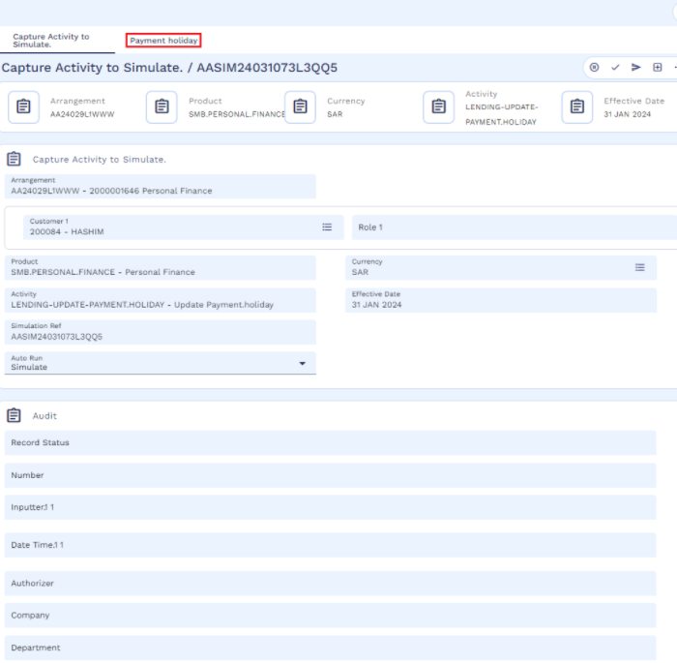
The user will input "1" in the installment field and select "Residual" for recalculation, where system will skip the instalment and add the same in last instalment.
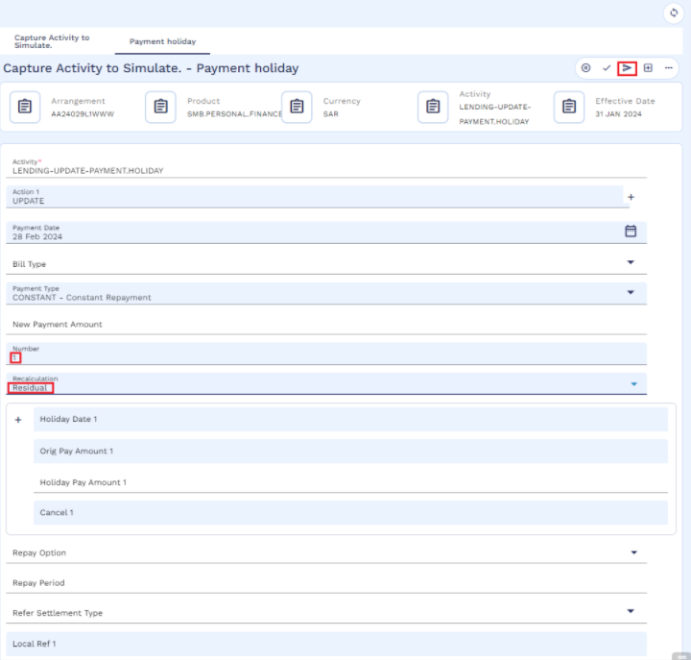

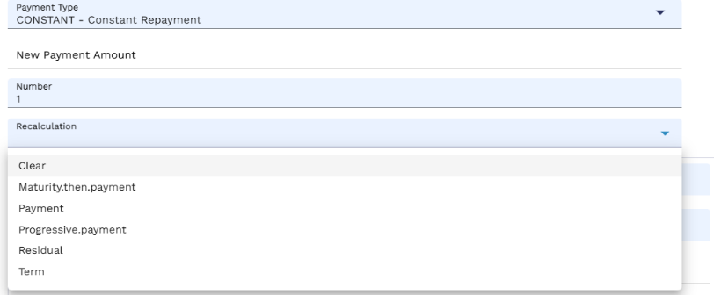

Below are some other options that can be used for payment holidays with below functionalities.
- Payment – the payment amount will be changed.
- Term – the term of the arrangement will be altered.
- Residual – the residual amount will be changed.
Following that, the simulation process will commence.
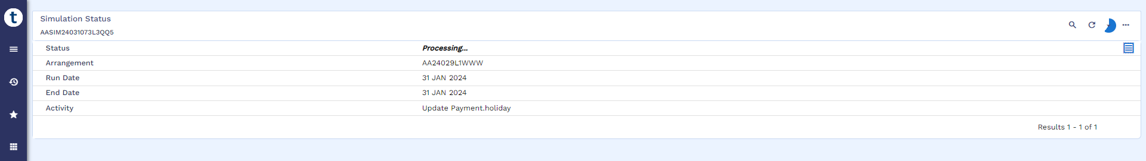
Once the simulation is completed, the user will click on the overview icon as indicated in the screenshot below.
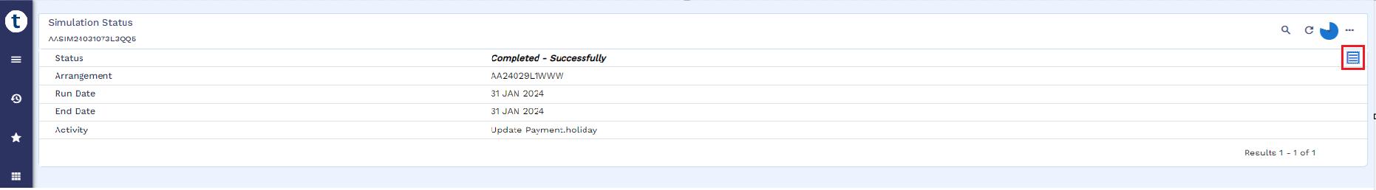

In the overview, the user can verify that the deferred installment dated February 28, 2024, displays a zero amount, as shown in the screenshot below.
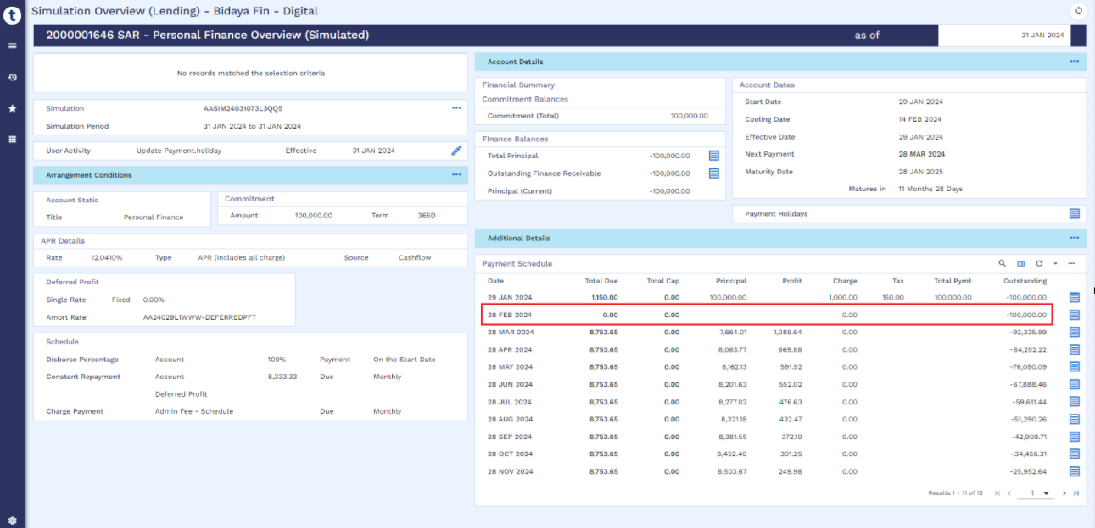
User can also check the last installment amount has increased as it includes the deferred installment amount. User can execute the simulation as mentioned in the below screen short
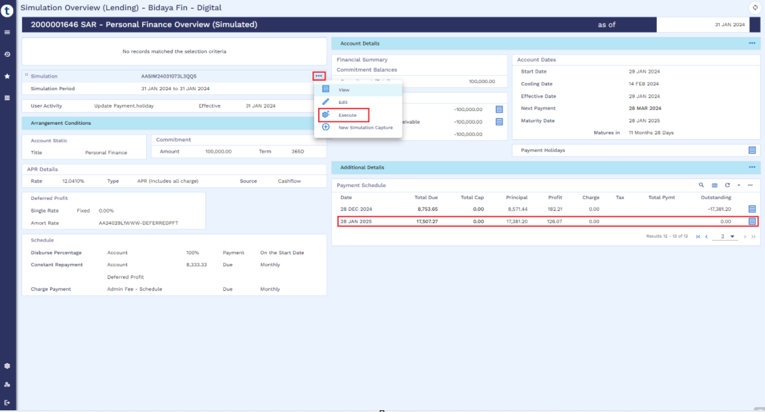

The user will finalize the simulation by committing the Simulation Runner.
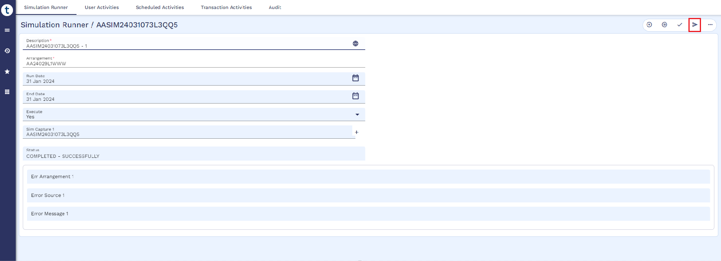
The simulation will begin processing.
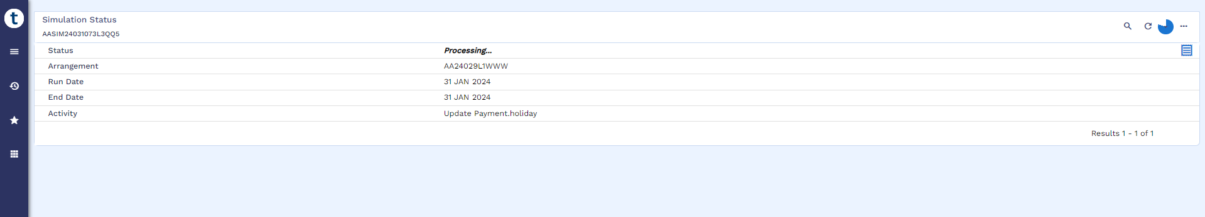

After a few minutes, the execution will be completed, as depicted in the screenshot below.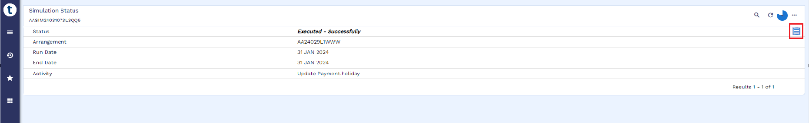

Worksheet details:
- File name : Tawarruq Working Sheet
- Sheet name : Deferment-TA
- Deferment schedule is same as defined in referred Tawarruq Working Sheet.

Early Pay off (WS01-IJR-010)
Post cooling period, if customer comes to any FI for early settlement, then Transact provides an option to exercise Payoff functionality. This can be executed from 360 overview of arrangement as mentioned below. A payoff statement is generated that contains all the financial information like, income receivable, principal receivable, any overdue item and fee etc. All such information is part of product setup sheet which is used as client/regulatory specific product requirements.
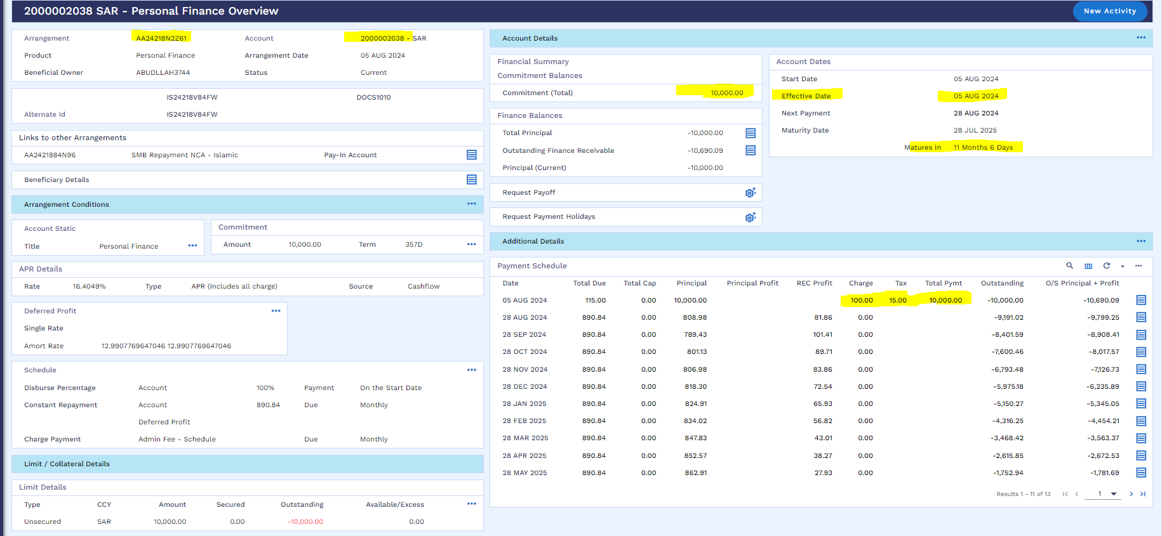
User can perform cancellation as per below navigation.
Menu Islamic Operation Early Pay Off Early Payoff Simulation
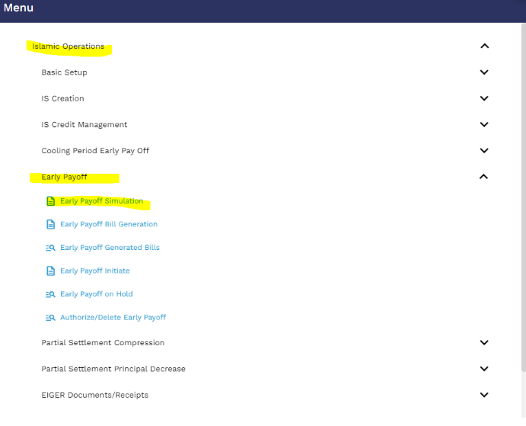
User will click on the new icon
User will put the arrangement reference and click on the validate icon
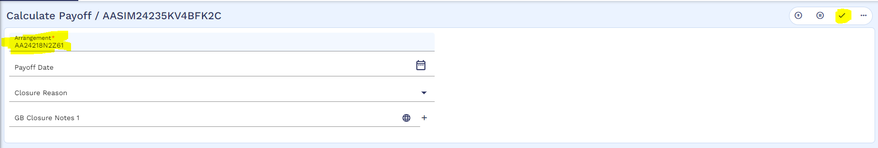

User will validate and commit the below window
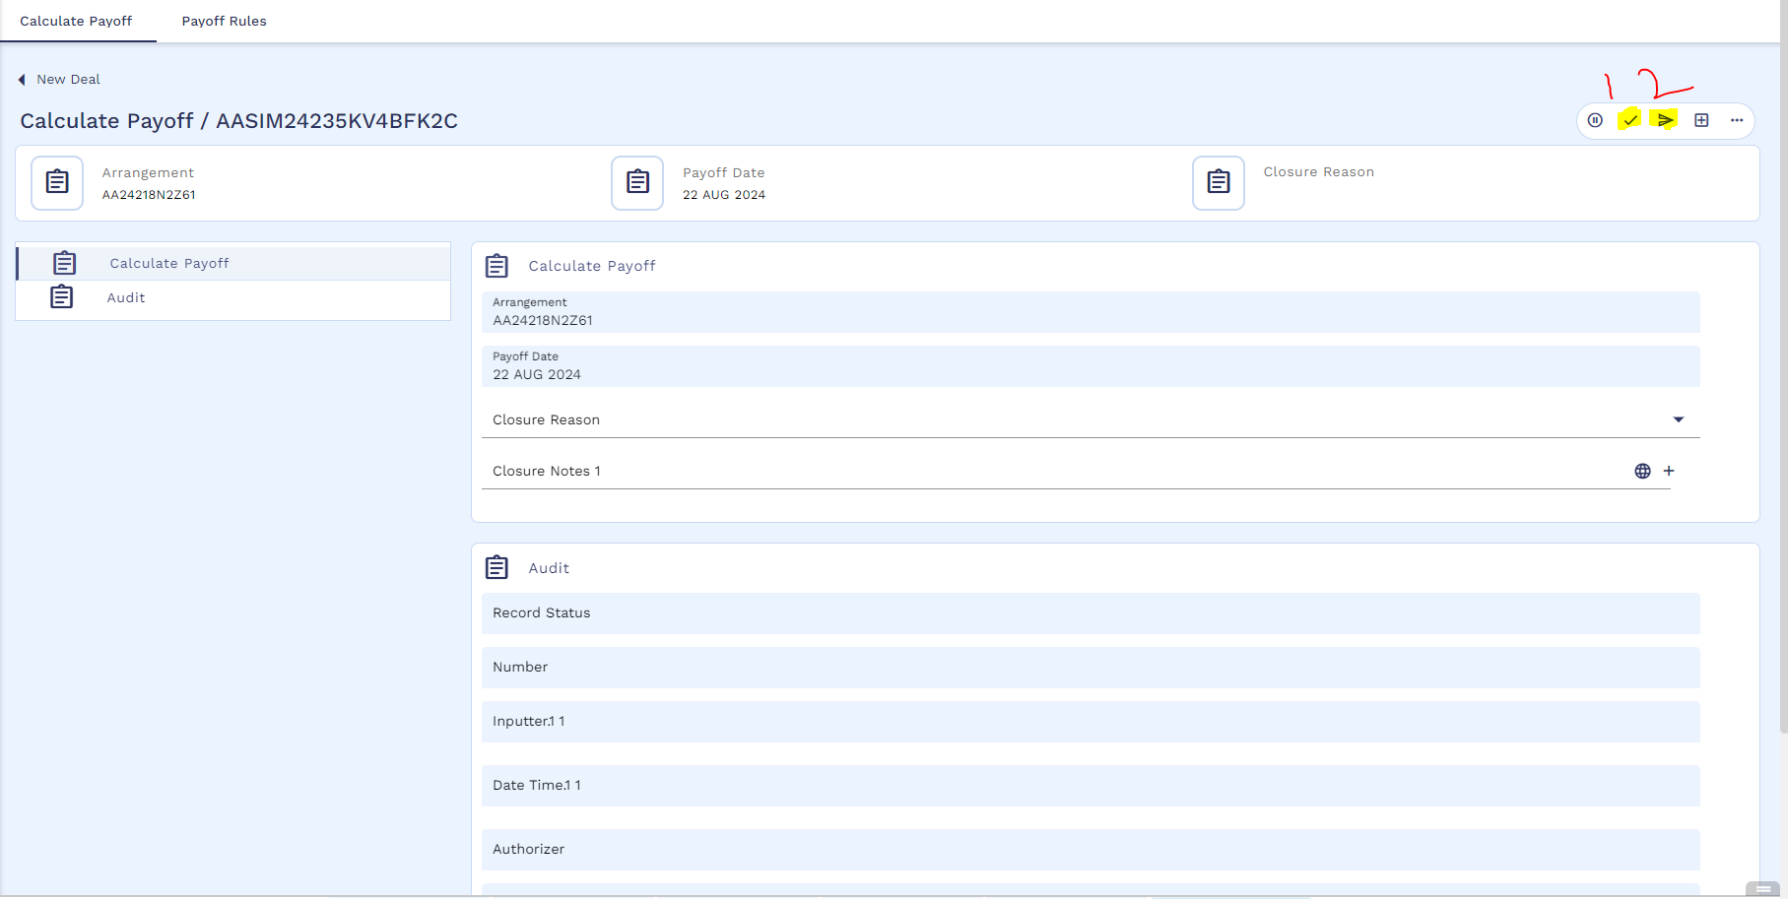
After that Simulation will start processing
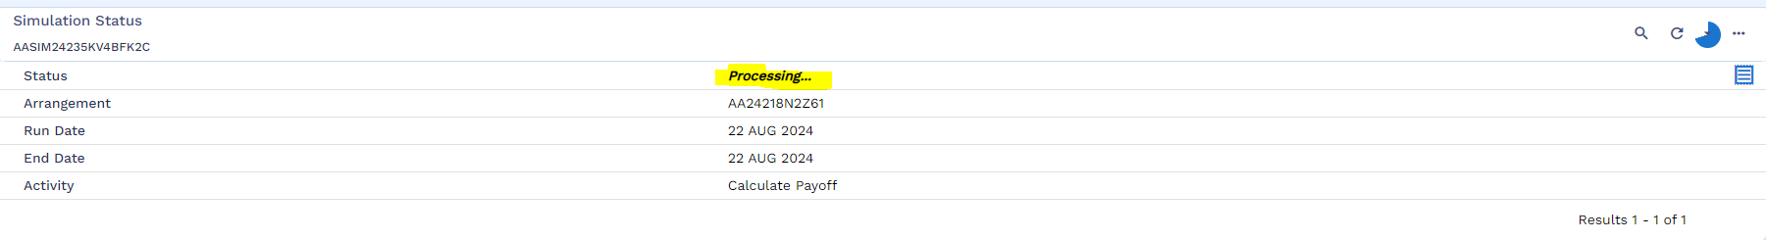
Once the simulation is successful, user will click on the view icon
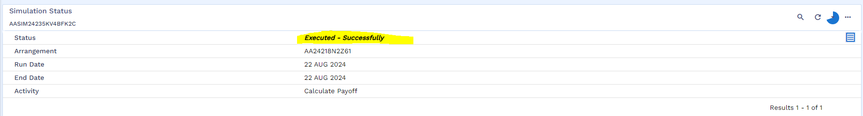
Simulation result is attached below
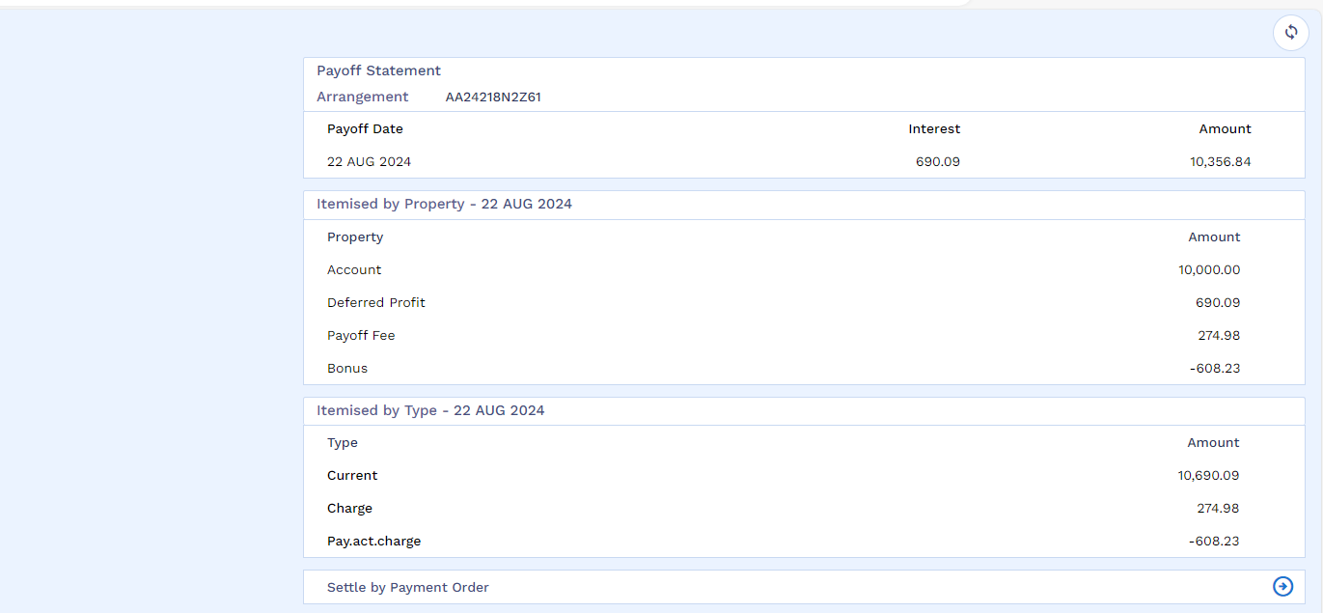

After that user will go for bill generation by following the below navigation
Menu Islamic Operation Early Pay Off Early Payoff Bill Generation
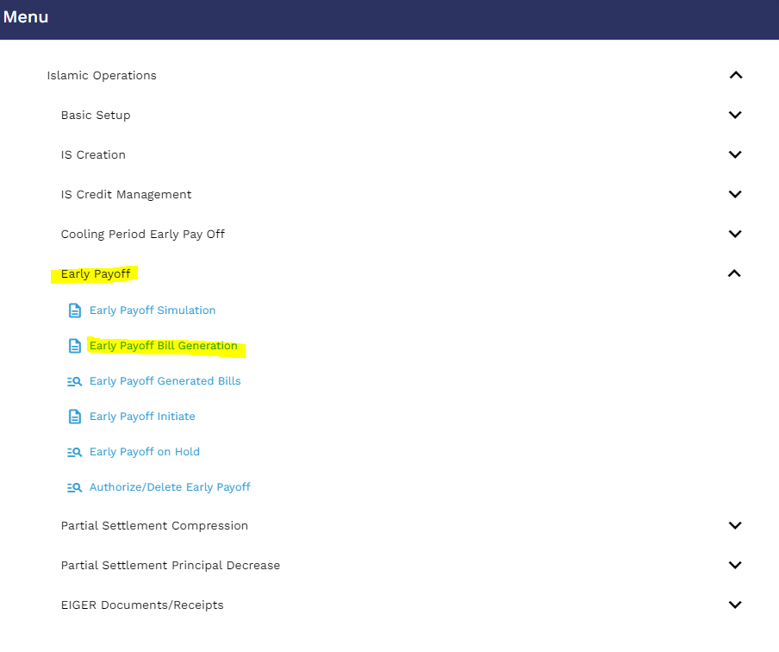
User will click on the new icon
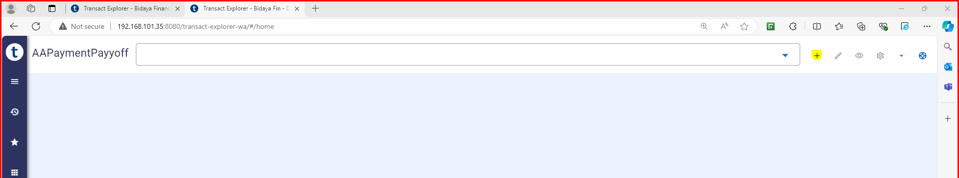
User will put the application ID and mention the source of income then validate and hold the record.
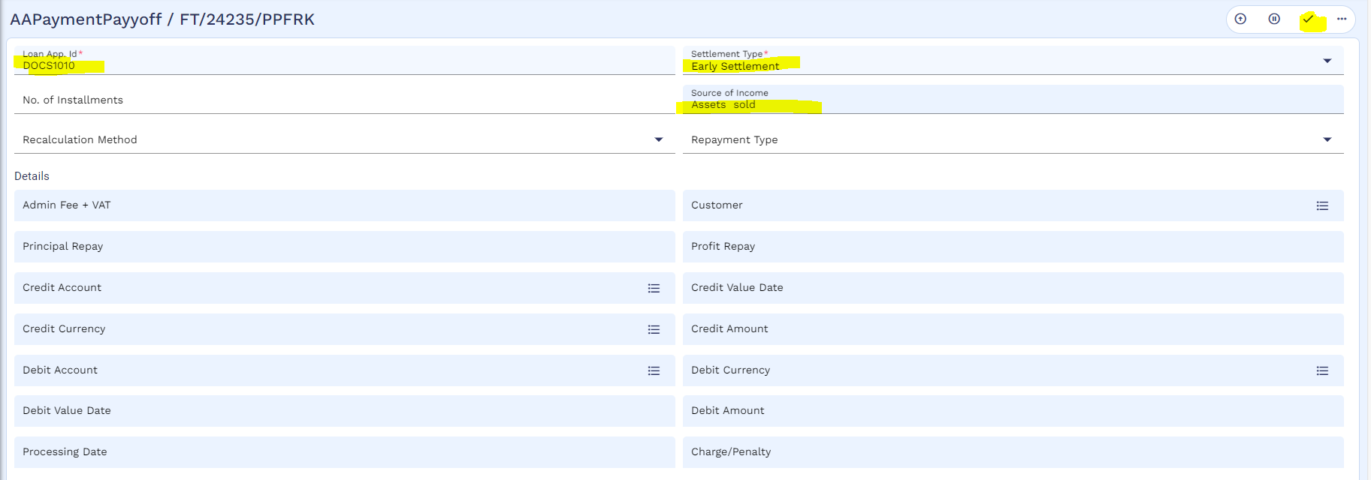
After that bill process is completed
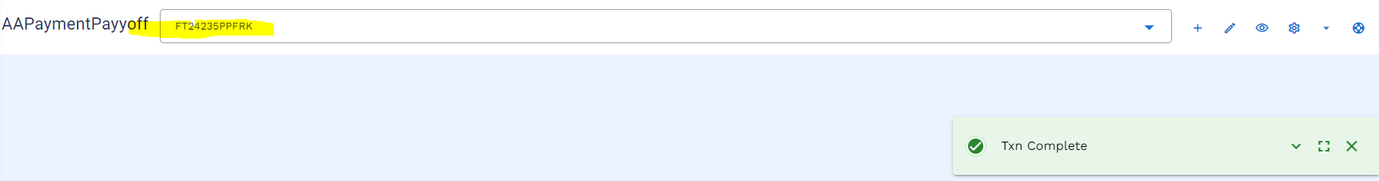

User can view the bill through below navigation
Menu Islamic Operation Early Pay Off Early Payoff Bill Generated bills
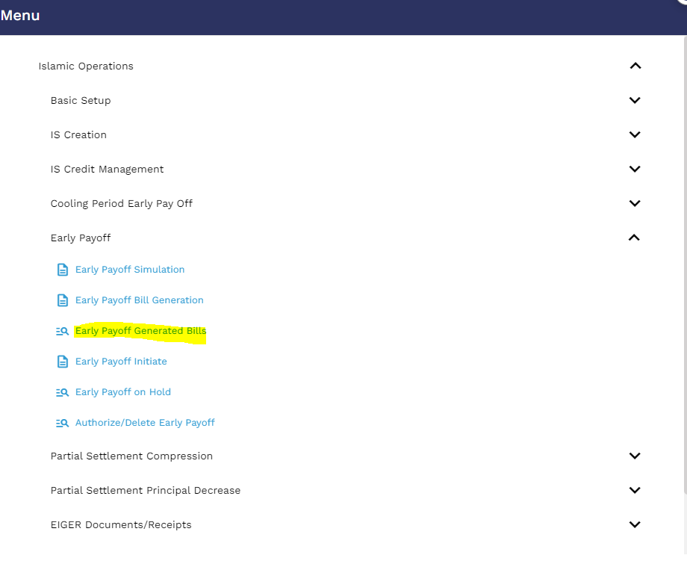
User will put the application ID and then click on the find icon
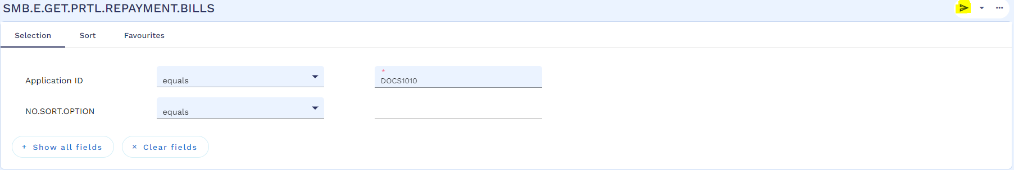
User will click on the view icon
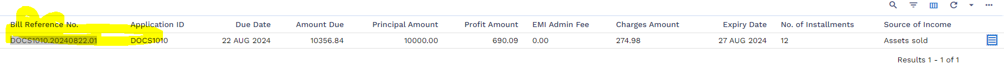
Below is the generated bill . this bill can be used for SADDAD bill to inform customer.
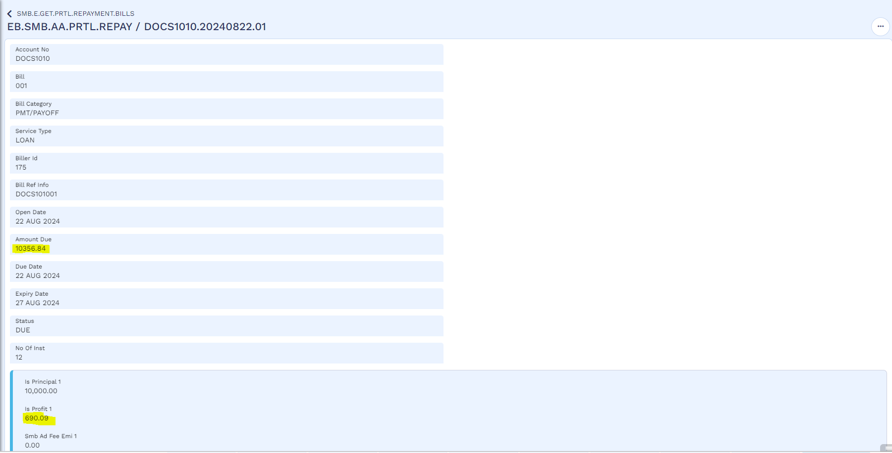

SADDAD bill generation and upload rules.
This rule has been developed in order to manage both monthly instalment invoice and early settlement invoice that can be requested at any time.
If the payoff invoice is issued between 29th of the current month till 27th SOD of the following month (considering 28th is cycle date of product) then expiry of the same invoice will be 27th EOD of the following month this is because monthly invoice can be generated on 27th EOD. The early settlement charge will be 3 months starting from next month.
If the invoice is generated on 28th there is no extra accrual and only 3 months early settlement charge starting from the next month will be collected expiry of this invoice will be 28th EOD.
Once customer will pay the Sadad bill then d funds are transferred to customer’s repayment account which is maintained by Transact, then an automated process will be run to settle customer’s loan account and balances. Below is the manual process of the same. There is another process of bulk file upload of FT, for which a format has been designed. Please see sheet name as “DayN-File Upload” in excel file. This is an automated process however user can also manually make FT if required.
Once the required amount is credited to the customer’s account a service will be executed to settle the loan account. Below is manual process as well.
User will initiate cancellation by using following navigation
Menu Islamic Operation Early Pay Off Early Payoff Bill Initiate
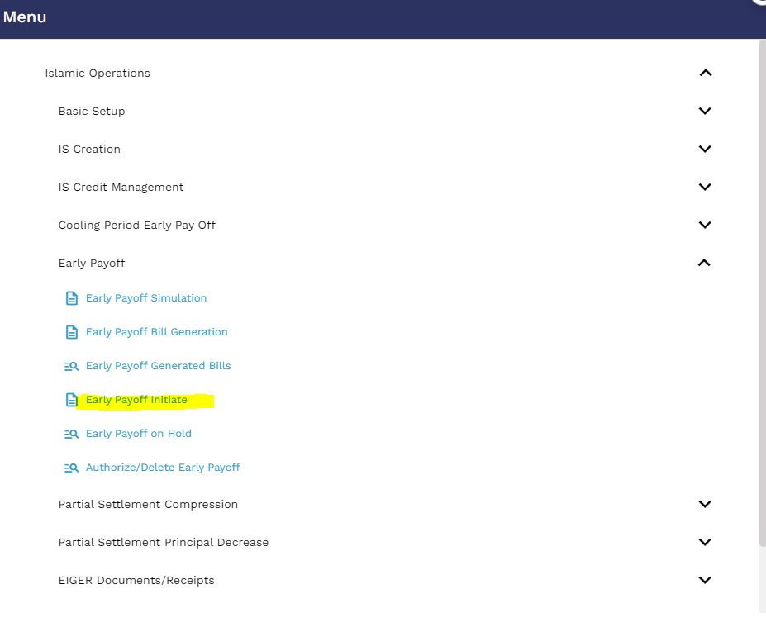
User will put the application ID and icon on the edit icon
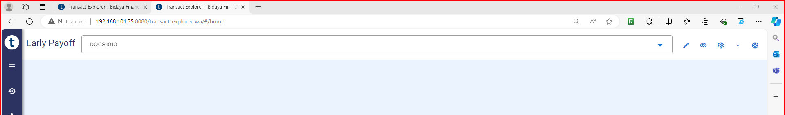
Then user will mention bill reference no, then validate and commit the record
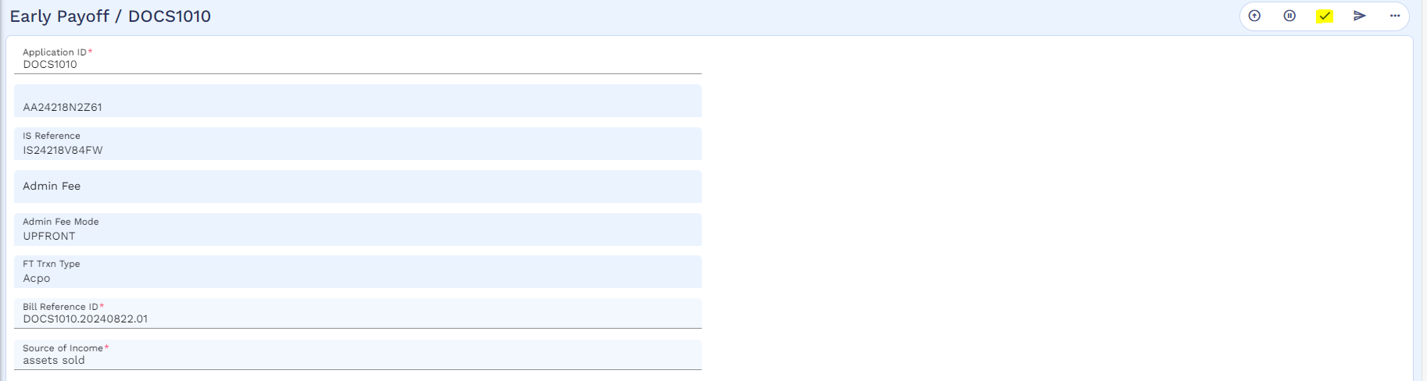
The process has been initiated.
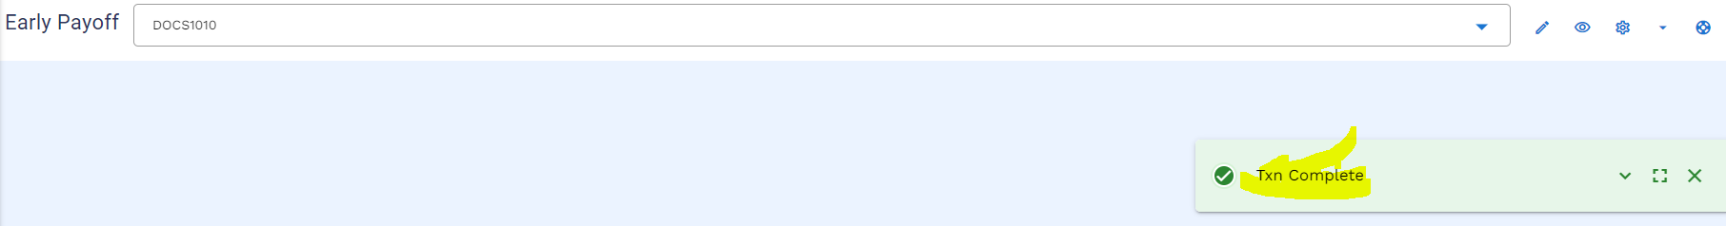
User will check the transaction on Hold stage by using below navigation
Menu Islamic Operation Early Pay Off Early Payoff on Hold
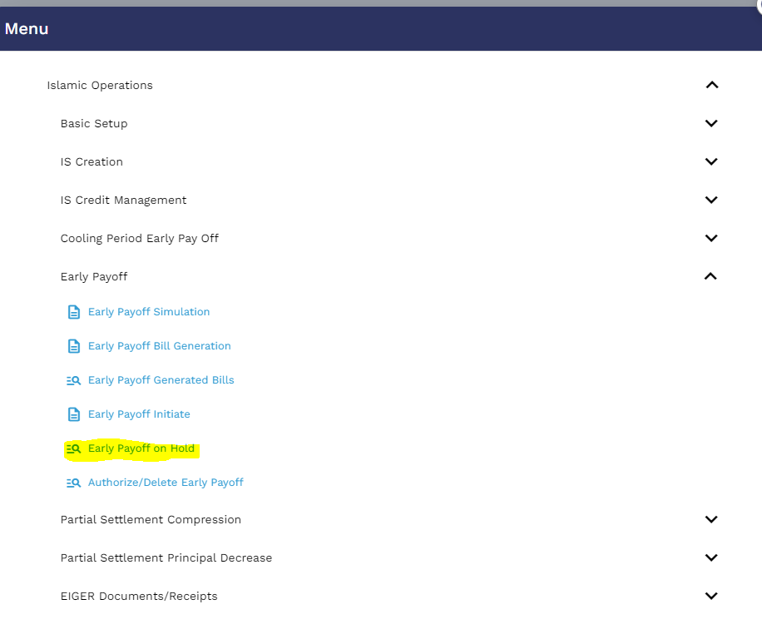
User enters the application ID and click on the find icon
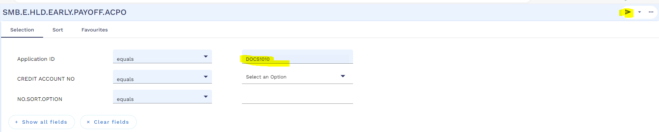
Then user will click on the view icon
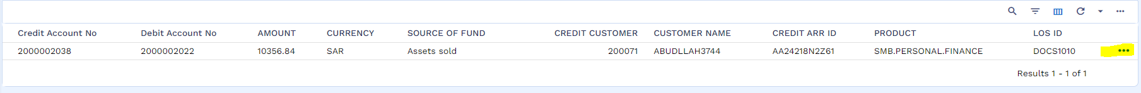
User will validate and commit the record
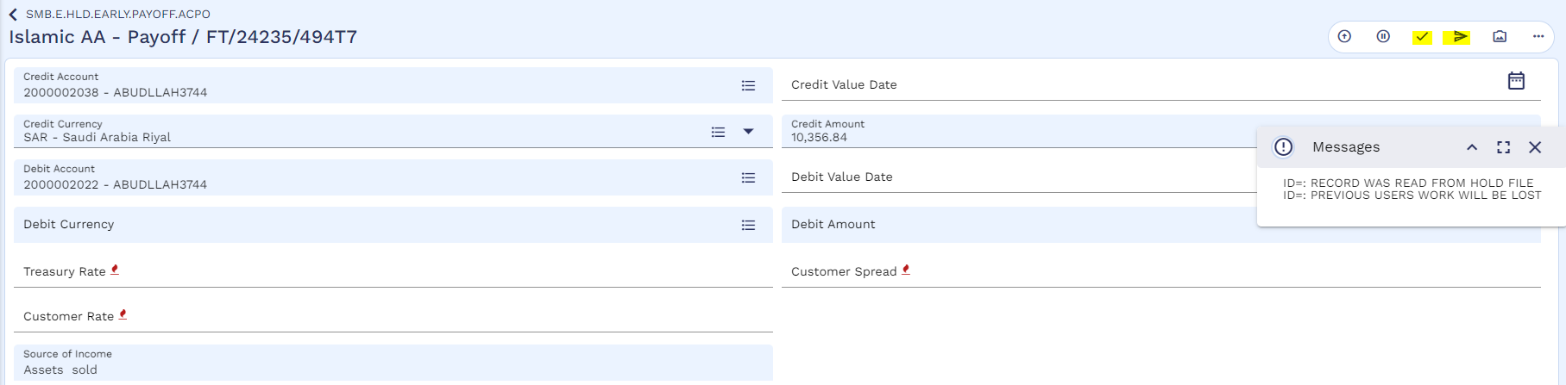
And accept the override
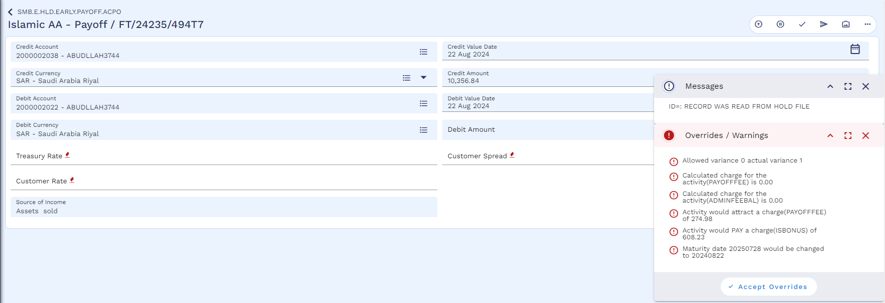
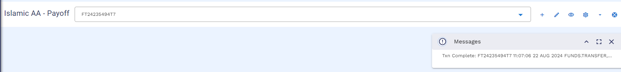
Authorizer will authorize the pay off by using below navigation
Menu Islamic Operation Early Pay Off Authorize / Delete Early Payoff
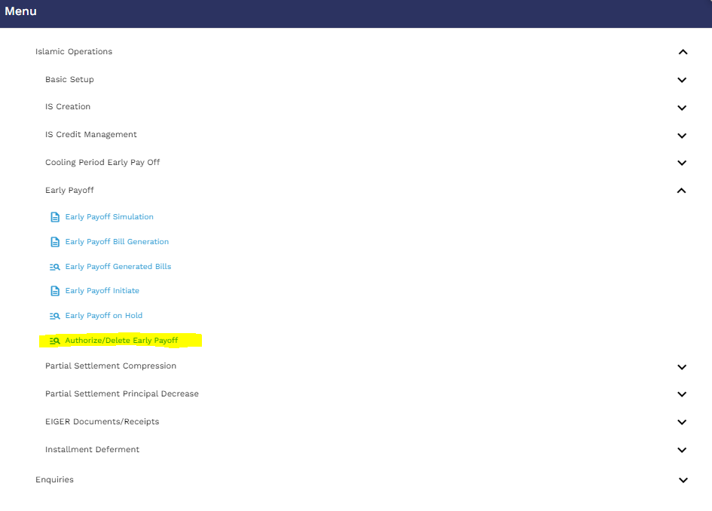
Authorizer will enter application ID and then click on the find icon
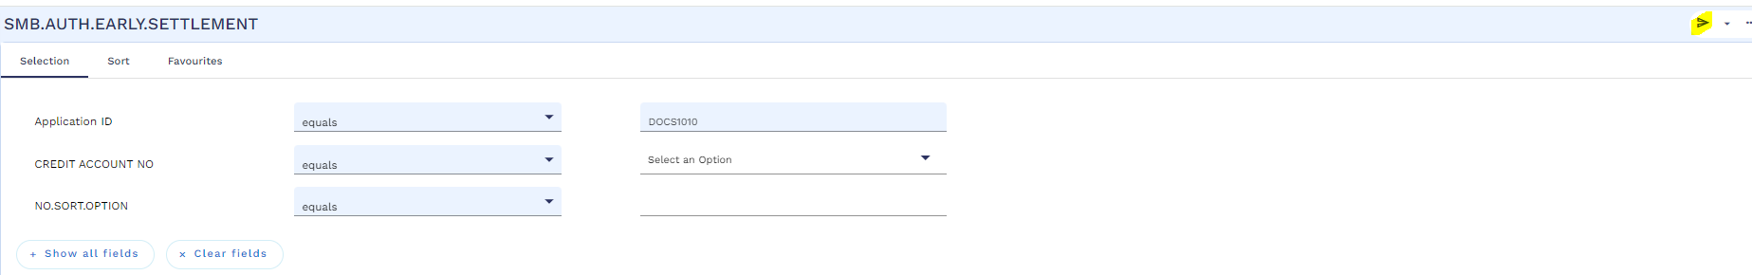
Then click on the view icon
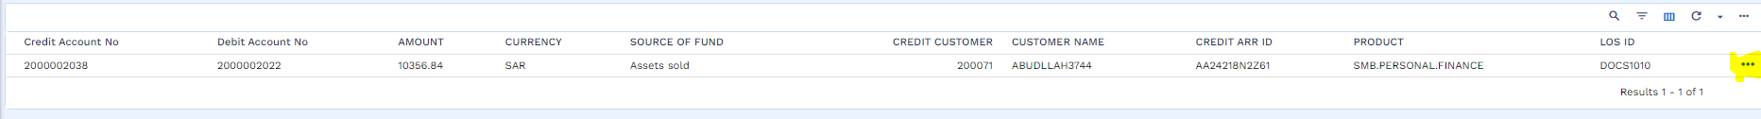
Authorize the transaction
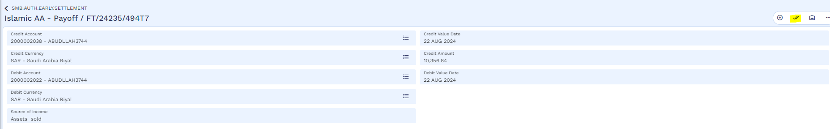
Authorization is completed
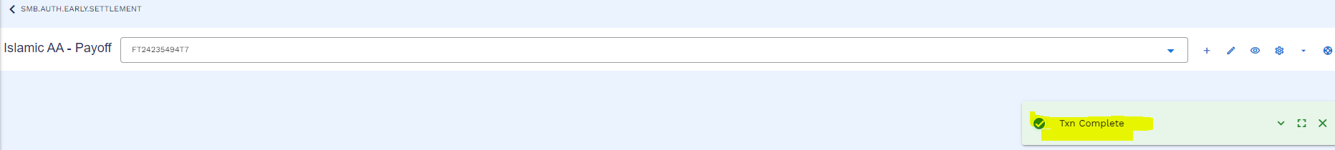
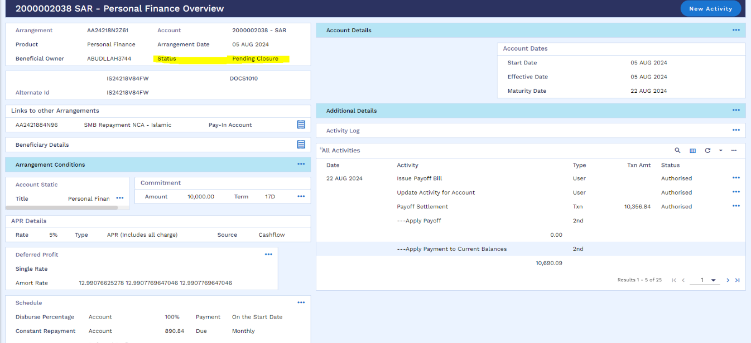
Arrangement status has been changed to “Pending Closure”

Worksheet details:
- File Name: Ijarah Working Sheet
- Sheet Name: DayN-File Upload

Write off (WS01-IJR-11)
User can write of the arrangement by following the below steps:
User will open the arrangement overview and click on the “New Activity”
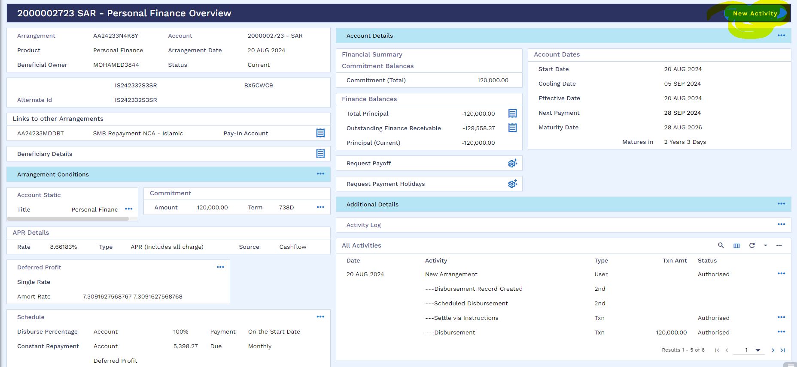
User will go to the “write of Arrangement” and click on “do activity today”
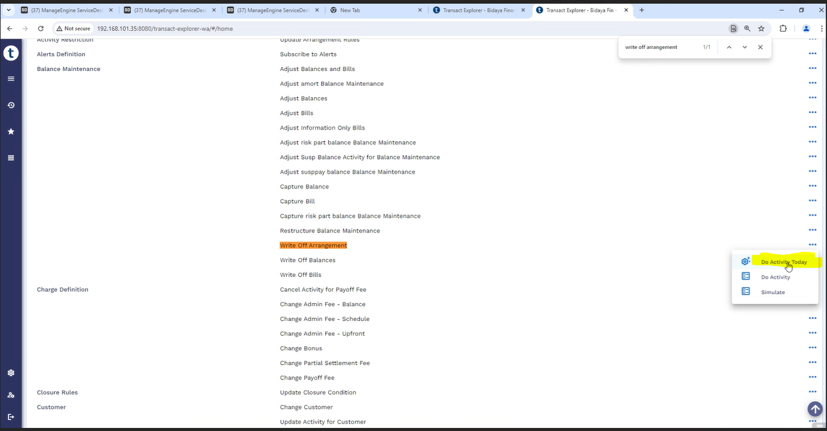
User will click on the balance maintenance tab
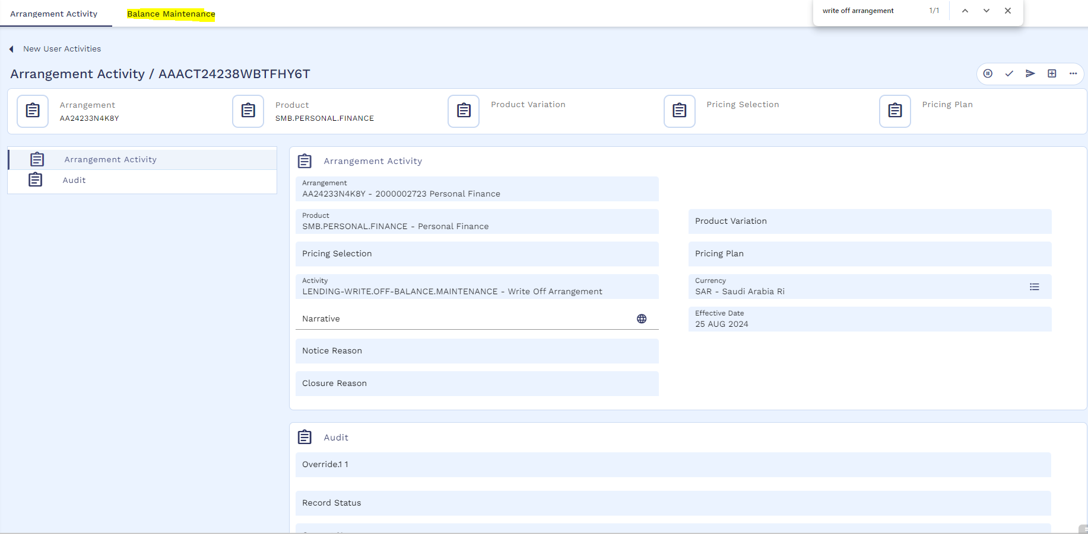
And then click to validate and commit the record.
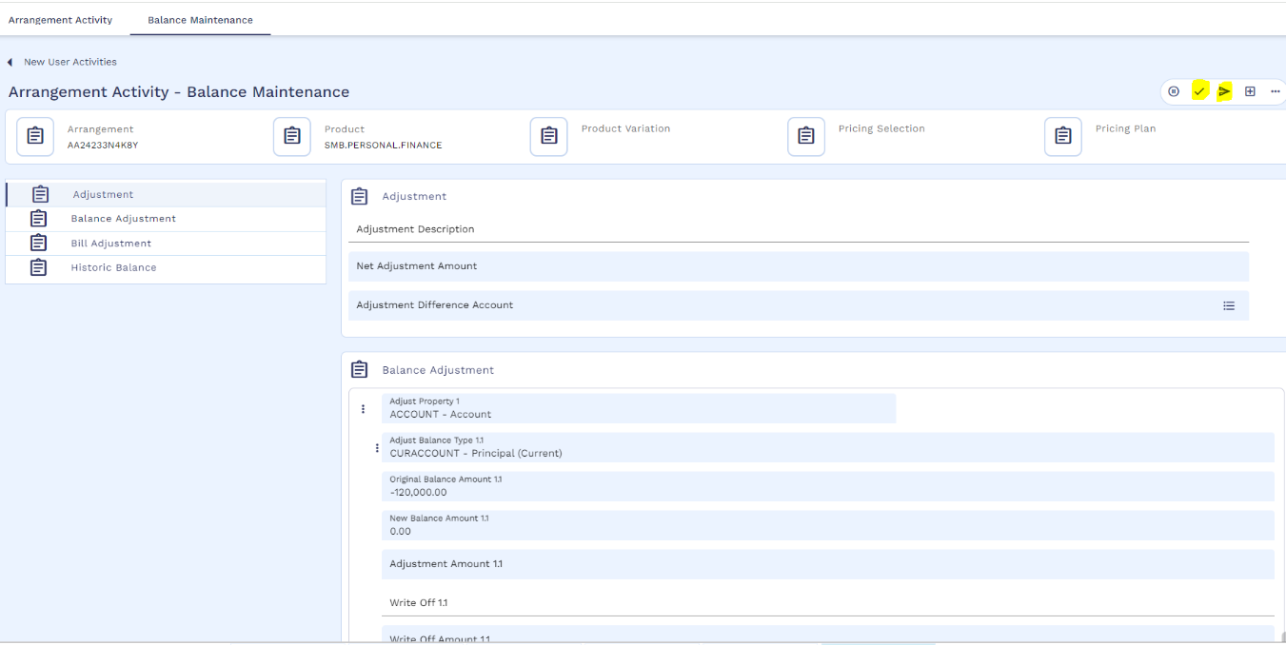
record has been committed.
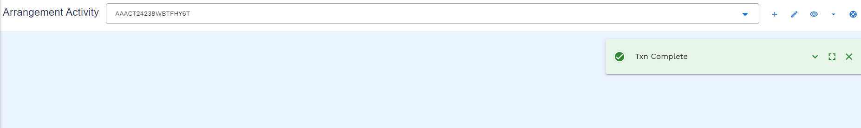
Authorizer can authorize the write off activity from the arrangement overview and click on the menu icon to authorize the activity.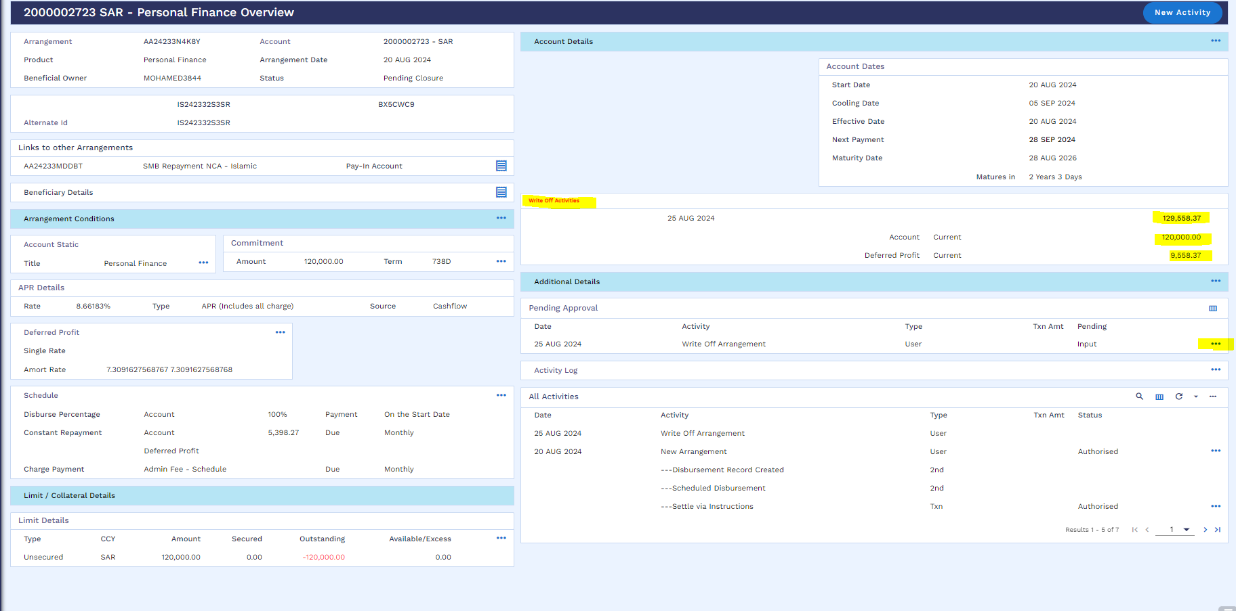
Commit the record to authorize the activity
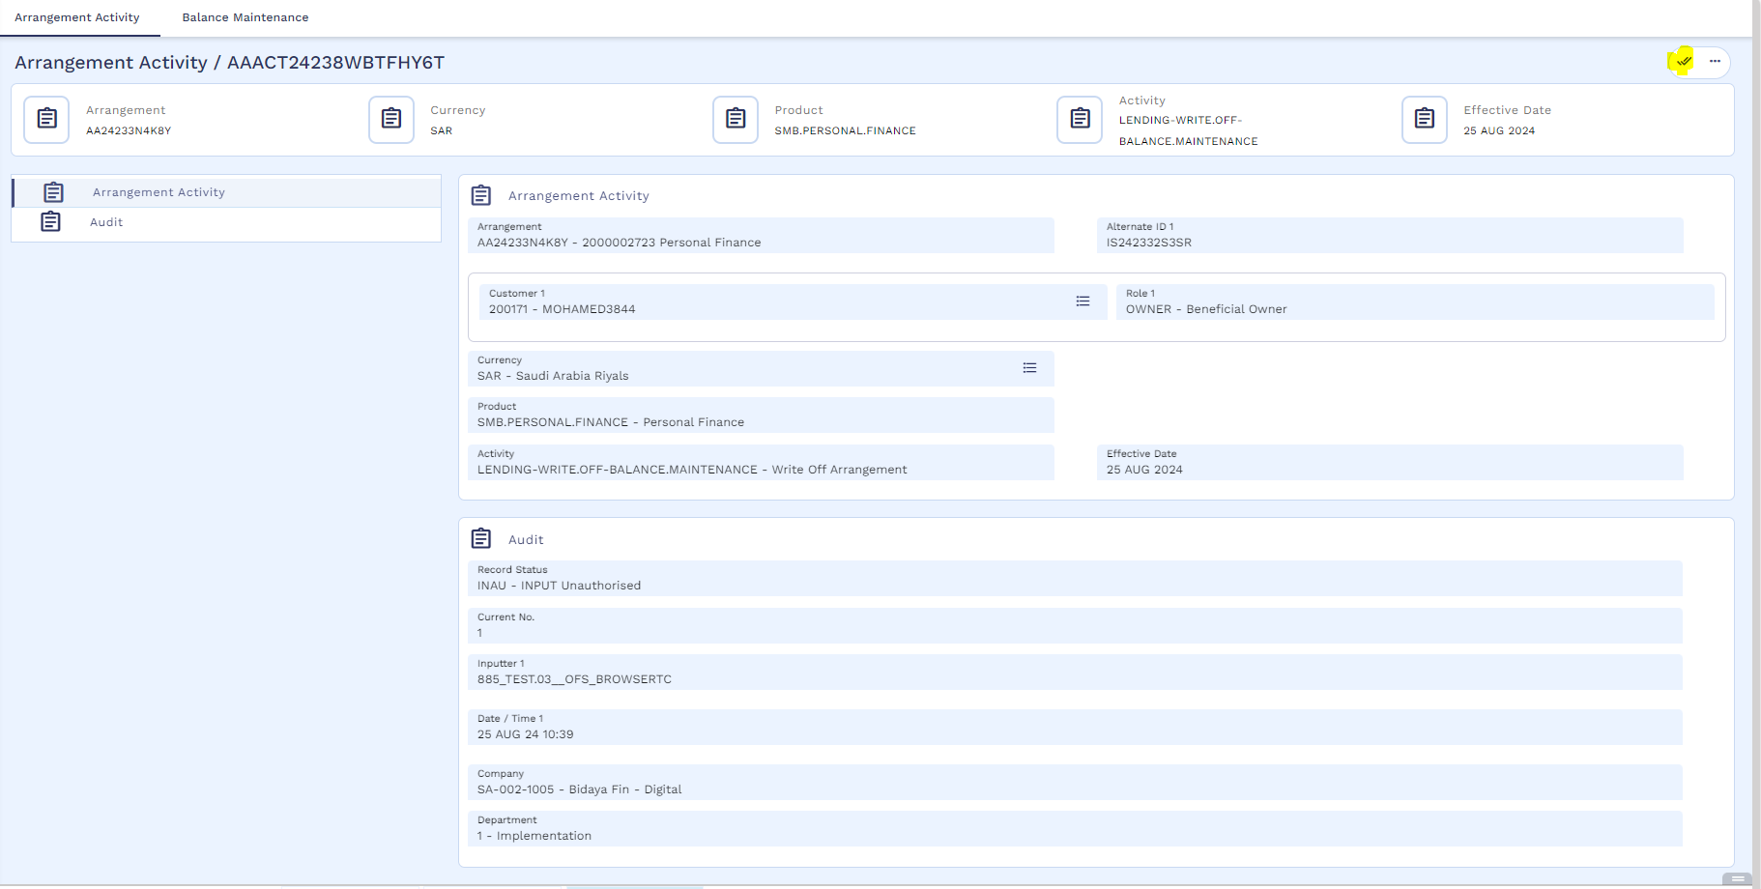
Authorization is completed
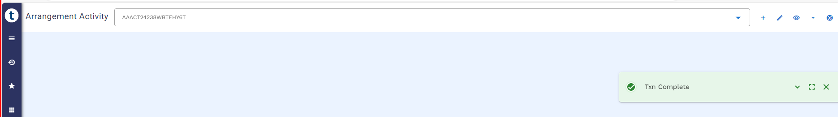

User may check the accounting entries from enquiry section.
Accounting entries
Stage | Debit/Credit | Accounting Entries | Description | Core/ Customized | Account Reflection
Write off of Arrangement | DR | Internal Account / PL | Write-off Internal Account / PL | -100,000.00 | On Balance Sheet
Write off of Arrangement | CR | DUEACCOUNT | AA Arrangement - ACCOUNT | 100,000.00 | On Balance Sheet
Write off of Arrangement | DR | PL/ Expense | PL Category | -10,027.40 | On Balance Sheet
Write off of Arrangement | CR | DUEDEFERREDPFT | Due Profit Receivable | 10,027.40 | On Balance Sheet
Write off of Arrangement | DR | ACCDEFERREDPFT | Unearned Profit | -25,000.00 | On Balance Sheet
Write off of Arrangement | CR | PL/ Expense | PL Category | 25,000.00 | On Balance Sheet
Write off of Arrangement | DR | PL/ Expense | PL Category | -25,000.00 | On Balance Sheet
Write off of Arrangement | CR | RECDEFERREDPFT | Profit Receivable | 25,000.00 | On Balance Sheet

Partial Settlement (WS01-IJR-12)
Partial Settlement can be done in two ways
- AA - Compression payment
- AA Principal Decrease

AA - Compression payment
In AA – Compression payment customer can settle minimum 2 and 5 maximum instalments. It is on customer’s preference either the customer opt to reduce the instalment or reduce the tenor.
User will follow below navigation for Partial settlement
Menu Islamic Operation Partial Settlement Compression Compression Bill Generation
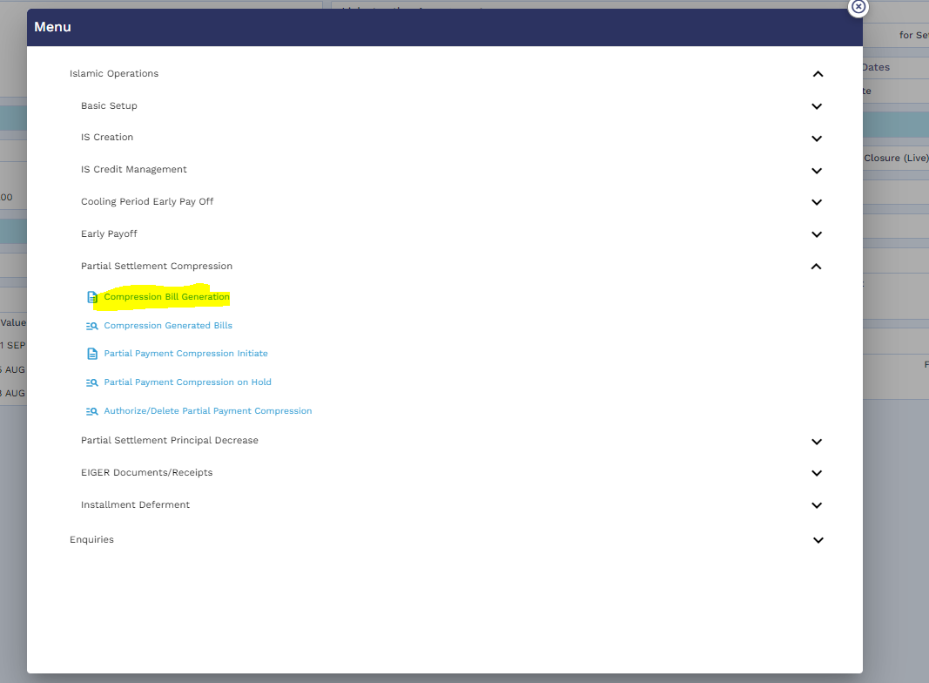
User will click on the edit icon
Then mention Loan App id, Settlement Type, No. of instalments, source of income, Recalculation Method and Repayment type.
Please note that if the customer wants to reduce the Tenor, then the Recalculation Method as “Term” should be selected, and the customer wants to reduce the instalment amount then the Recalculation Method as “Instalment” should be selected.
After that the user will validate the activity through validation icon.
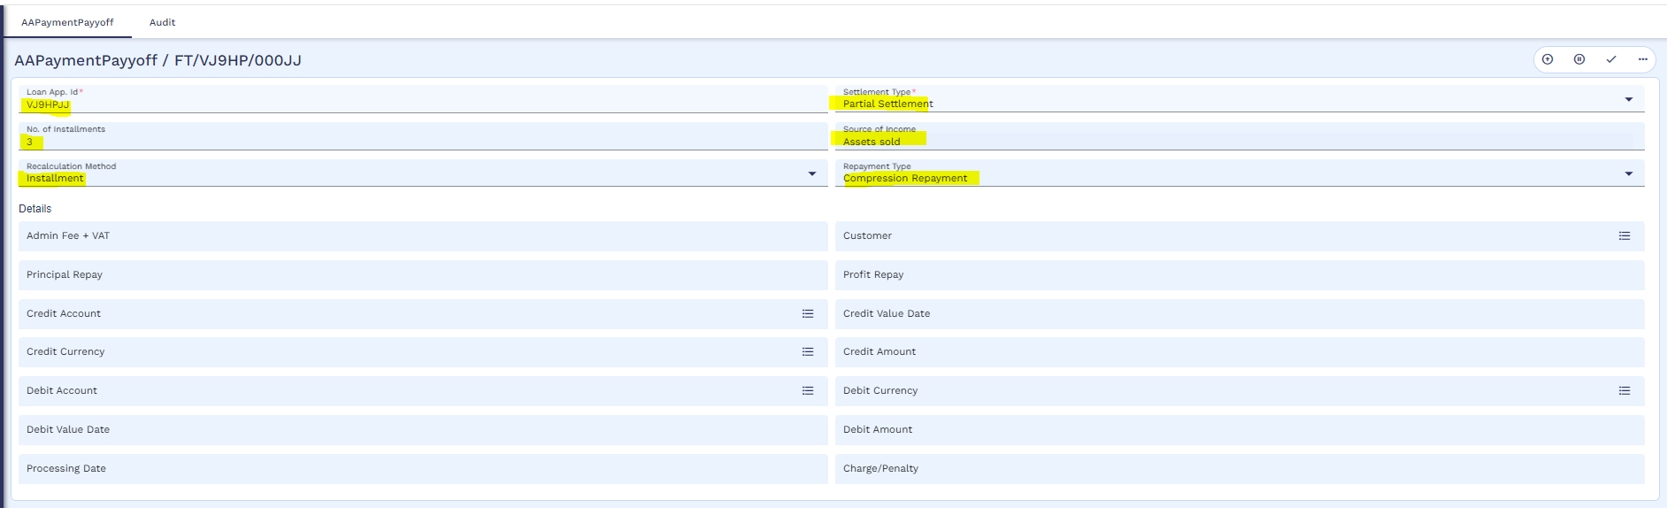
And then commit the record.
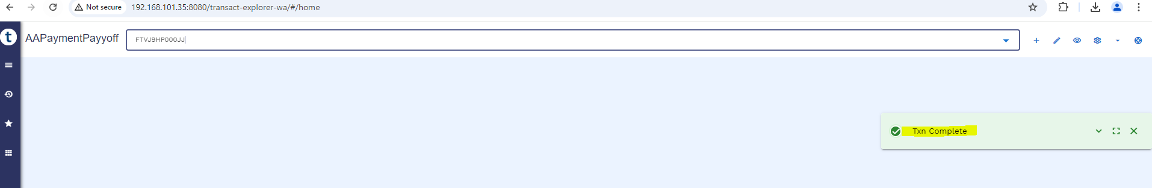

User can check the bill by using below navigation
Menu Islamic Operation Partial Settlement Compression Compression Generated Bill
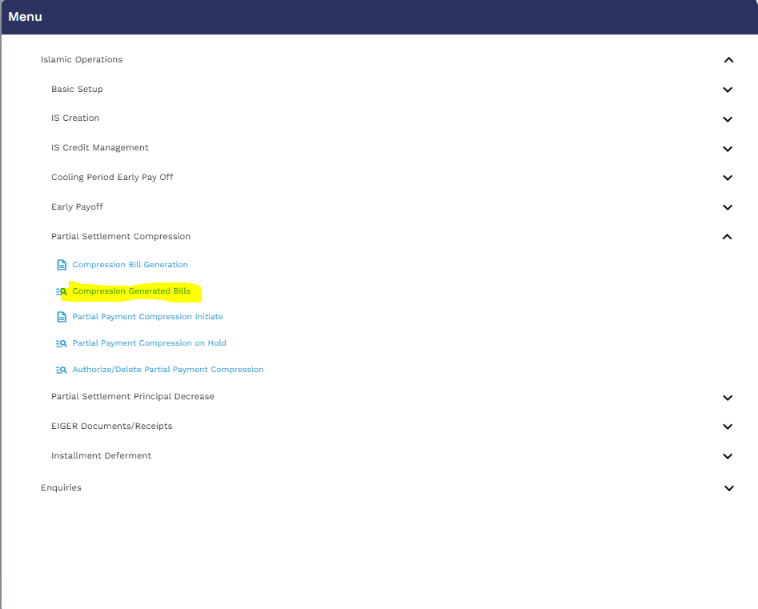
User will put the application ID
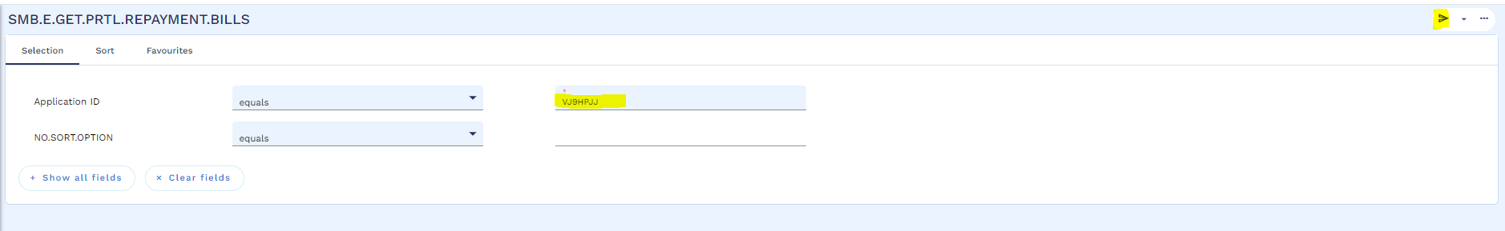
Below window will open, User will click on the view icon

Generated bill as below, through a service this is integrated with SADDAD. Like other processes, this process can also be integrated with servicing app.
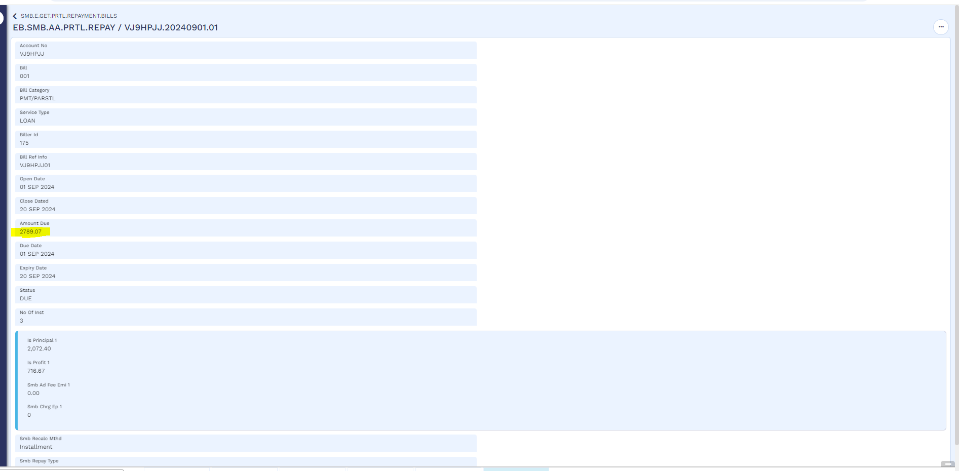
User will make the funds available in customers repayment account as mentioned in early payoff section
Once the funds are available in customer repayment account, user will initiate compression payment as per below navigation
Menu Islamic Operation Partial Settlement Compression Partial Payment Compression Initiate
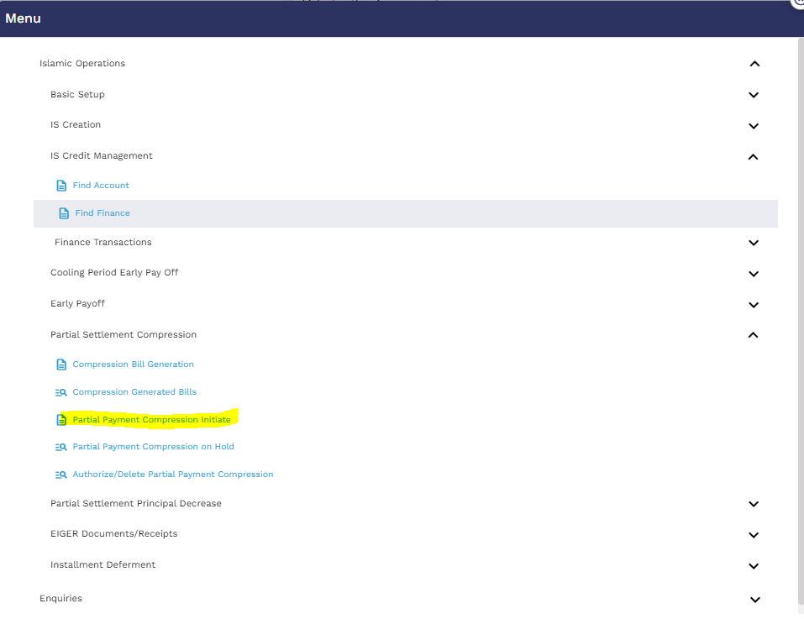

User will enter the application id and then click on the edit icon

After that user will put the bill reference and then validate the activity
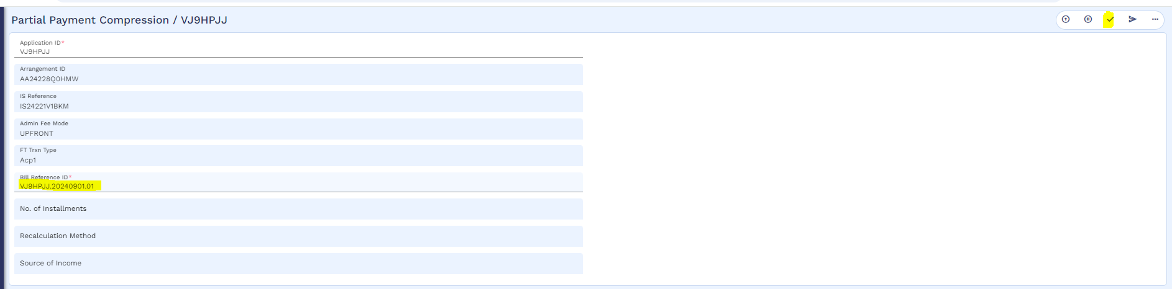
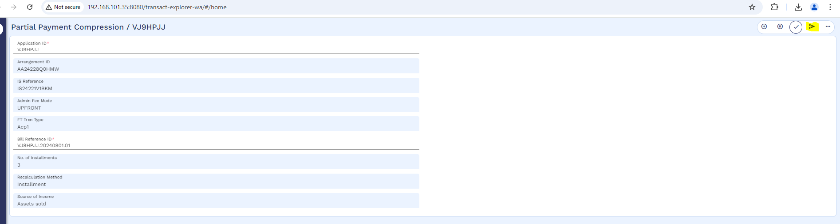
And then commit the record.
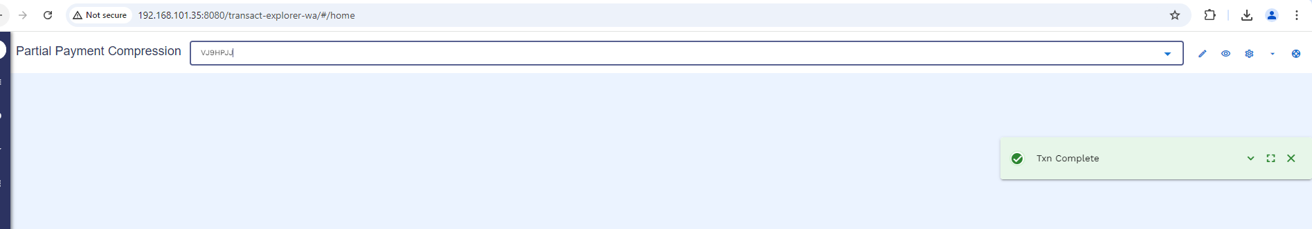
User will follow below navigation to commit the record from hold
Menu Islamic Operation Partial Settlement Compression Partial Payment Compression on Hold
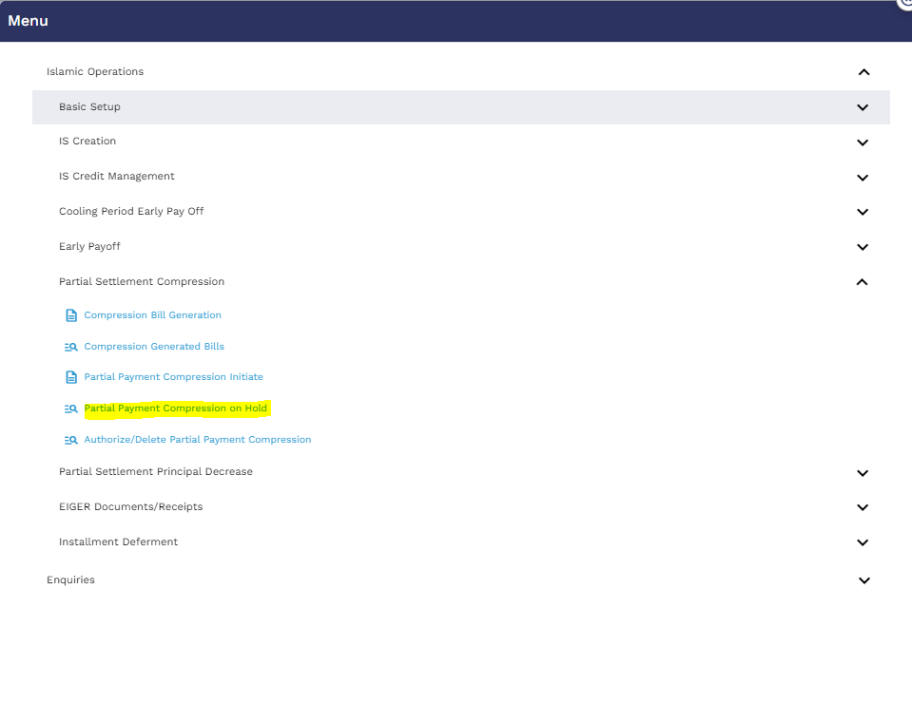
User will put the application id and click to find icon
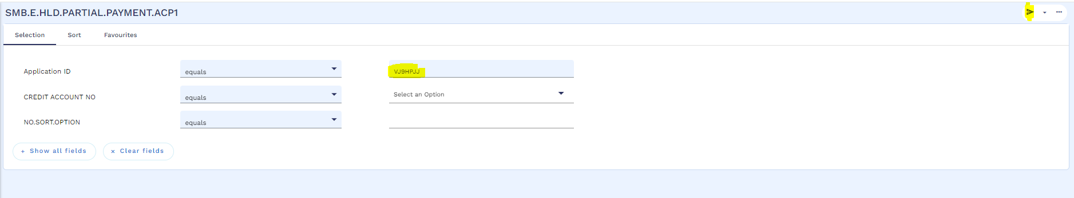
Below window will open, then user will click on the view icon to commit
User will validate and commit the record.
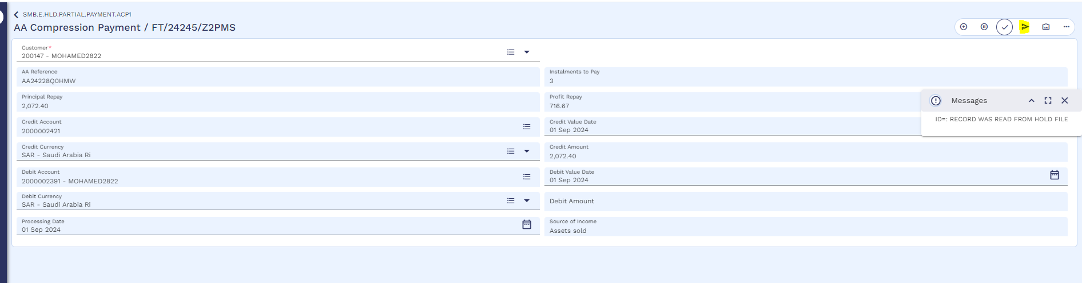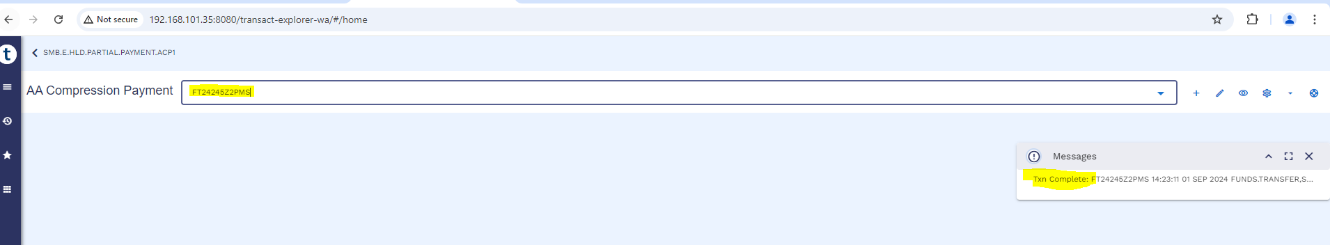
Now the authorizer will authorize the record by following below navigation
Menu Islamic Operation Partial Settlement Compression Authorize / Delete Partial Payment Compression
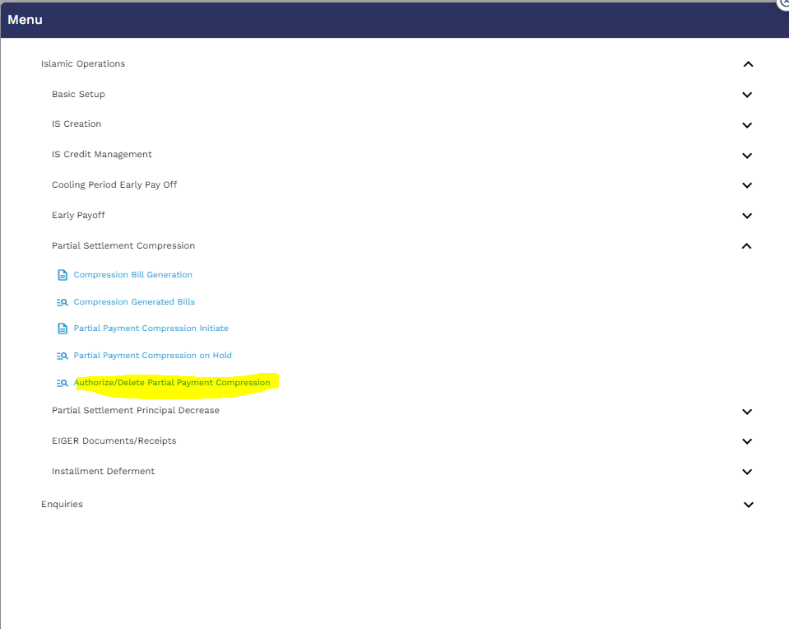
User will put the application id and click on the find icon
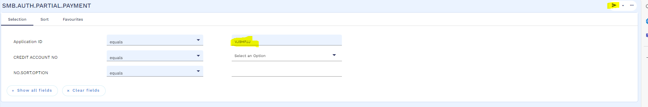

Then click on the view icon
Authorizer will validate and commit the record.
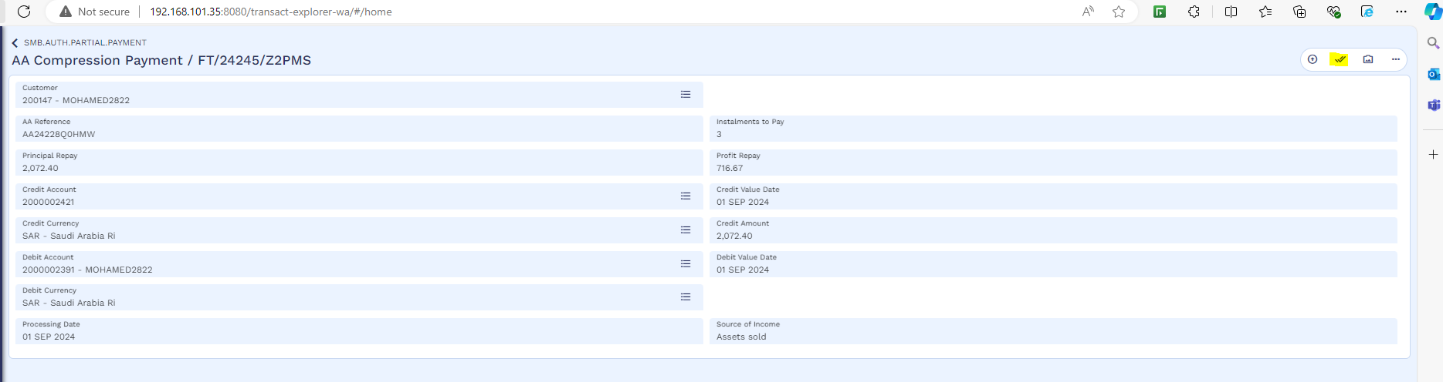
Authorization is completed.
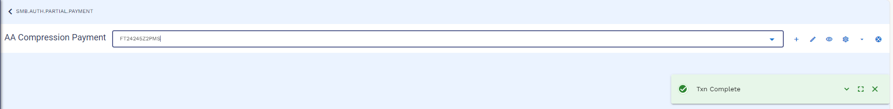

Worksheet details:
- File Name: Tawarruq Working Sheet
- Sheet Name: “Partial Settlement - Installment-TA” and “Partial Settlement - Revise Term-TA”
Partial Settlement treatment are same as defined in referred Tawarruq Working Sheet.

AA – Principal Decrease
The user can conduct a "Principal Decrease" as a partial settlement activity when the customer intends to settle six installments. It's important to note that principal decrease can only be executed when settling six installments
User will follow below navigation for Partial settlement
Menu Islamic Operation Partial Settlement Principal Decrease Principal Decrease Bill Generation

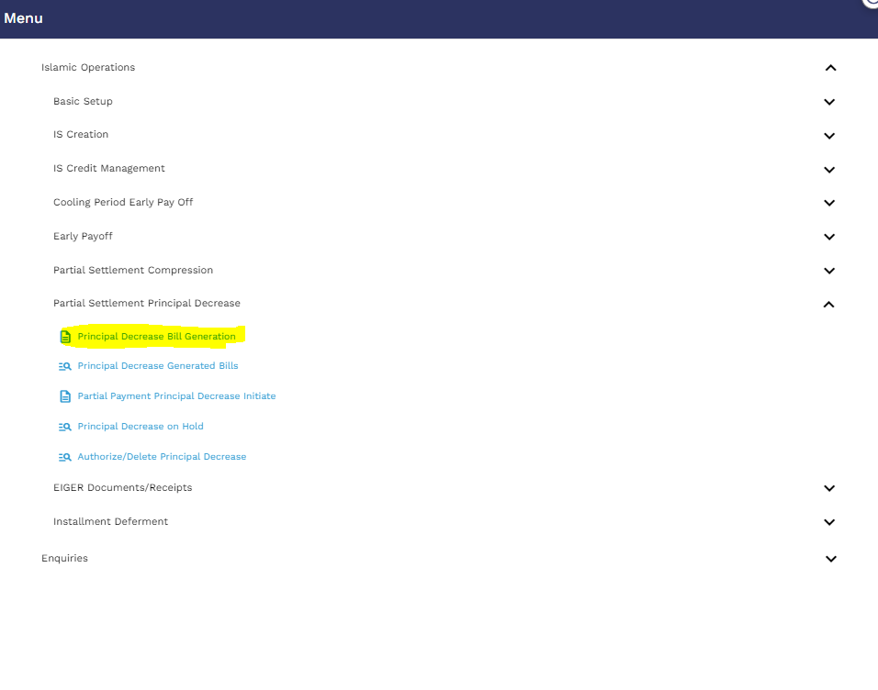
User will click on the edit icon
Then mention Loan App id, Settlement Type, No. of installments, source of income, Recalculation Method and Repayment type.
Please note that if the customer wants to reduce the Tenor, then the Recalculation Method as “Term” should be selected, and the customer wants to reduce the installment amount then the Recalculation Method as “Installment” should be selected.
After that the user will validate the activity through a validation icon.
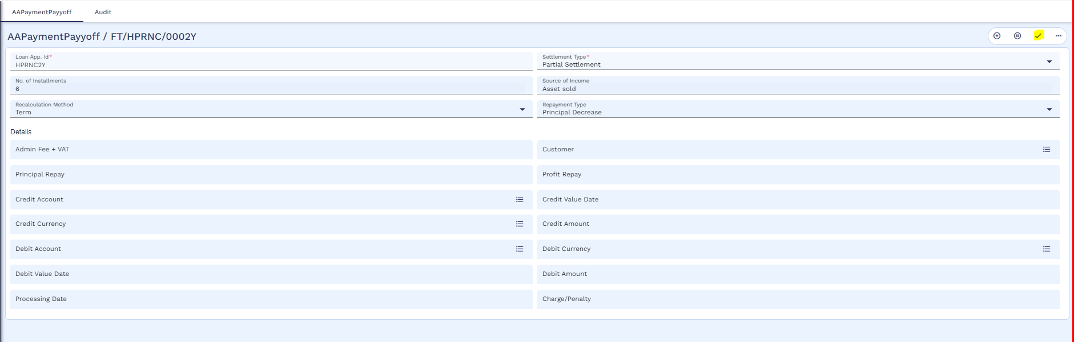
And then commit to the record.
User can check the bill by using below navigation
Menu Islamic Operation Partial Settlement Principal Decrease Principal Decrease Generated Bills
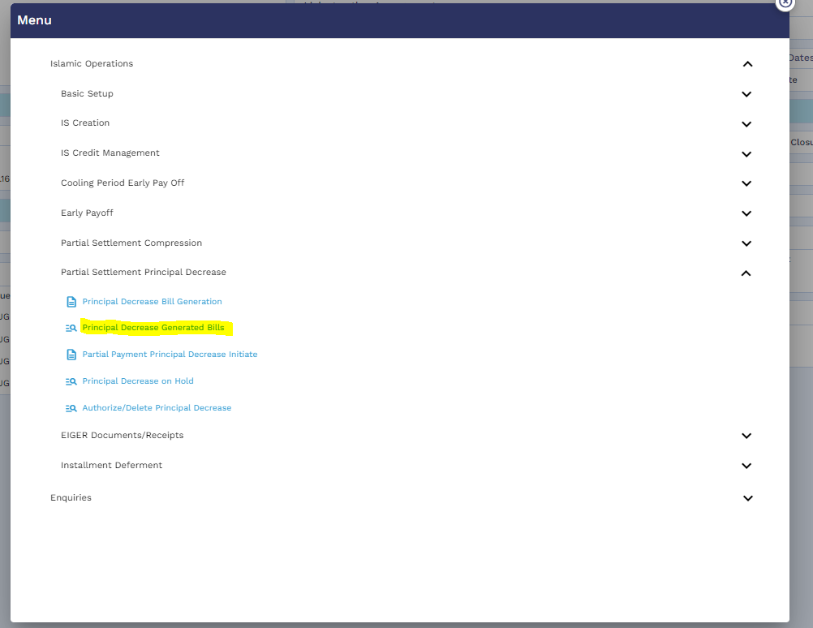
User will put the application ID
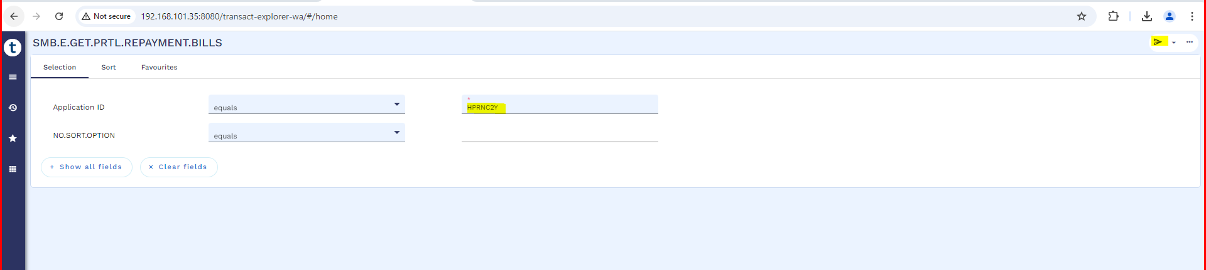
Below window will open, User will click on the view icon
Generated bill as below
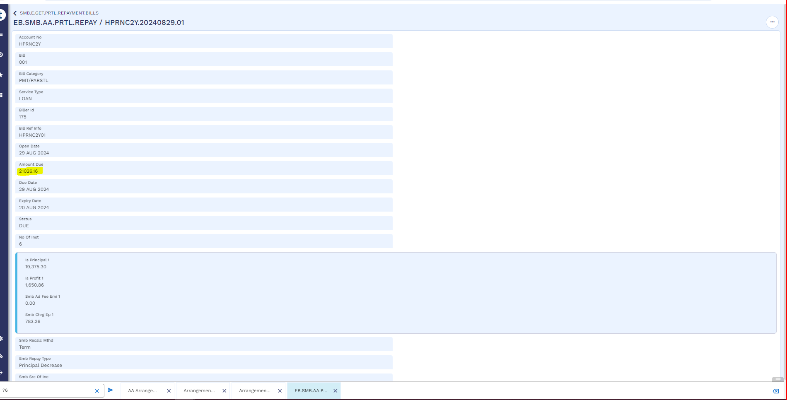
Through a service this is integrated with SADDAD. Like other processes, this process can also be integrated with servicing app.
User will make the funds available in customers repayment account as mentioned in early payoff section
Once the funds are available in customer repayment account, user will initiate Principal Decrease payment as per below navigation
Menu Islamic Operation Partial Settlement Principal Decrease Partial Payment Principal Decrease Initiate
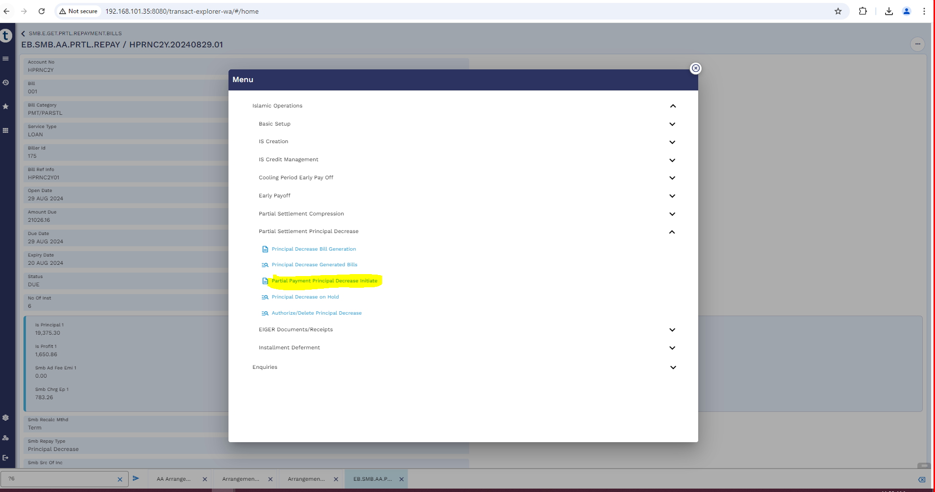
User will enter the application id and then click on the edit icon
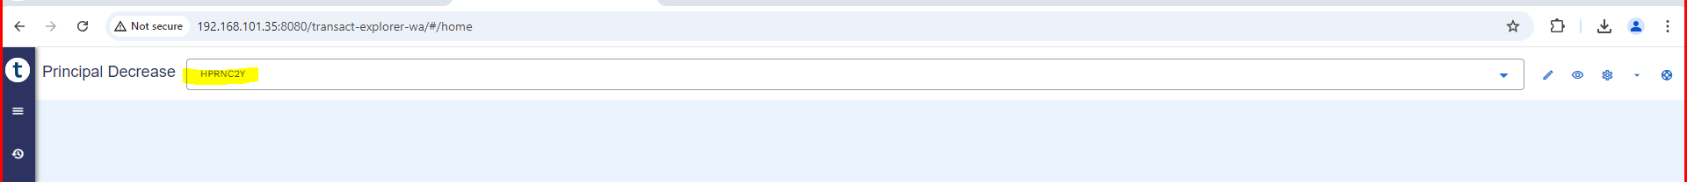
After that user will put the bill reference and then validate the activity
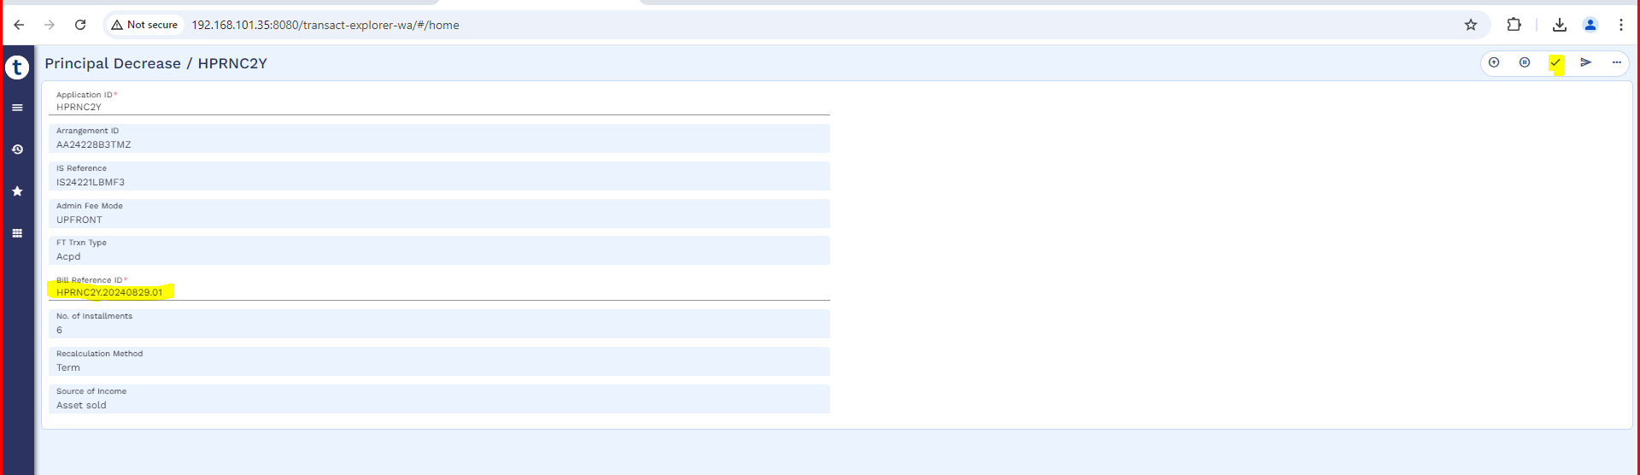
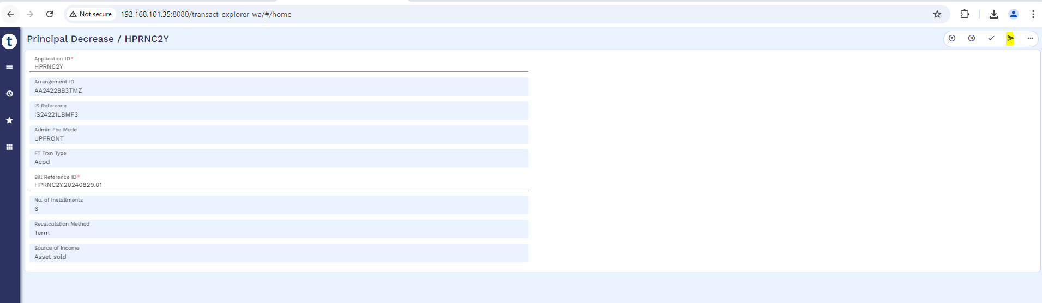

And then commit the record.
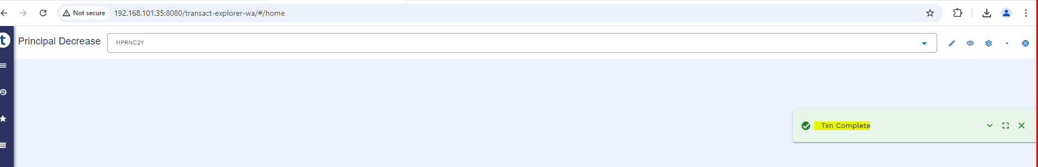
User will follow below navigation to commit the record from hold
Menu Islamic Operation Partial Settlement Principal Decrease Partial Payment Principal Decrease on Hold
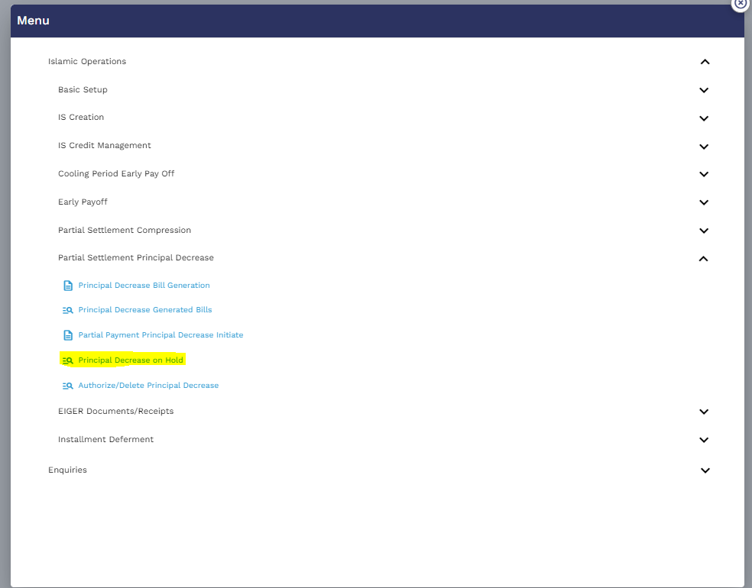
User will put the application id and click to find icon
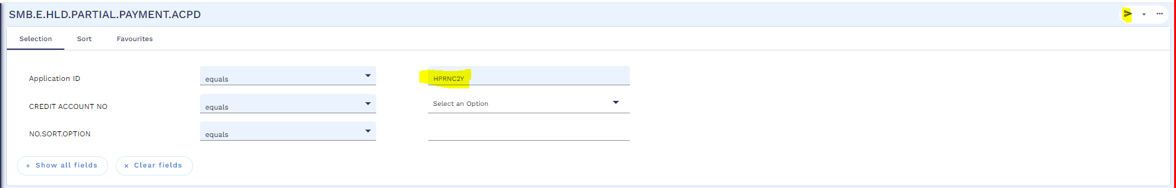
Below window will open, then user will click on the view icon to commit

User will validate and commit the record.
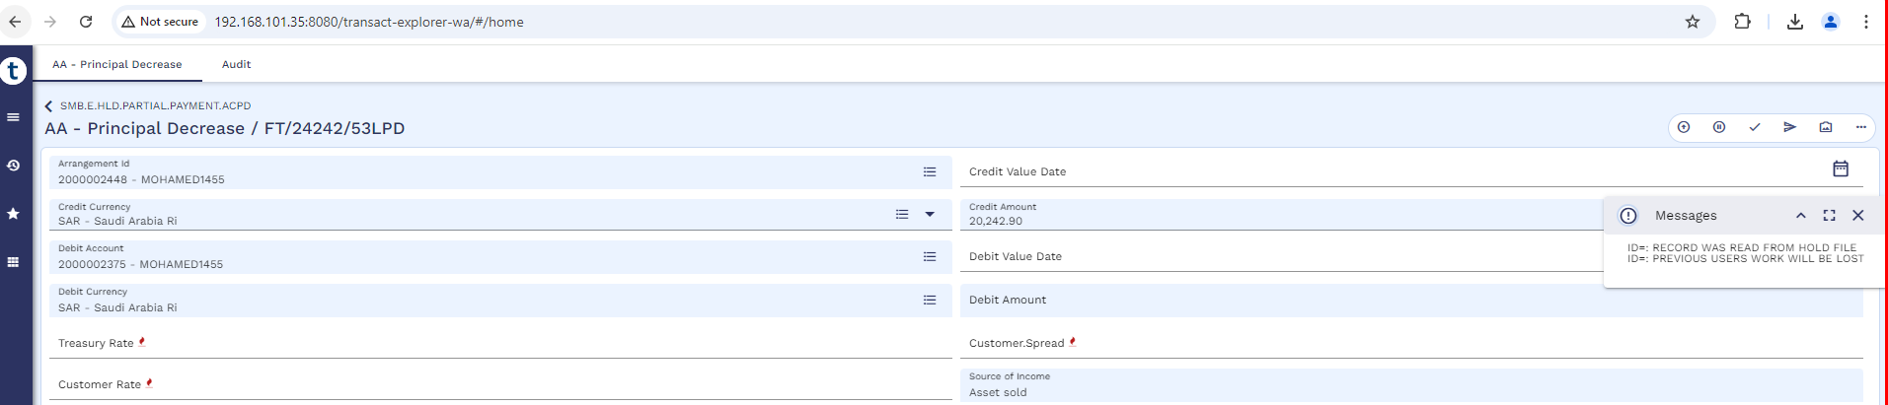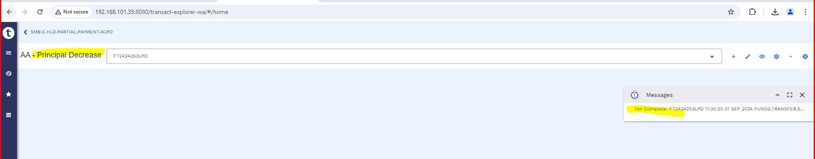
Now the authorizer will authorize the record by following below navigation
Menu Islamic Operation Partial Settlement Principal Decrease Authorize / Delete Partial Payment Compression
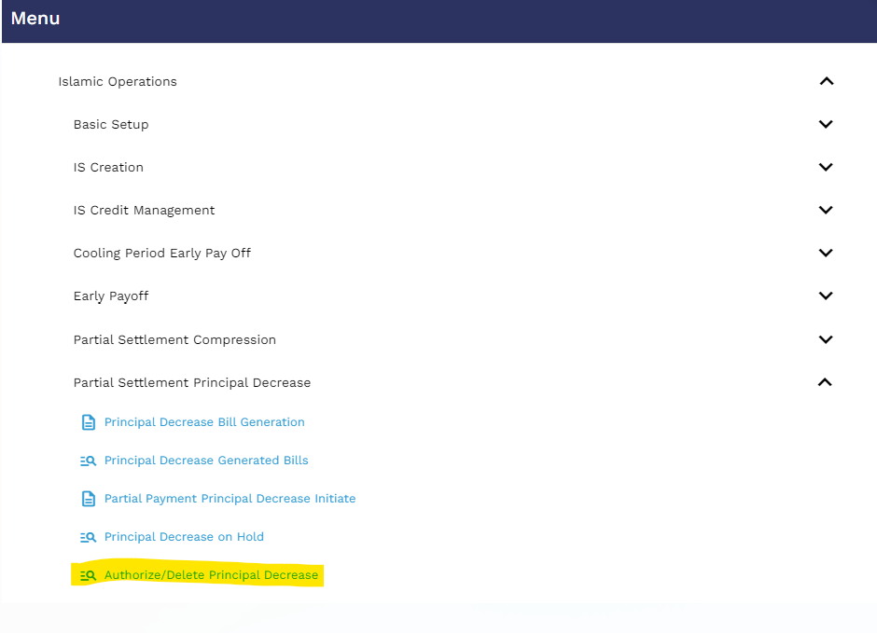
User will put the application id and click on the find icon
Then click on the view icon

Authorizer will validate and commit the record.
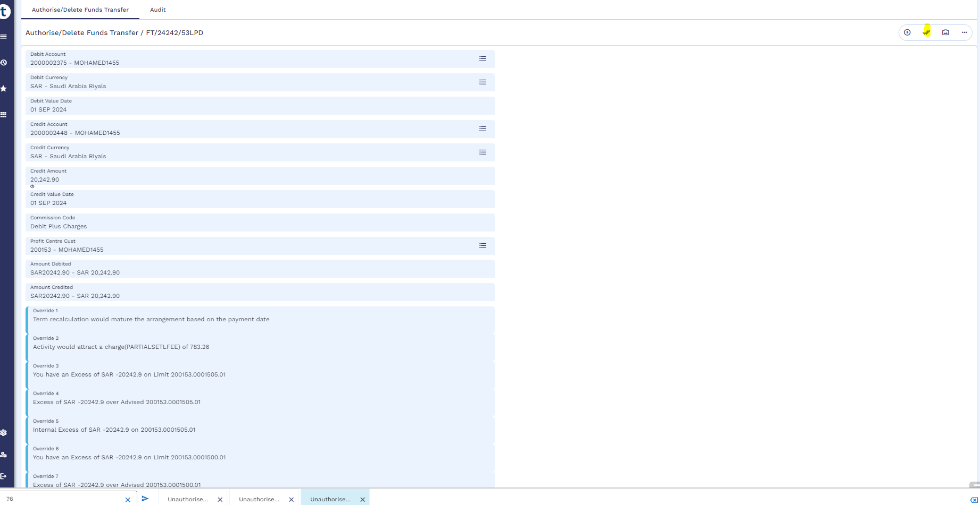
Authorization is completed.
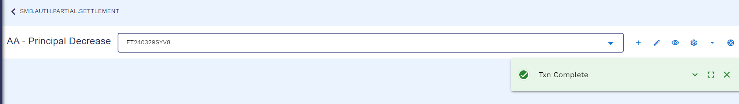

Worksheet details:
- File Name: Ijarah Working Sheet
- Sheet Name: “Principal Decrease - Installment-TA” and “Principal Decrease - Term-TA”
- Partial Settlement treatment are same as defined in referred Tawarruq Working Sheet.

Restructuring (WS03-IJR-13)
Below restructuring process is Tawarruq product however same mechanism will be updated in order to incorporate asset capture and takaful functionality in restructure of finance.
There will be four scenarios in restructuring:
- Principal Only
- Principal + Profit
- Top-up + Principal
- Top-up + Principal + Profit
Existing restructuring process requires several steps as shown below:
Customer CIF | 100630
IS Contract | IS23257Q00FR
Payin (Repayment) Account | 3000008035
Old Arrangement | AA23257ZLBPK, 3000008019

Request Stage
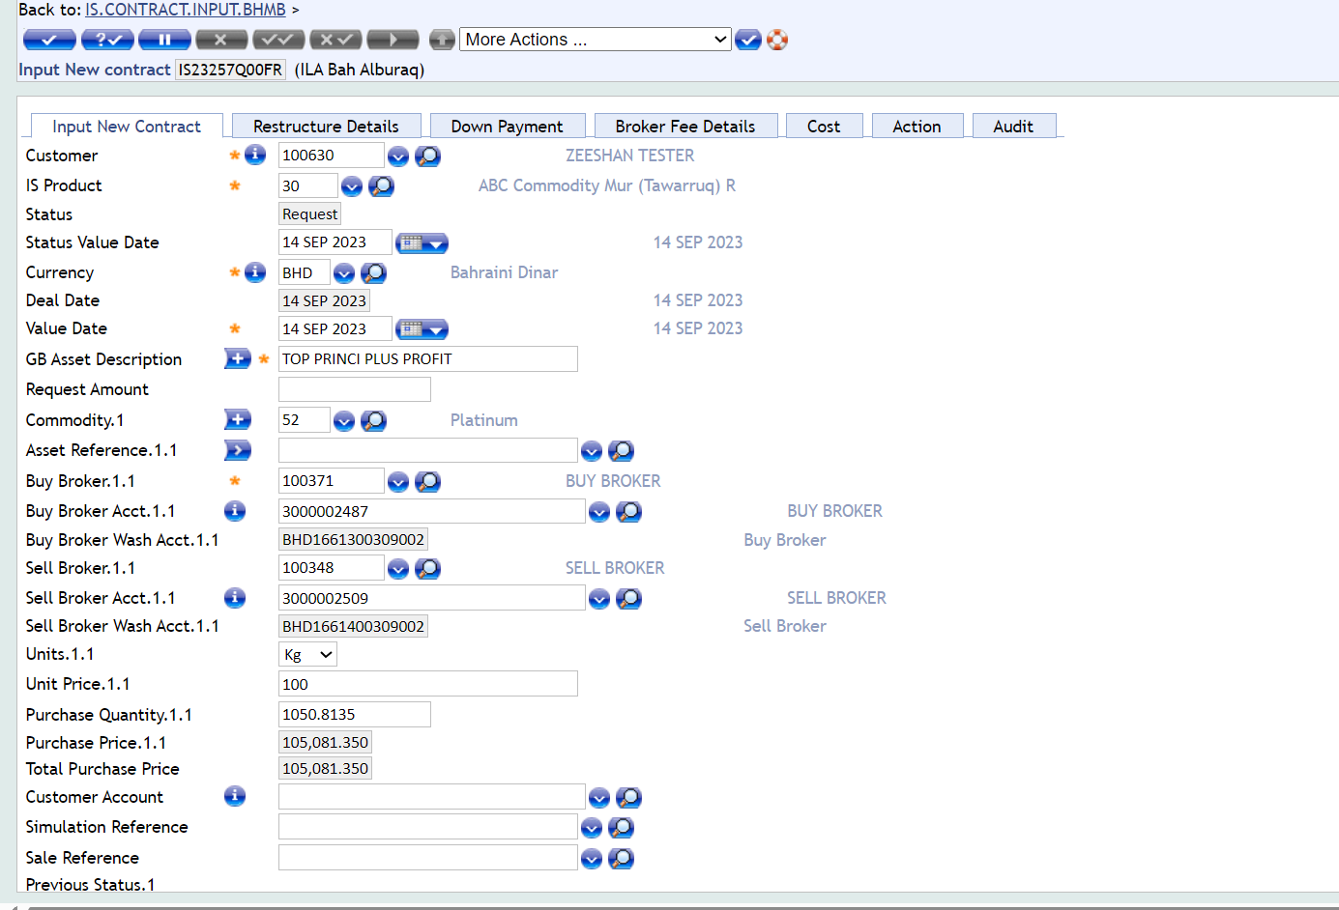

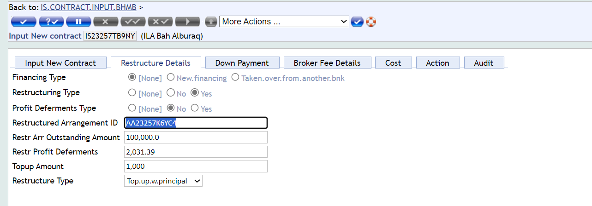
Authorization
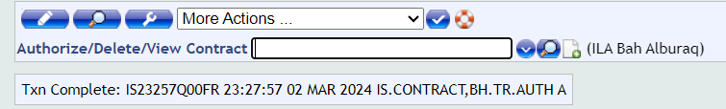

Approval Stage
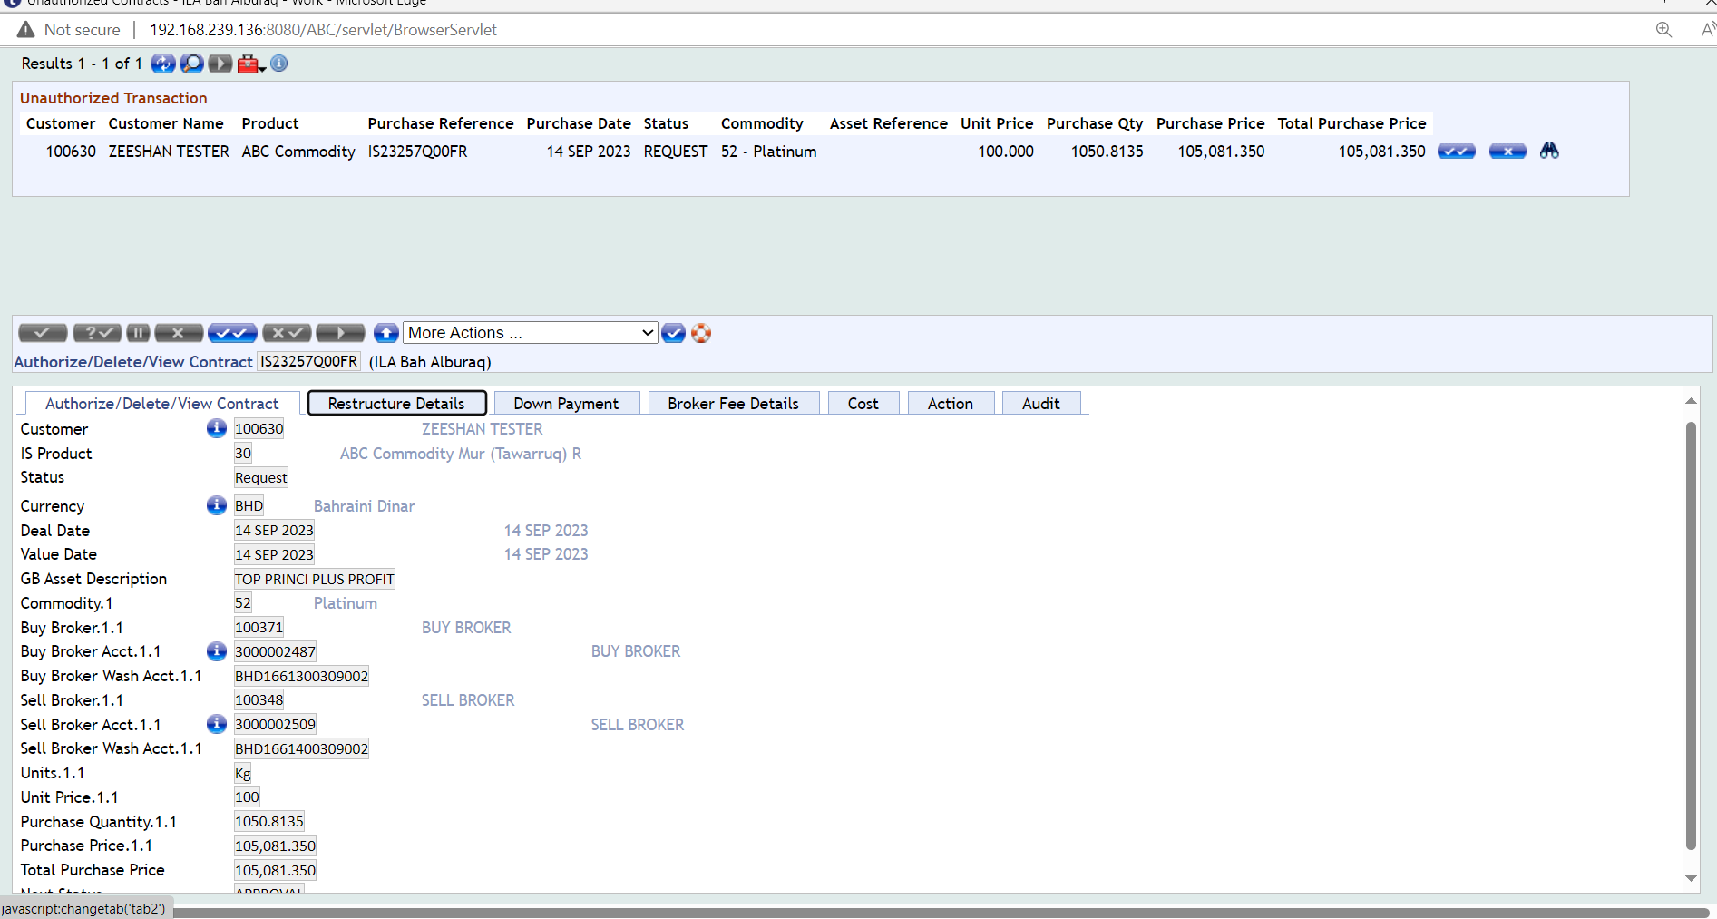
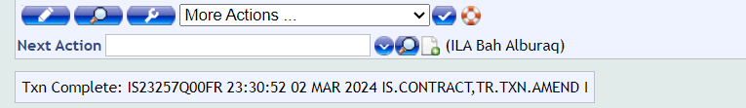
Authorization
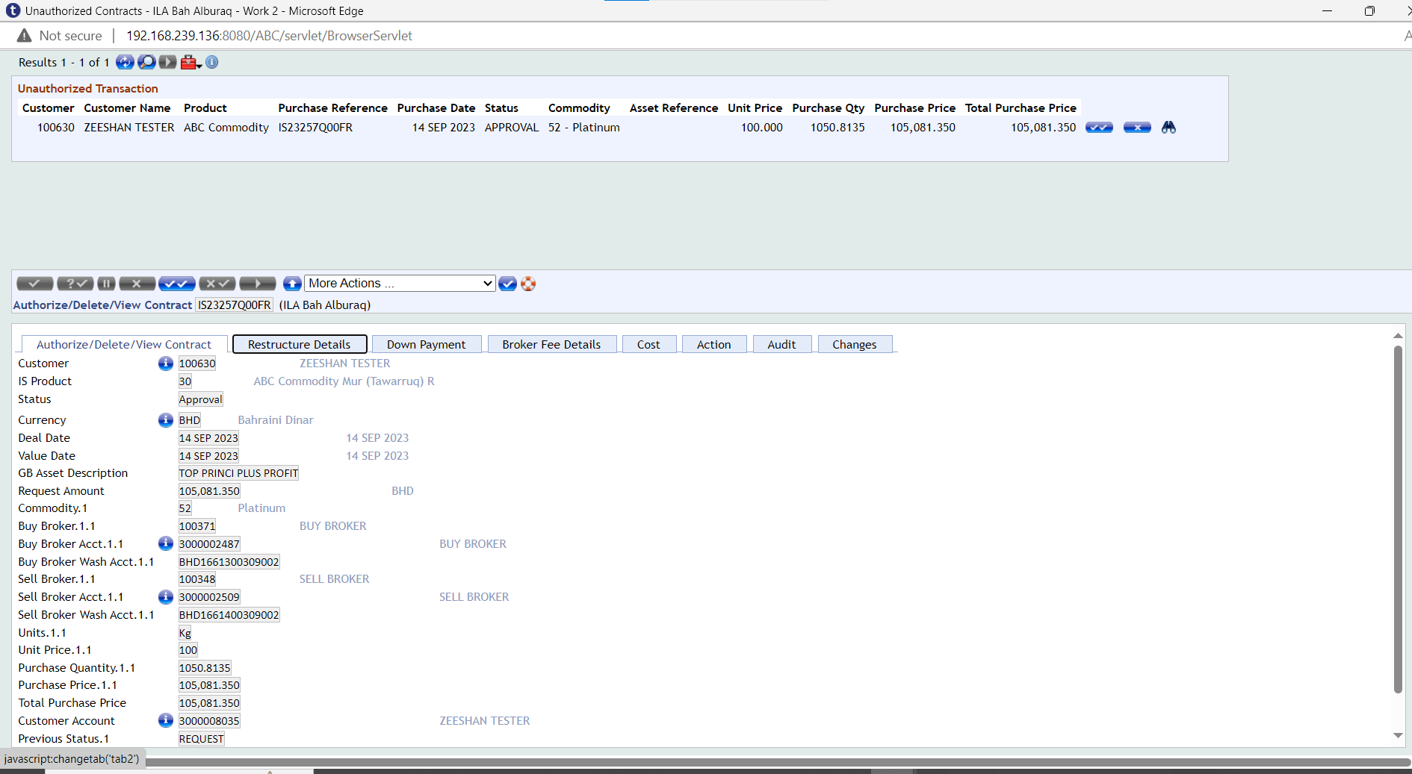

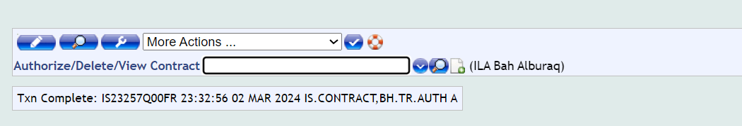

Purchase Stage
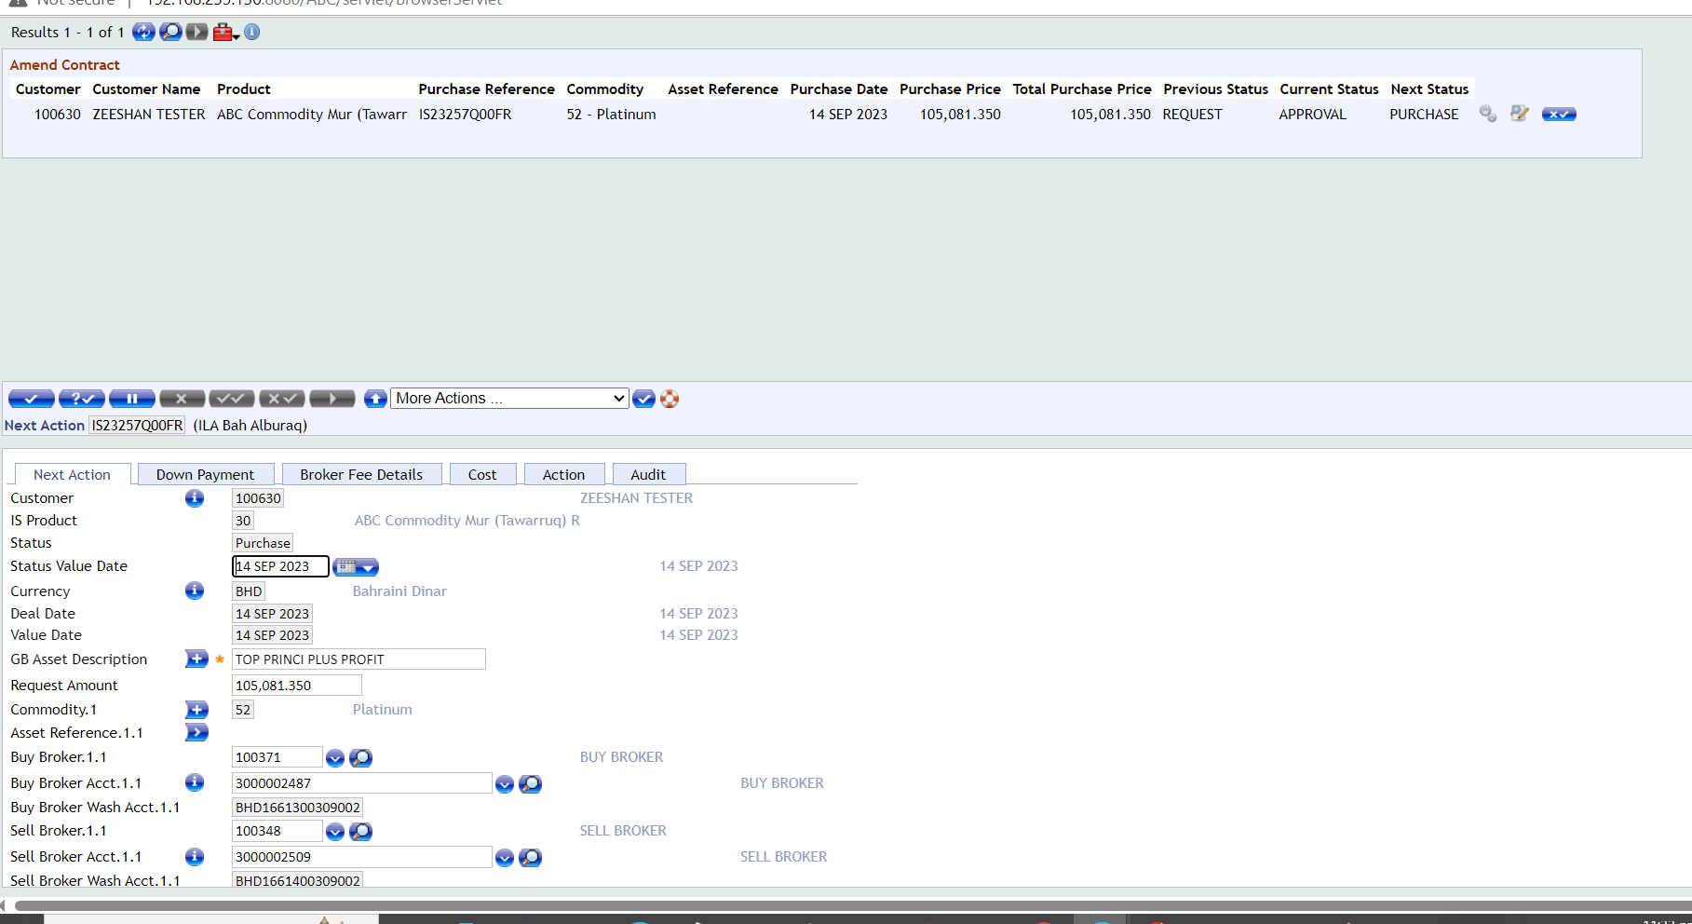

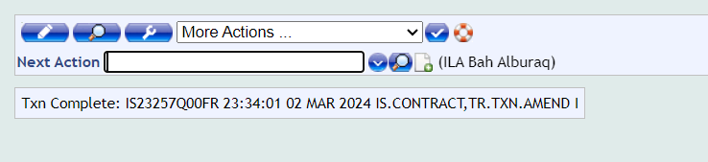
Authorization
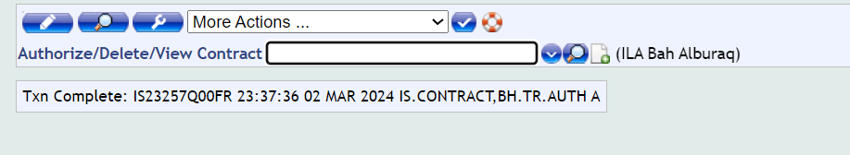

Arrangement Booking
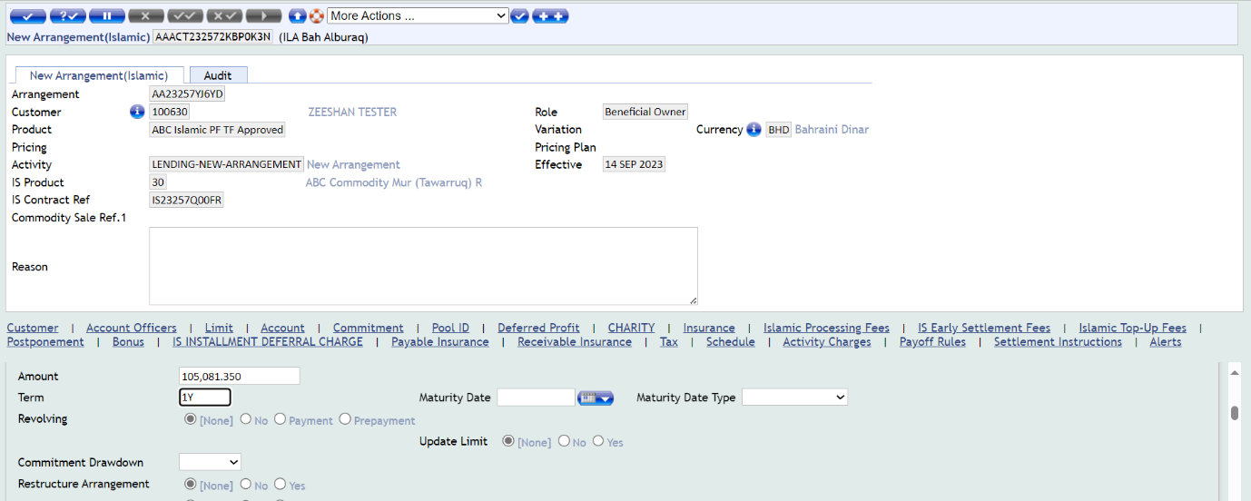
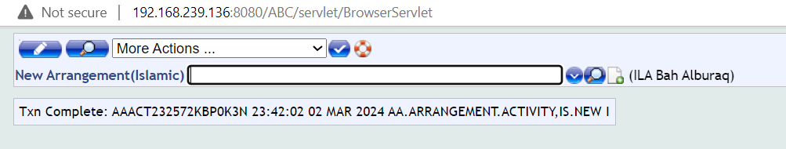
Authorization
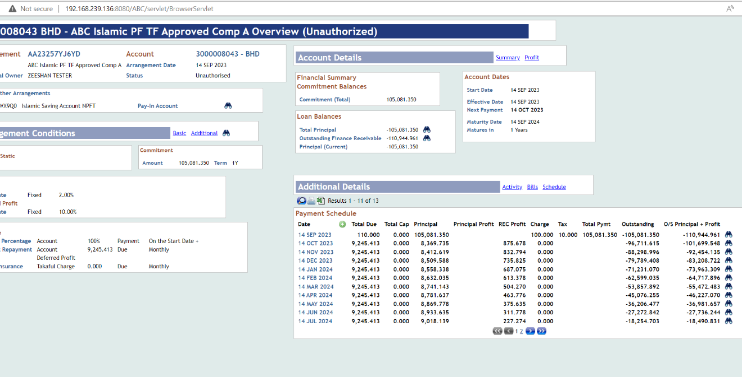
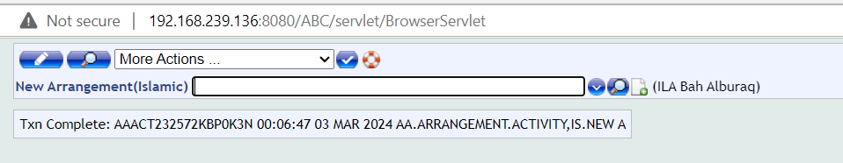

Commodity Restructuring Stage
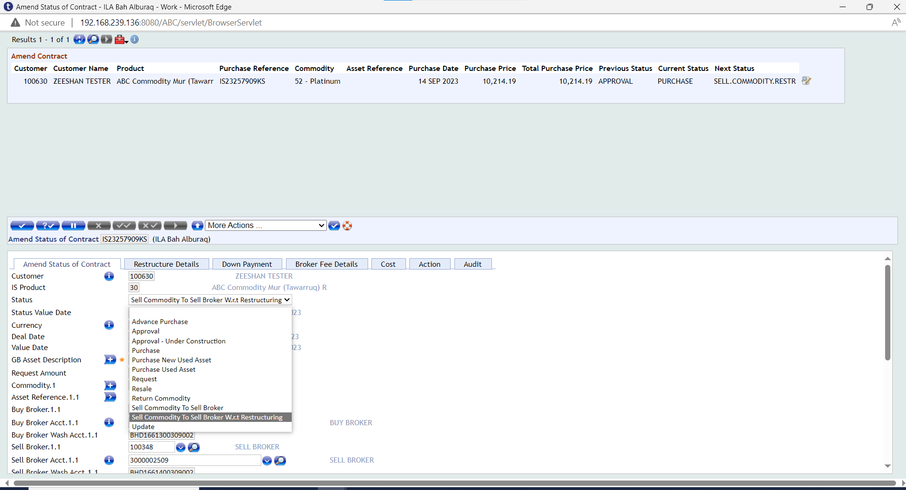
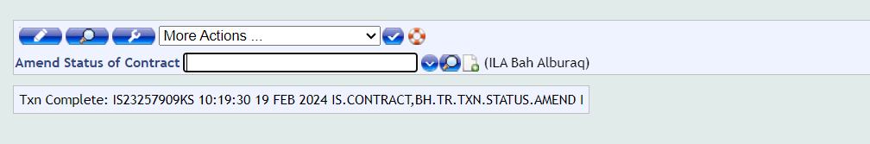
Authorization
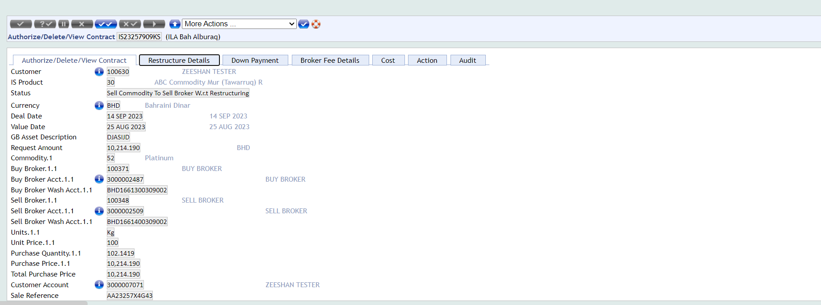
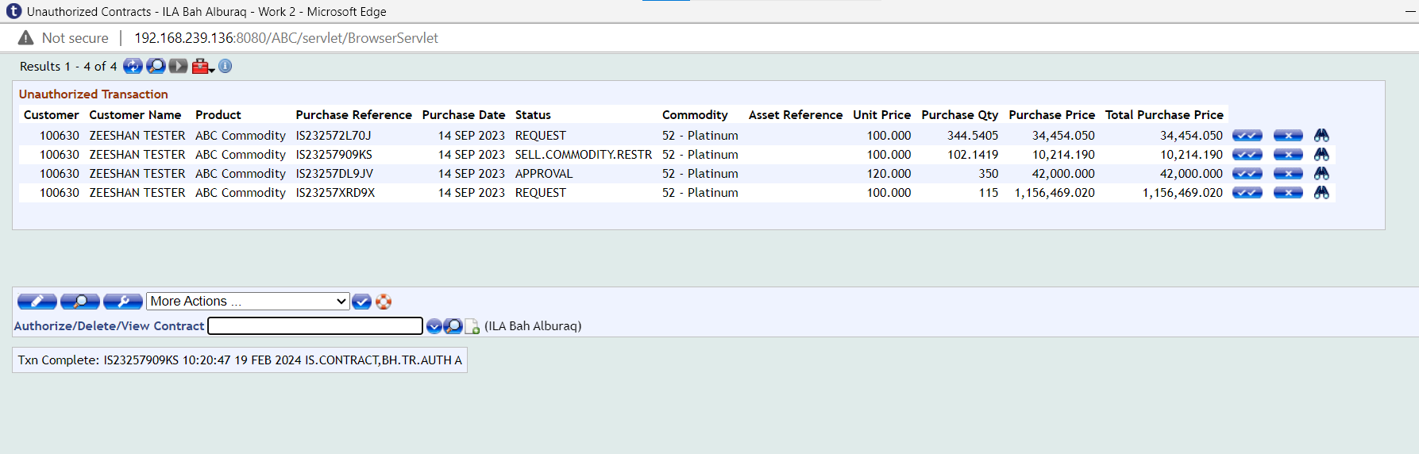

Financial Entries

List of Entries
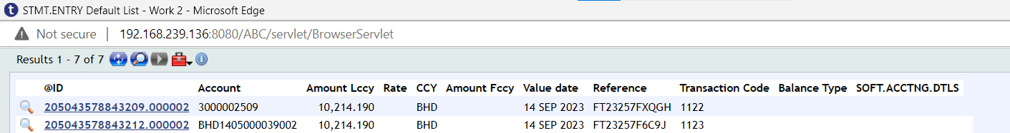
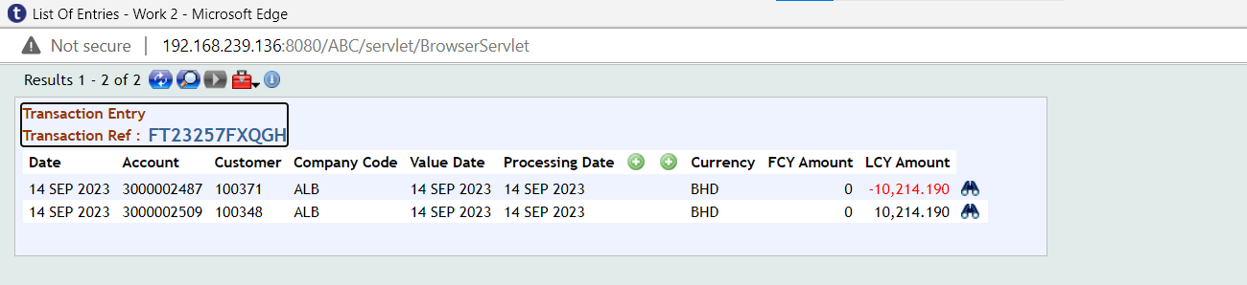
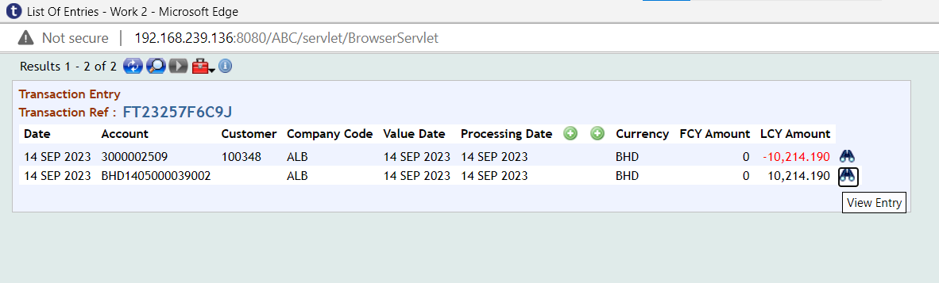

Enquiries (WS03-IJR-14)
Below enquiries are available in SMB.
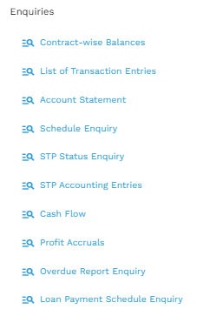
- Contract-Wise Balances
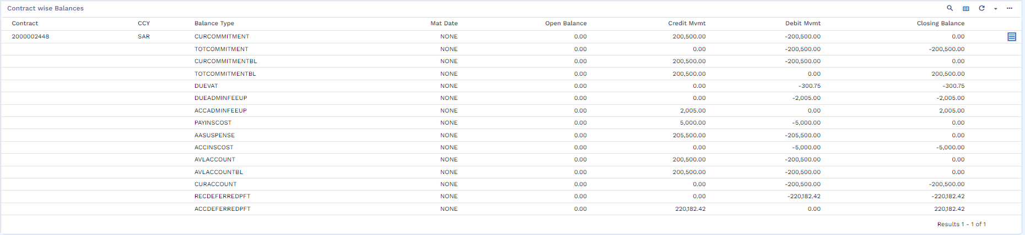
- List of Transaction Entries
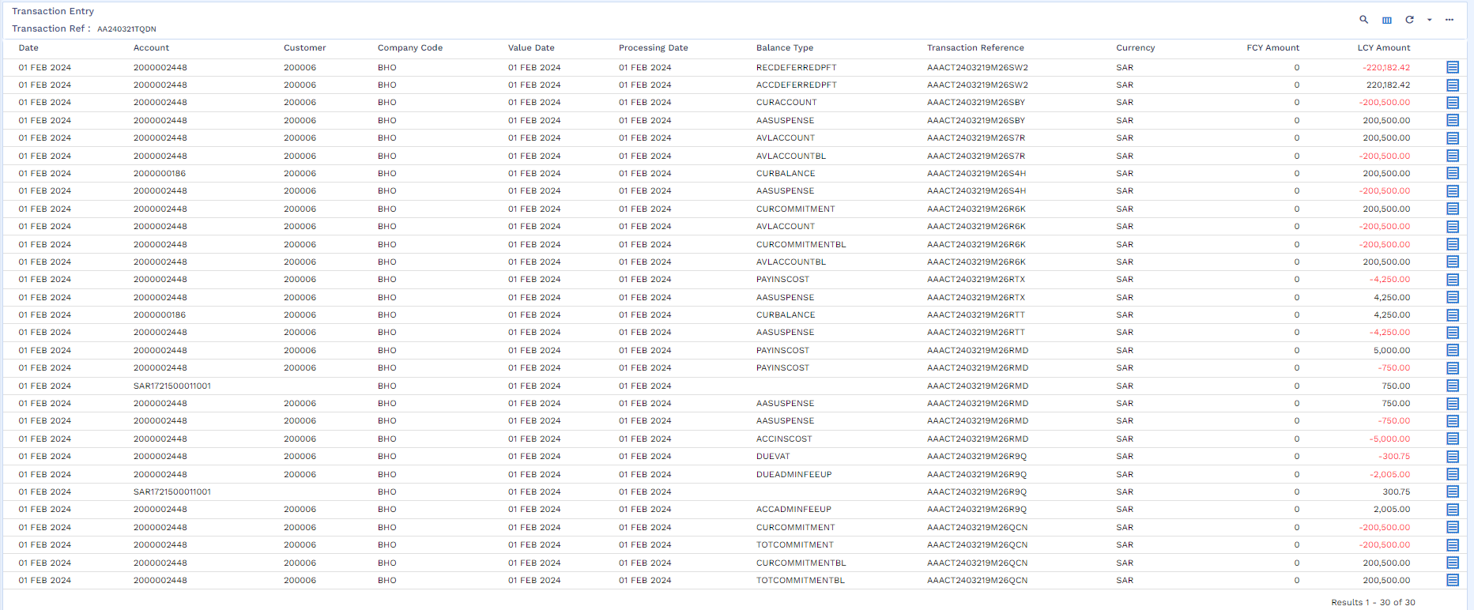

- Account Statement
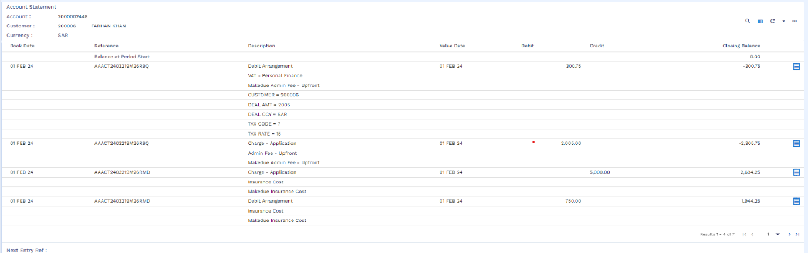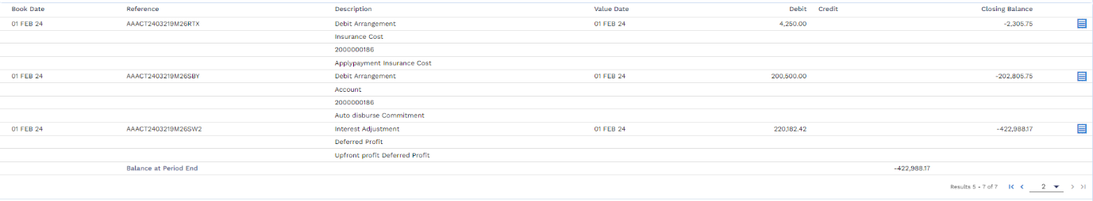
- Schedule Enquiry

- Cash Flow Enquiry
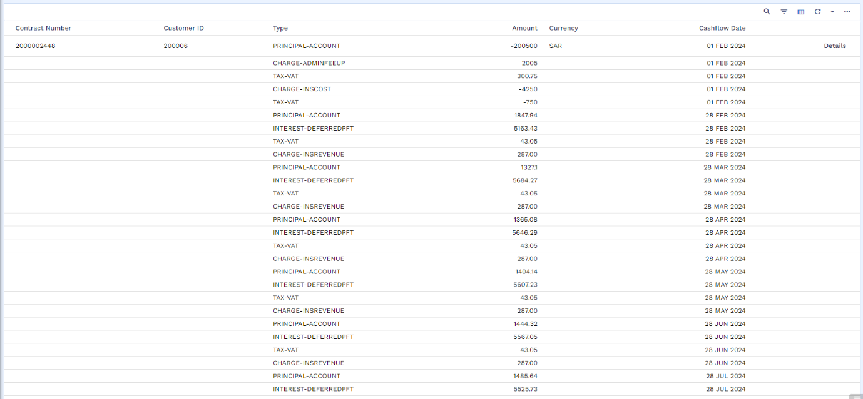
- Profit Accruals
- Overdue Report Enquiry
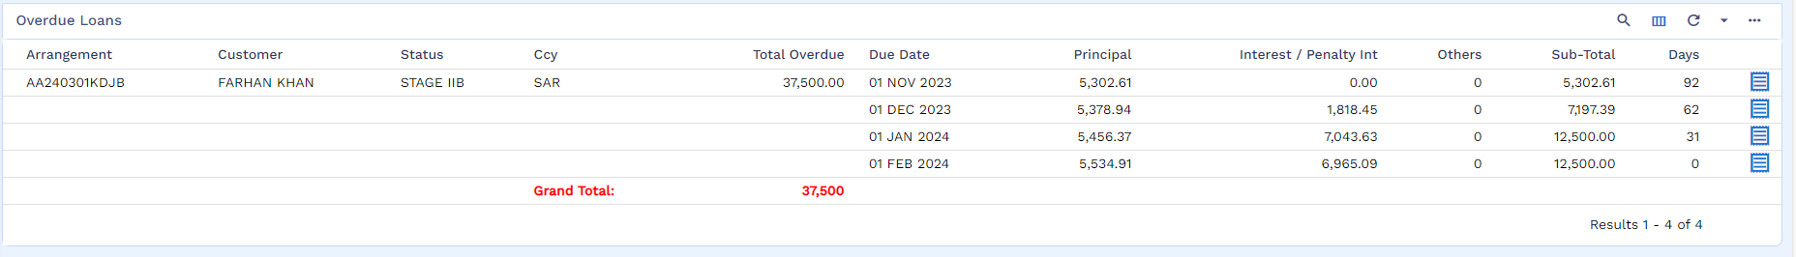
- Loan Payment Schedule Enquiry
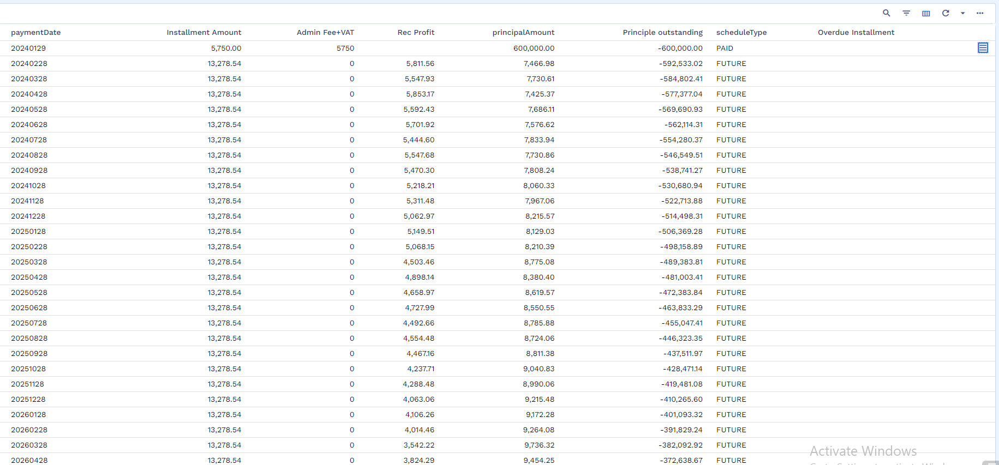

Deltas
Following gaps are captured in this document:
S. # | Gap Number | Gap Details
01 | WS03-IJR-03-01 | Amend IS Contract Stage
02 | WS03-IJR-02-01 | List of Vendors
03 | WS03-IJR-02-02 | Validation for sufficient funds
04 | WS03-IJR-03-02 | E-Invoice for VAT
05 | WS03-IJR-06-01 | Routing Entry for VAT
06 | WS03-IJR-08-01 | Calculate Insurance Balance
07 | WS03-IJR-06-02 | Accident Stop instalment
08 | WS03-IJR-06-03 to WS03-IJR-06-07 | Insurance configuration
09 | WS03-IJR-06-08 | STMT Transaction
10 | WS03-IJR-03-03 | Reversal for Asset Capture and IS Contract
11 | WS03-IJR-02-03 | Expiry of Repayment Schedule
12 | WS03-IJR-06-09 | Arrangement Generation via Delivery form
13 | WS03-IJR-06-10 | Document Upload at Delivery Stage
14 | WS03-IJR-06-11 | Validation on Pre-Paid charge
15 | WS03-IJR-06-12 | Traffic Violation Fee Dates
16 | WS03-IJR-10-01 & WS03-IJR-12-01 | Advance/Partial Payment
17 | WS03-IJR-06-13 | Limit Attachment before Arrangement
18 | WS03-IJR-06-14 | Tawtheeq Integration
19 | WS03-IJR-06-15 | Discount
20 | WS03-IJR-10-02 | Post Delivery Cancelation – With Court Decision
21 | WS03-IJR-10-03 | Post Delivery Cancelation – Without Court Decision
22 | WS03-IJR-10-04 | Termination (in case of reposes car)
23 | WS03-IJR-06-16 | Delay Transfer Fees
24 | WS03-IJR-06-17 | Waiver (Only Fees)
25 | WS03-IJR-06-18 | Loan Transfer / Loan Transfer with Repricing Only for Ijarah
26 | WS03-IJR-02-04 | Reallocation Payments & Down Payment only for Ijarah
27 | WS03-IJR-09-01 | Deferment Mandatory Insurance Payment
28 | WS03-IJR-10-05 | Total Loss Settlement through Insurance Claim
29 | WS03-IJR-03-04 | Reversal of Down Payment, Admin Fee & Insurance
30 | WS03-IJR-02-05 | Straight Through Process
31 | WS03-IJR-13-01 | Restructuring
32 | WS03-IJR-12-01 | Takaful Treatment in Partial Settlement
33 | WS03-IJR-03-05 | Offer letter, contract generation and other letters-

Detailed Description of Deltas

Amend IS Contract Stage - WS03-IJR-03-01
Once the IS Contract is created and system has generated the IS Contract number, after that there should be a new stage to amend the Asset Capture stage to add the details like Registration Number, Istemara Number. Bulk upload is also required on this stage which is “Amend Asset Capture”.

List of Vendors - WS03-IJR-02-01
Tamweel Team will provide the Vendor list which needs to be added in Transact the vendor can be active or de-active. Each Vendor will have its own CIF and CIF’s account.
- Category wise segregation is required Vendor e.g. Ijarah Vendor, Tawarruq Vendor etc.
- ID number for Vendor (TA please write length and data type)
- VAT Registration Number (TA please write length and data type)
- The TA (SAP) team will provide a unique SAP Vendor Number for each vendor. This number must be stored and associated with the corresponding vendor record in Temenos Transact.
- For Vendor CIF, Customer BSDD must be signed with above information. This BSDD is only for reference.

Validation for sufficient funds - WS03-IJR-02-02
Before generation of GL (Entry related to contract) a validation is required for sufficient funds in customers repayment accounts. To check that the available balance is equal to the repayment amount. This gap has been parked to LOS where offer letter must not be accepted if customer has not paid down payment, processing fee and insurance. LOS will fetch this information from LMS to confirm the payment. Moreover, following SADAD bills needs to be generated to enable customer to credit funds
- Down payment
- Admin fee with VAT
- Insurance with VAT
The admin fees is not based on product setup rather it is based on service provider, Admin Fee values are based on schemes whereas in product we will set the GL in product to manage the APR & this admin fee will be parked in customer repayment acc as an advance amount till the contract is generated.

E-Invoice for VAT - WS03-IJR-03-02
E-invoice is required to be issued for VAT amount which will be sent to the customer. This VAT will be applicable on insurance and admin fee.
File name : VAT E-Invoice Template
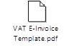

Routing Entry for VAT - WS03-IJR-06-01
Routing entry for VAT needs to be create as stated in (Day9- Proposed E2E Acct. Ent.)

Worksheet details:
File Name: Ijarah Working Sheet
Sheet Name: Day9- Proposed E2E Acct. Ent.

Calculate Insurance Balance - WS03-IJR-10-01
A routine needs to be developed for calculating insurance balance (payable/receivable) for normal maturity, early settlement cases and total loss.

Worksheet details:
File Name: Ijarah Working Sheet
Sheet Name: Day4-Insurance entries

Accident Stop Installment - WS03-IJR-06-02
No more instalments should be generated after date of accident, means update profit rate as 0% on contract. A version needs to be given to enable user to change interest rate as zero, along with change of schedule.

Insurance configuration WS03-IJR-06-03 to WS03-IJR-06-07
- WS03-IJR-06-03 - Insurance Cost will be booked upfront and amortized on a yearly basis. (Note for technical SA Team, it is a credit charge on AA)
- WS03-IJR-06-04 - Insurance Revenue will be configuring as a monthly charge which will be accrued on a daily basis. (Note for technical SA Team, it is a debit charge on AA)
- WS03-IJR-06-05 - For early settlement there will be routine to calculate the amount of insurance balance by comparing the amount of Insurance Cost paid from template and subtract the monthly charge (insurance revenue). For calculation of insurance please refer to section 8.6
- WS03-IJR-06-06 - VAT E invoice will be generated on monthly basis i.e. on instalment date. For invoice format please refer to section 8.4
- WS03-IJR-06-07 - An enquiry needs to be developed to determine the total-loss of any arrangement for which a local template is required. Pease refer to section 8.26.

Worksheet details:
For all above points, below is reference excel.
File Name: Ijarah Working Sheet
Sheet Name: Day9- Proposed E2E Acct. Ent. (for a & b), Day-1 Insurance (for c),

STMT Transaction - WS03-IJR-06-08
For every Transaction in STMT, TA needs IS CONTRACT, APPLICATION ID, SADDAD Reference. this is important for reporting purpose.

Reversal for Asset Capture and IS Contract - WS03-IJR-03-03
After Asset Capture and IS Contract creation, reversal is also required. This is part of core.

Expiry of Repayment Schedule - WS03-IJR-02-03
AA financing will be opened through manual user intervention with minimum input. At this stage system will create repayment schedule along with all financials including APR.

Worksheet details:
File Name: Ijarah Working Sheet
Sheet Name: Flat Rate APR - Ijarah

Document upload at Delivery Stage - WS03-IJR-06-09
At the time of delivery, documents need to be uploaded, a technical assessment is required. TA will provide list of documents and sample format

Validation on pre-paid charge - WS03-IJR-06-10
For all pre-paid charges mentioned in excel sheet, there is no role of infinity. TA LOS will send request and LMS will generate SADDAD bill, once it is received then system will automatically settle the amount. There must not be any overdue item before sending services request. Validation is required. These charged are not part of amortization table/ repayment schedule.

8.14.1 Worksheet details:
File Name: Ijarah Working Sheet
Sheet Name: Day2-Ijarah Charge List

Traffic Violation / Renewal Fee - WS03-IJR-06-11
The traffic violation and Renewal fee will be added in schedule manually by user, if it is from 1st to 20th of any month then this bill will be set for current month instalment due date +1 day, else it will be set on next month instalment due date +1Day. This setup will be done by users on arrangement level, whenever these charges are incurred by TA.
TA also needs bulk service upload file for traffic violations/other manual services if any.
Bulk upload for other charges.

Advance/Partial Payment - WS03-IJR-12-01
There is a possibility that customer transfers funds from IBFT where there is no invoice number (It is treated as Advance Payment), in this case if any request of partial payment/ payoff is received the invoice/bill amount will be net off with this advance amount and in case, the resulted amount becomes zero then only simulated schedule will be sent to customer and upon the acceptance of this schedule entry will be passed.

8.16.1 Worksheet details:
File Name: Ijarah Working Sheet
Sheet Name: DayN-File Upload

Limit Attachment before Arrangement -WS03-IJR-06-12
Limit and collateral need to attach before creating Arrangement. Both of these should be auto populated on arrangement level.

Tawtheeq Integration - WS03-IJR-06-13
Integration with Tawtheeq is required. This should be covered in integration session.

Discount - WS03-IJR-06-14
Discount from Vendor

- A Discount Percentage will be provided by LOS, as mentioned in E2E Accounting Entries. TA needs to decide whether this % will come from LOS or it should be set on parameters. Accordingly, solution will be provided.
LO will share Total Amount, Discount Percentage, Discount Amount and Net Amount. Discount is part of scheme.
The discount of Vendor will be amortized in Ijarah
Discount from Tamweel:
There is possibility that customer will get discount for example first two instalment are free, means TA will settle these accounts internally from Marketing Expense
TA is giving any free instalment to customer (settling the first N bills through their internal account), in this case there wouldn’t be any changes in customer’s APR. Moreover, since this is instalment free period for customer no SADAD bill should be generated. Free Instalments number should be communicated by LOS to LMS.

Worksheet details:
File Name: Ijarah Working Sheet
Sheet Name: Day9- proposed E2E Acct.Ent.

Post Delivery Cancelation

With Court Decision - WS03-IJR-10-02
Customer is supposed to pay all the bills and accrued Profit before the date of Judgement and rest should be manually waved by user.
Receivable from customer
Customer Dr
Receivable Cr

Waiver/Write-off after Court Judgment will be executed as per section 8.32.
PL Operation Loss Dr
Receivable Cr
Requirement is to add date of judgement

Without Court Decision - WS03-IJR-10-03
TA will sell out the Car in market through auction and settle the principal, earned income, any dues. Any difference will be paid by the Customer. Early Termination functionality will be used without any additional fees (no 3 months profit fee will be taken in this case) and if the vehicle was sold less than the outstanding balance amount then difference will be paid by customer. For this, a payoff statement is required.
The payment process of auction will be executed via manual payment that is new customer will send money through bank transfer. Then a file of repayment will be upload. (same is being used in Repayment with marking on field “RECEIVEDFROM” = Auction). This file will contain single car price. Dr. Tamweel Internal Account and Cr. Settlement Account. So, if the customer (Bidder) has paid 50,000 SAR then below entry will generate.
Car Remaining Principal + Dues = 65,000
Auction amount it 50,000
Tamweel Internal A/C Dr 50,000
Settlement repayment/disbursement A/C Cr 50,000
Settlement of Loan
Settlement A/C Dr 50,000
Customer Account Cr 50,000

A payoff needs to be run after getting auction amount in order to calculate net-off amount. Customer will transfer the differential amount that is 15,000. The collection department will send notification through email or call and SADDAD bill will also be generated.
Now after payoff statement below entry will be executed through user manually.

Differential amount 15,000 paid by customer

Tamweel Internal A/C Dr 15,000
Customer repayment/disbursement A/C Cr 15,000

Loan Settlement
Customer repayment/disbursement A/C Dr 65,000
Loan Account Cr 65,000

Requirement is to add auction amount field in payoff statement.

Termination (in case of reposes car) - WS03-IJR-10-04

The repossession process will be executed in TAC, however, once TAC user confirms T24 user about the completion of process then T24 user will park a flag of repossession on that arrangement. In the second step the user can add couple of charges as mentioned below.
“Repo certificate charges” and “towing company charges” these charges will become part of arrangement and whenever user will go for payoff, this will appear as due.
“Repo certificate charges” and “towing company charges” will be added in Arrangement so that at the time of payoff it comes as due.
In the repossession process, all the overdue items will be collected, insurance, profit and principal. For future insurance balance will be calculated and profit will be discounted, if the auction about is not sufficient the rest of the principal part will be aged. A flag of repossession required.

Delay Transfer Fees - WS03-IJR-06-15
After the maturity date of a loan, vehicle is supposed to be transferred to the end user. In order to avoid unnecessary delays, “Delay Transfer Fees” will be set in Transact after the maturity date with grace period. In this connection, there will be no accrual on daily basis. System will generate bill on instalment date and SADDAD is required on each month there can be ""N"" months grace period, will come from LOS, so next instalment start date after maturity will be maturity +""N"" Months. However, if customer comes (after the grace period) in middle of month, system should generate amount with respective days (local customization). Need to see with deferment and payoff scenarios in both cases recalculation is required.

8.22.1 Worksheet details:
File Name: Ijarah Working Sheet
Sheet Name: Day17-Termination Process

Waiver (for only fees) - WS03-IJR-06-16
Waiver can be executed for all due balance component.

Loan transfer/Loan transfer with repricing only for Ijarah - WS03-IJR-06-17
In this process, a new loan journey will be initiated by another customer, mainly new to the TA, with an existing loan ID/ Application ID. In this connection, old AA must not have any dues.
A new CIF will be onboarded with the contract reference of the loan which outstanding amount will be transferred to this CIF’s contract. Once the CIF is created close the previous contract and transfer this amount to new arrangement of new CIF. Previous arrangement will be closed by pay-off without any charges and then create a new contract for new CIF.

Reallocation Payments and Down Payment only for Ijarah - WS03-IJR-02-04
If the customer has cancelled/rejected relationship with TA, and repayment account still contains any Credit balance this balance can be used in next loan.

Deferment mandatory insurance payment - WS03-IJR-09-01
In case of deferment, the adjustment of Insurance, must be aligned as per required scenario, that means the accrual of cost must be aligned as per re payment schedule. For example, if the deferment reduces the term of the loan, then what will be the treatment of insurance premium. We need one schedule before and after from TA team.

Total Loss Settlement through Insurance Claim - WS03-IJR-10-05
In case of total loss scenario in which arrangement will be settled against insurance claim. Below are the scenarios through which total loss settlement will be executed.

Total Loss with charge
A charge will be taken for total loss settlement against the insurance claim. Detailed calculation is attached in Ijarah Working Sheet - day9to13-TL with charge.

8.27.1.1 Worksheet details:
File Name: Ijarah Working Sheet
Sheet Name: day9to13-TL With charge

Total Loss without charge
No charge will be taken for total loss settlement against insurance claim. Detailed calculation is attached in Ijarah Working Sheet - day9to13-TL without charge.

8.27.2.1 Worksheet details:
File Name: Ijarah Working Sheet
Sheet Name: day9to13-TL Without charge

Total Loss with Insurance differential
Differential between monthly insurance received and actual insurance paid will become part of settlement of amount either its receivable or payable to customer. Detailed calculation is attached in Ijarah Working Sheet - day9to13-TL with insurance.

8.27.3.1 Worksheet details:
File name = Ijarah Working Sheet
Sheet name = day9to13-TL With insurance

Total Loss with Back Date Accident
If any installment is received after the accident of vehicle, then respective insurance and profit amount of those installment will be reversed and credited to customer account. There will a discount equivalent of installment amount where user will input manually for recovered installment.
Detailed calculation is attached in Ijarah Working Sheet - day9to13-TL Back dated.

8.27.4.1 Worksheet details:
File name = Ijarah Working Sheet
Sheet name = day9to13-TL Back dated

Total Loss with Death Claim
If a customer is deceased in the event of accident, then settlement of arrangement will be made against combination of life and vehicle insurance claim, any amount excess after settlement will be credited to customer repayment account. Detailed calculation is attached in Ijarah Working Sheet - day9to13-TL With death claim.

8.27.5.1 Worksheet details:
File name = Ijarah Working Sheet
Sheet name = day9to13-TL With death claim

Reversal of Down payment, Admin fee and Insurance - WS03-IJR-03-04
The reversal of down payment, admin fee + VAT and insurance will be occurred in the below scenarios:
- Rejection/Expiry of offer
- Rejection of financing contract
- Rejection of promissory note
- Rejection by customer on IVR authentication

GAP - STP Process - WS03-IJR-02-05
- LO will send list of fields to LM to get simulated schedule from LM, which will be used for Qarrar and offer letter generation.
- Post offer acceptance, LO will push complete list of fields related to customer in response LM will create the CIF and Repayment account of customer. For CIF related information please refer to Customer’s documents.
- Bill will be generated for downpayment and admin fee. Upon payment of bill Credit Admin will issue the PO and sent it to vendor manually.
- Vendor will share the green card details with the LO
- Credit will do the selection of insurance
- Contract will be generated through ND (if rejected/declined Reversal of: downpayment, admin fee, Insurance)
- Promissory Note creation and acceptance by customer through NAFITH (Reversal of: downpayment, admin fee, Insurance)
- IVR call to be responded by the customer, IVR authentication if customer reject offer then Reversal of: downpayment, admin fee, Insurance)
- IS Contract Stage: Auto process will trigger (Asset Capture and IS Contract creation – Auto Creation)
- Insurance policy needs to be issued
- Delivery Stage: Istamara Number will be input in Transact. AA will be created manually where Istamara number will be input. Repayment Schedule with APR effective from delivery date will be generated on the same stage. From the same date the accrual of profit will start, during EOD process.

Restructuring - WS03-IJR-13-01
For restructuring of Ijarah finance assets capture details needs to be captured in order to book IS Contract and AA Arrangement thereon. Moreover, treatment of balance of takaful amount (receivable / payable) will also be incorporated for restructured arrangement.
In case of overdue insurance customer is supposed to pay all overdue insurance amount as a part of downpayment before starting the new contract.

Takaful Treatment in Partial Settlement - WS03-IJR-12-01
In case of partial settlement insurance template needs to be updated with takaful amount to be recovered as advance installment (i.e. compression or principal decrease). This means if any advance payment has been executed then treatment of Takaful should be recalculated so that it should not be exceeded projected amount, TA needs to confirm.

Offer letter, contract generation and other letters- WS03-IJR-03-05
` S.no | File Name | Document
1 | Clearance letter
2 | Ijarah contract - SAMA
3 | Ijarah contract

In points 2 and 3 above, the TA needs to confirm which contract will be generated: the one mentioned in point 2 (Ijarah Contract – SAMA) or the one in point 3 (Ijarah Contract), as both cannot be created.
In order to generate synch APR on contract and loan account, it was agreed that TA will be generating contract on daily basis till the expiry of offer. There is no impact on offer generation, offer will contain maximum APR. There is no change in first instalment date calculation, which is based on offer expiry date.

Please also provide template of other notification like SMS with events if required from LMS

Post write-off recovery- WS03-IJR-11-01
In current design, once the case goes for write-off the loan account status becomes pending closure as mentioned in section 6.6.4. therefore, in order to recover the amount in future, system should maintain each balance component that were waived / written-off. TA needs to elaborate how the payment of such cases will be executed. Either IBFT or SADDAD.
TA needs to explain if write-off is required on different business events with different PL, else one screen will be given with default GL.
In addition to this bulk write-off is also required as mentioned in section 6.6.4.

Bullet Payment and EPC (Early Payoff Charges) WS03-IJR-10-06
If a customer has paid DP, and now wants to pay rest of the amount in last instalment, then in this case a bullet schedule will be generated. This information will come from LOS. The EPC charge / penalty now needs to be enhanced. Presently it’s taking current month profit to Ijarah Income and upcoming 3 months instalment profit in EPC. Now same routine will take current month profit in Ijarah income whereas since there is no EMI instalments therefore upcoming 3 months profit will be taken in ECP charge. Same enhancement will work for quarterly and semi-annually repayment cases.

Abnormal Cancellation WS03-IJR-10-07
In case of recall (abnormal cancelation) of the car by TA there will no Early Termination Fee and Accrued Profit (broken days profit). Reversal of Accrued profit will be managed through Discount Property. There will no reversal of admin fee and down payment.

Residual Value WS03-IJR-06-18
Residual value will be set on schemes, LOS will send Transact RV % and RV Amount that will become part of last instalment. For last instalment, SADAD bill will be sent to customer that is last instalment amount + RV. If this RV is not settled by customer, then TA will see how to manage this amount. This also required an internal discussion on TA side. Any changes in process are part of Addendum of BSDD.

File upload of repayments through IBFT
For all those customers’ that will manually transfer payment through IBFT, a file upload process will be used to execute the payment in transact. This will enable to settlement accounts to get funds and to process loan bills. Below is the agreed file format.
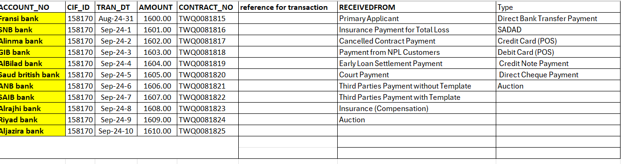

Worksheet details:
File name = Ijarah Working Sheet
Sheet name = DayN-File Upload

No Colling Period: so Ijarah cases will be tread as normal early maturity

